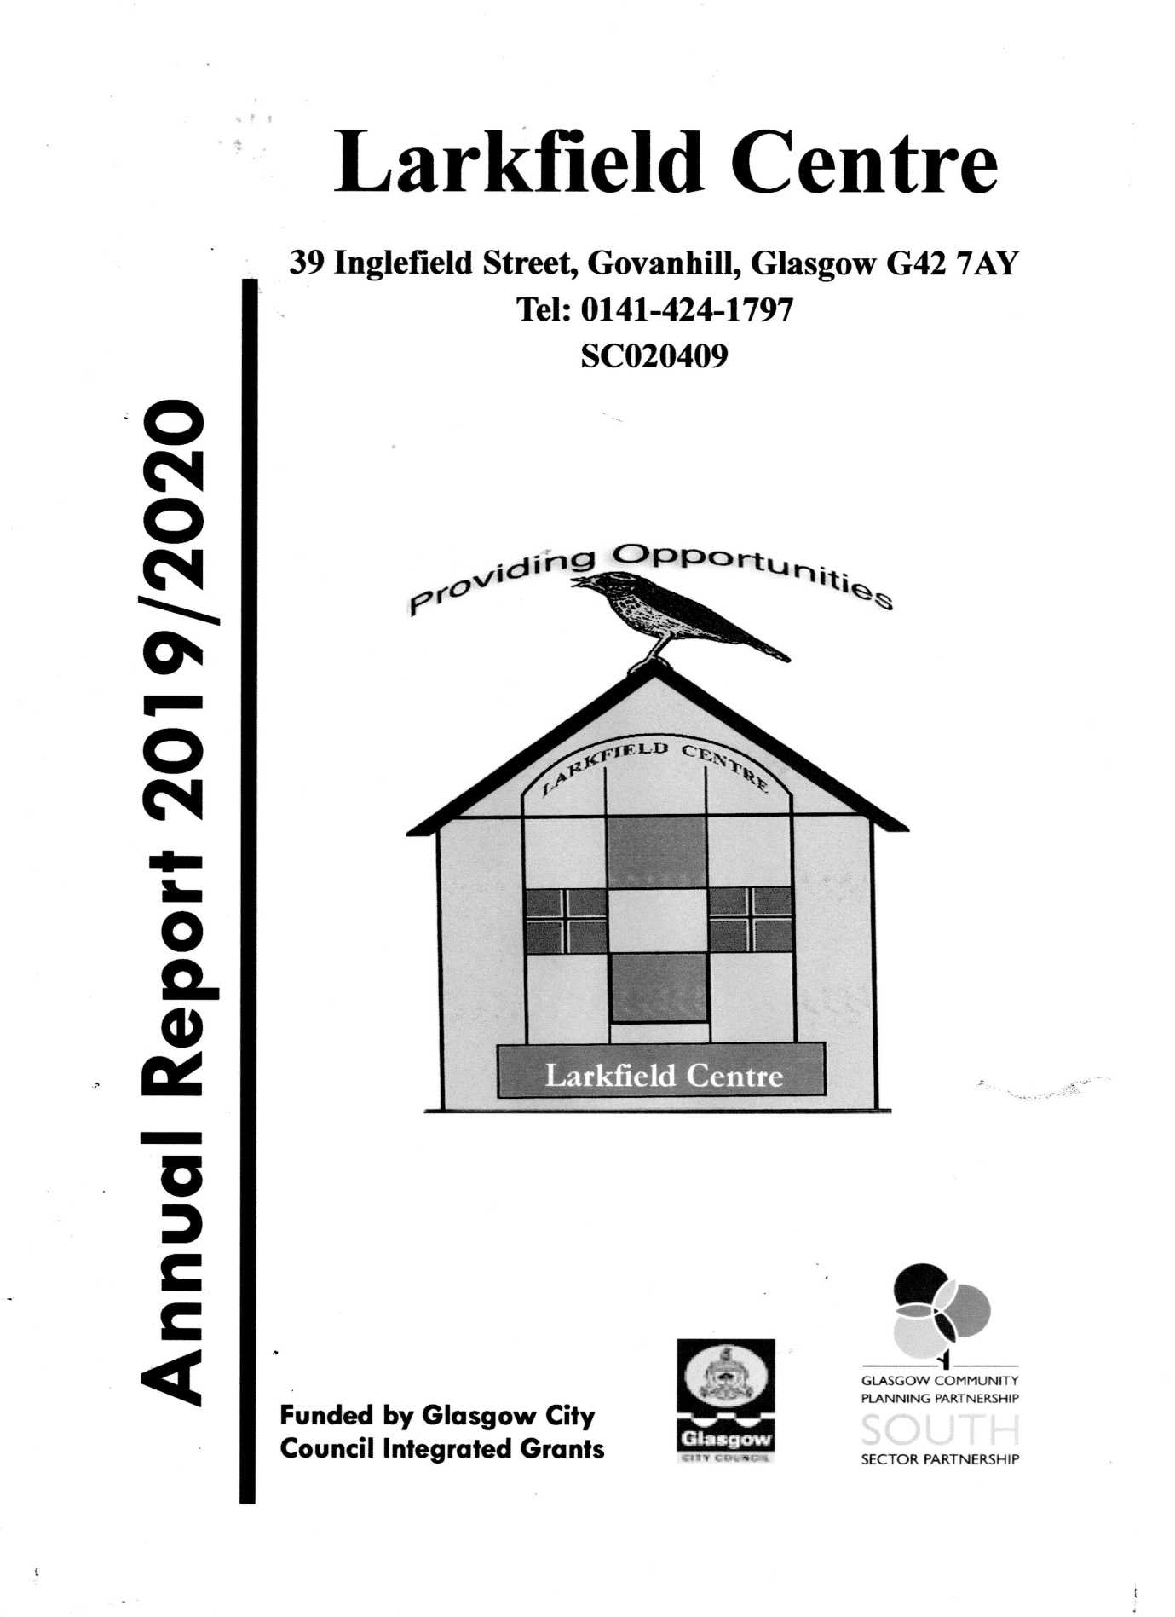
Mission Statement
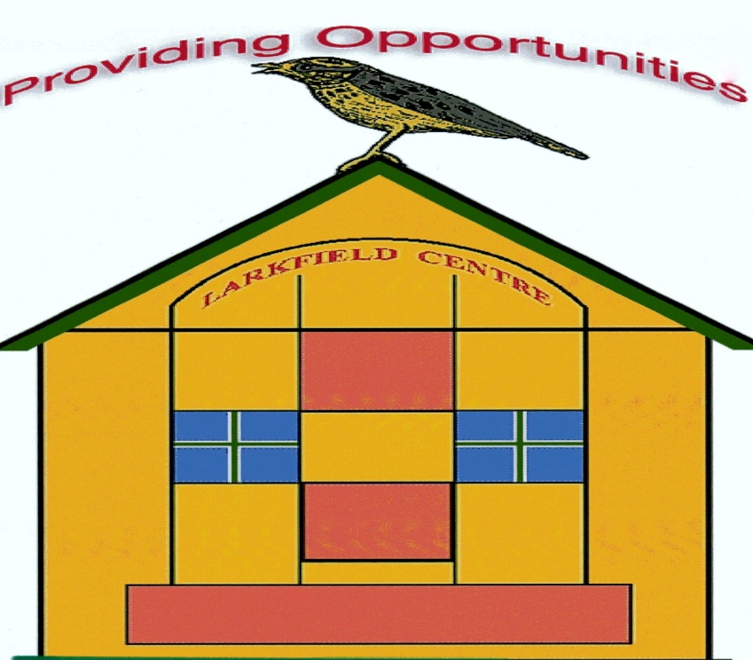

The Larkfield Centre is established solely for charitable purposes within the Govanhill Area and its Environs. It’s Mission is to promote, for the benefit of the inhabitants of Govanhill and its environs, activities, programmes and events, offered without distinction of political, religious, or other opinions and to advance educational programmes. This will be achieved through associating the inhabitants, voluntary organisations, and local authorities, in common effort and by providing facilities for social welfare, for recreation, and leisure time activities, with the object of improving the conditions of life for our stated community.

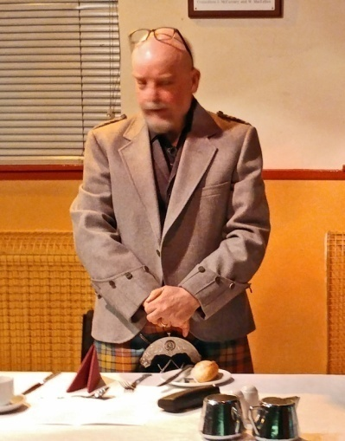
Chairperson Report

The 2019/20 year has been strange and surreal, especially since Lockdown with the Centre closed to all since March. Since the restrictions came into play and I had to take the difficult decision to close the Centre, Anne Marie has continued to ensure that the administrative side of the Centre is looked after, whist the Management Board has met regularly using Zoom.

Prior to Lockdown, the Centre fulfilled its aims in serving Govanhill and its environs with a programme that had as highlights the Christmas events of the Grotto, the Light Switch On with all the usual choirs and entertainment we have been so lucky to attract and of course the Pantomime.

The Autumn saw us focussing on the Remembrance Event and the Halloween Schools event, which this year attracted more schools than ever before with writers and storytellers from various clubs performing to the children.

We hope that as restrictions are eased, we will be able to open again and attract the wide programme of activities into the premises, though we are continuing to wait for guidance concerning social distancing and how best to implement the new strategy into the Centre.

We are also aware that in the forthcoming period the grant support structure is undergoing considerable change and the Centre may not be able to rely on the same level of funding. Should this be the case, we will be calling a public meeting to consider the best way forward. To prepare for this eventuality, the membership took the brave decision to become a different kind of charity, a (SCIO) Scottish Charitable Incorporated Organisation and the process toward this is still being pursued.

It is my hope that 2020/21 will be a much easier year and I commend our staff, committee members and all those who support what we try to do. Why don’t you also become involved on the committee or volunteer?

Marc R Sherland
Chairperson of the Larkfield Centre Management Committee
Groups

Music Rehearsal

The music rehearsal group has been running at the centre for many years and is made up of a group of friends that hire out the space so they can play instruments and sing together as if it weren't for the space they would be unable to come together to rehearse their music together as they are good neighbours who don't want to annoy fellow neighbours.

SKYY (Singing Keeps You Young)

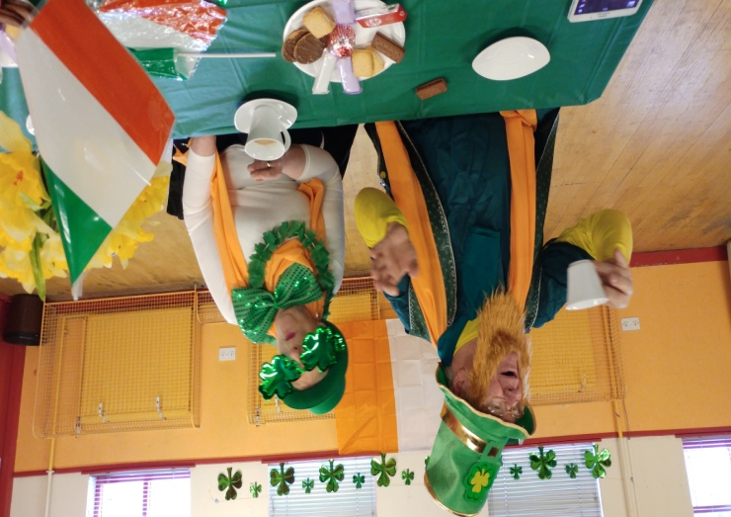
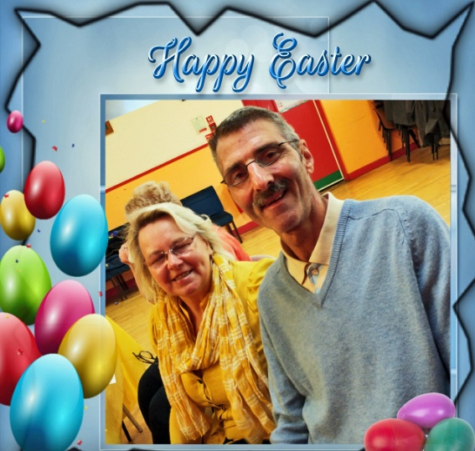
This group meets usually on the third Monday of the month at 1pm and brings older people together who have an interest in signing. They have also learned songs from other countries as one couple who attend have a Polish background. Below are some pictures of the different Themes the group have covered over the year.
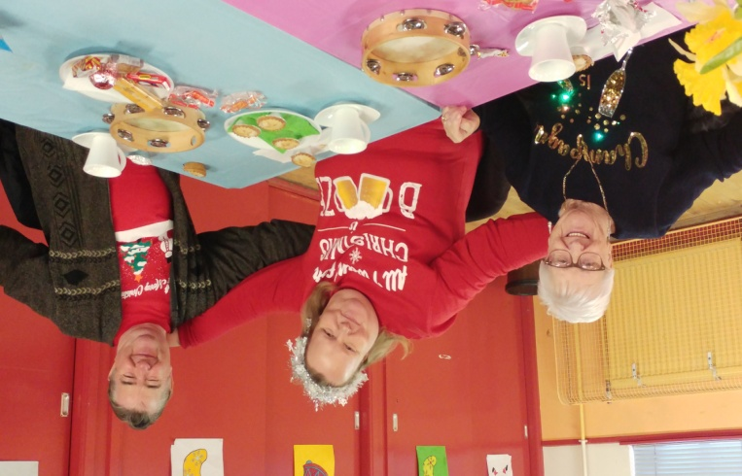
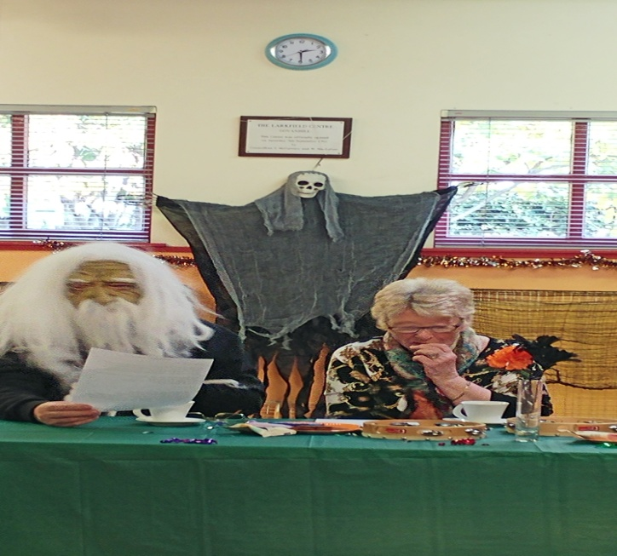

Groups Continued

ESOL

We continue to provide space for Clyde College, 'Langside Campus' to enable them to teach English in the community to people who are not quite ready to go into the structured educational facilities such as Clyde College'.

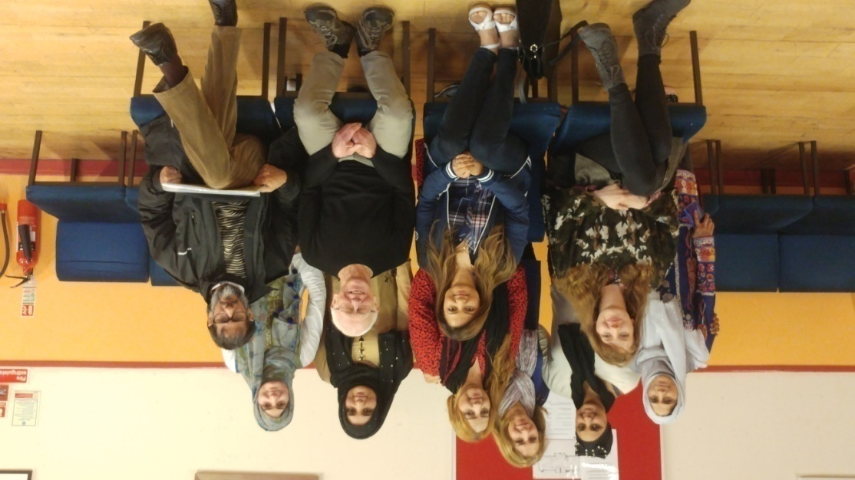
The community classes builds the confidence of its students to enable them to feel confident to participate in College life. It is also great to see the changes at first had that the classes have for the students as by the end of each term more and more of the students are happy and feel more confident to enter into conversation with people at the centre.

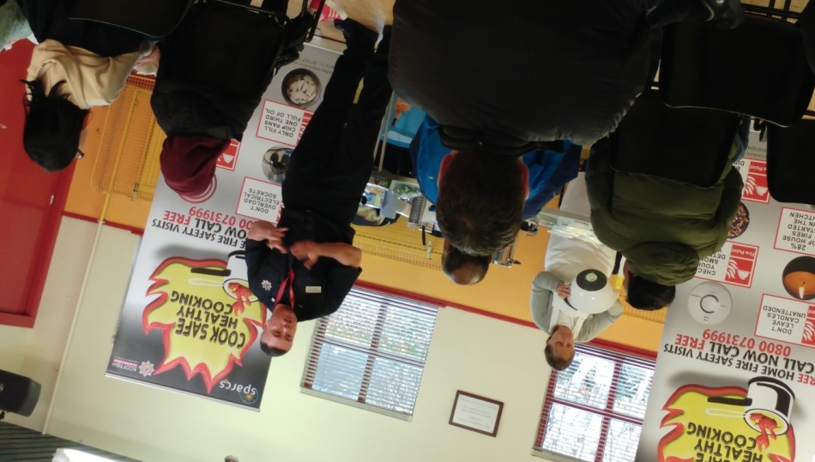
We also held a Fire Safety session for the ESOL Students were the Fire Service came in and gave the students a talk on safety in the home plus they also got shown some quick nutritious and easy soup to make along with Eaton mess..... The students loved it and it also gave them the opportunity to use the language that they were studying.

