Larkfield Community Centre

A
N
N
U
A
L

R
E
P
O
R
T

2
0
2
1
/
2
0
2
2
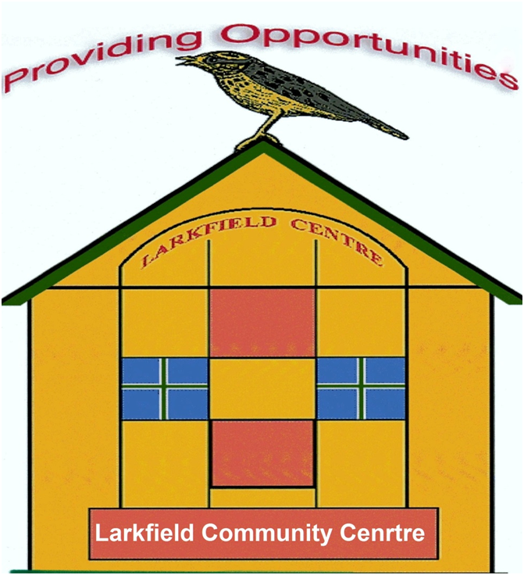

Funded by Glasgow City Council

New Communities Fund,

The WEIR Fund & COOP
39 Inglefield Street, Govanhill, Glasgow G42 7AY
Tel: 0141-424-1797
SCIO51309

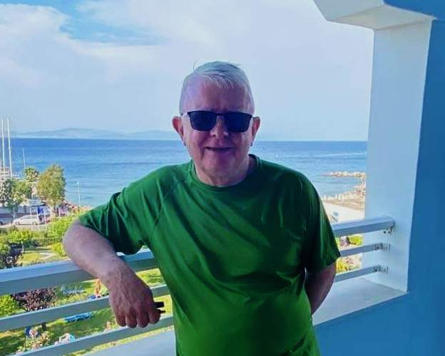
Chairperson Report

The past year continued to be strange for the centre with restrictions still in place for the safety of our Centre Users.

We spent most of last year as a Board completing the process of becoming a SCIO which was a lengthy process for the Voluntary Board Members to complete and the reason for doing this was due to it being a Condition of our Grant Funding from the New Communities Fund that we had to change our legal status from being an unincorporated charity to a SCIO (Scottish Charitable Incorporated Organisation).

We have now completed this process with all assets transferring over to the SCIO which we decided we would rename Larkfield Community Centre as the Board members felt it said what we were about whereas the original name of Larkfield Centre Management Committee didn’t let the public know what we do on a daily basis.

This change in status has had no impact on what we deliver at the centre and it is business as usual. We are delighted to advise that OSCR have approved our application for change in status and they granted our application to become a SCIO on 30 September 2021.

Also, over the past year we saw a long term member of staff James Winser retire and on behalf of the Board and Centre Users I would like to wish him well for the future.

Regards

John Peebles
Chairperson of the Larkfield Community Centre

Group News
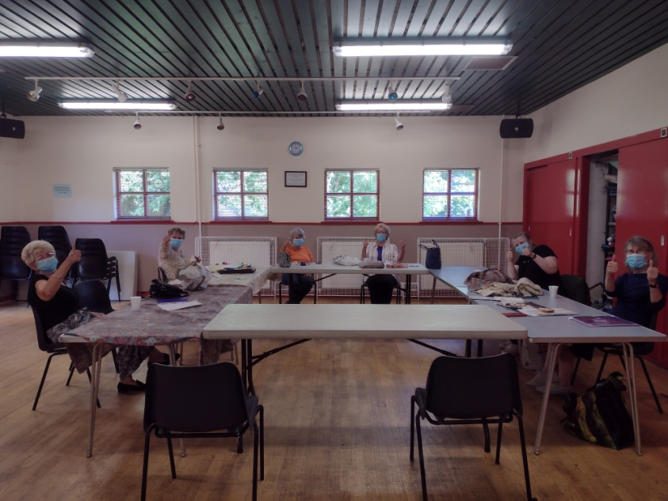
Art Group

The art group started back after the lockdowns and they were just having a cup of tea and chatting over the weeks and months, and after the centre manager sat down with them to see how we could assist them to take up the paint brushes again and it was easily recognised that they needed someone to get them back on track with their painting etc. Funding was secured and now they are happily taking out the paints and brushes and putting paint to canvas once again.

They are currently working towards an exhibition for the Project Getting Life Back. Group meets on a Tuesday from 1pm-3pm they still have a few spaces for new members.

Digital Photography Group
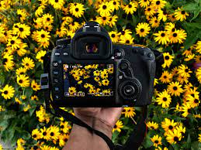
When the Digi Group as they are known as returned to the centre they too were struggling to do what they were atthe group for so spent many weeks/months sitting with a cup of tea and chatting, the volunteer who used to take the group had opened up a studio and time was precious to them but for a few weeks they came in to help the group but once they had to leave things went back the way and the manager sat down with them to see how they would go forward and again it was felt by a centre group that they needed a Tutor to take them forward to build their confidence
Group Continued

Digital Photography Group Cont.

back up. So the manager looked at possibilities of funding and started to think that they too could be part of the Project ‘Getting Life Back’.
Funding was secured and now the group are happily taking photographs working towards exhibiting them in the next financial year along with the Art Group. The Group meet on a Tuesday at 10am – 12noon and currently there are no available places and have started a waiting list.

Women’s Group

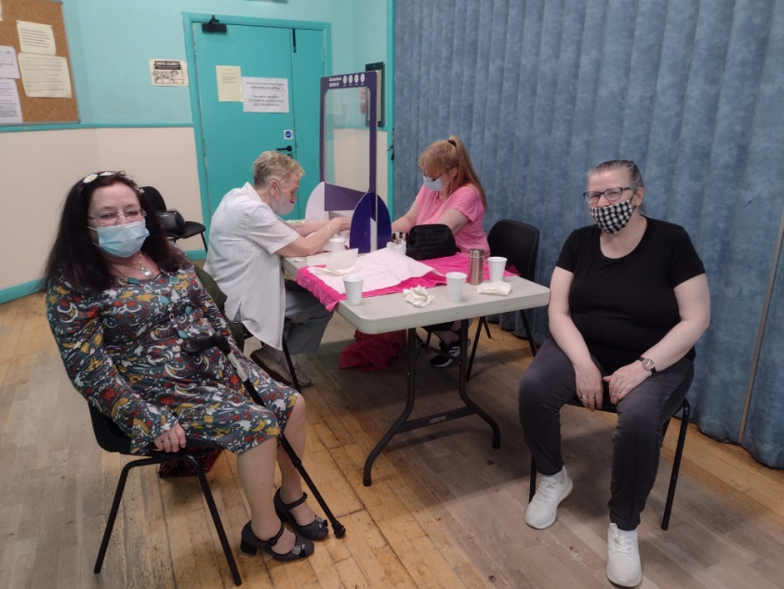
The women’s Group were fortunate that when we were able to bring them back into the centre we had funding from the COOP who were magnificent and allowed us to carryover the underspend into this financial year as without it we wouldn’t have been able to kickstart the group. However with the funding due to come to an end and after a discussion with the women it was felt that they too needed the skills of a Tutor/Therapist to keep them going as again it was needed as they women were not as enthusiastic as they had been pre pandemic and were still in a flat mode and in need of getting reenergised. It was agreed that they too could be part of the ‘Get Life Back’ project with them learning a yoga dance and performing it at the Art and Digital Photography Exhibition and as you have seen n the other two groups updates of the year the funding for the Project was secured and the women are looking forward to being part of it. The group meets on a Friday from 1pm and there are currently spaces available.
Group News Continued

Alcoholics Anonymous (AA)

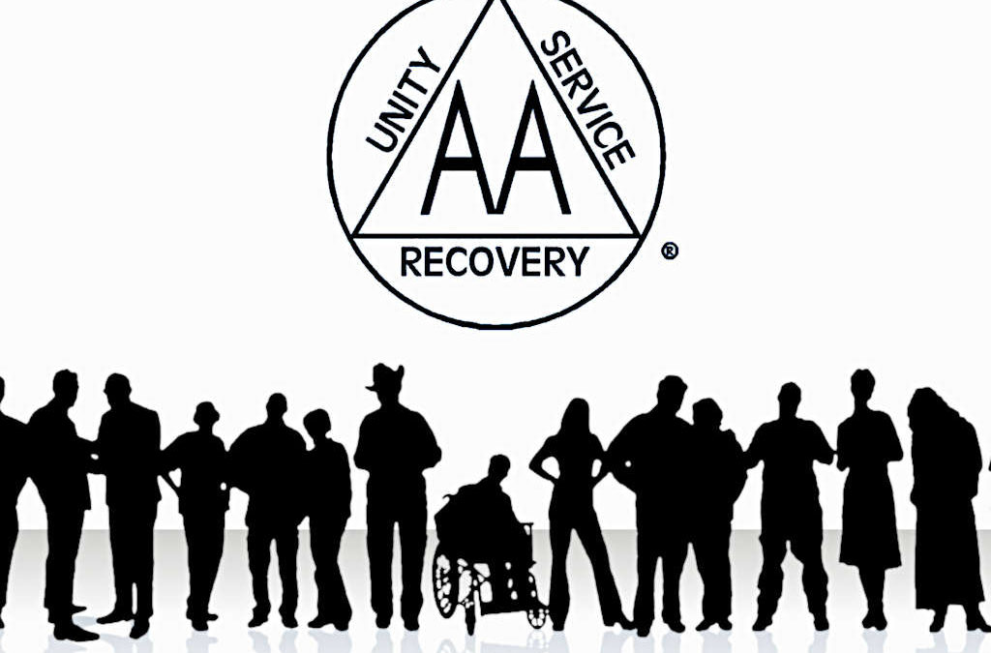
The AA group have returned after lockdown though the Board of the Centre had reduced their numbers to 20 members per meeting. This was for the safety of staff and other Centre Users. The use of the Kitchen has not been reintroduced to the public or groups as it would be difficult to ensure it would be cleaned down after each members of the public had exited the kitchen. The Board will continue to assess this in the year ahead. The group meet on a Wednesday evening from 7.30pm – 9.30pm

Positive Action in Housing

Positive Action in Housing continue to make use of the centre as a base to deliver services locally to the Romanian part of our Community as they have the Language Skills and also the expertise in Housing, Benefits and Residency etc. Currently they operate to an appointment system seeing many people over the course of a week as they are always busy due to the services being specialised that they deliver. They have services on a Monday from 10am-3pm Thursday from 10am – 3pm and 1st &3rd Fridays of the month from 10am – 3pm and 2nd & 4th Fridays from 1pm – 3.30pm

Group News Continued
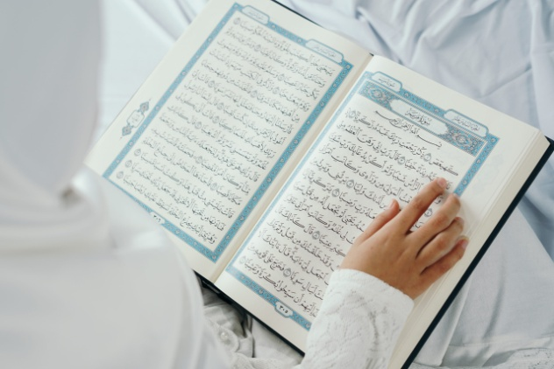
Language Class

The Arabic/Koran Class returned to the centre and its numbers seem to be back to as they were ore pandemic. It is good to see children/young people back accessing the centre. The group meets Monday – Thursday from 4.30pm – 6.30pm.

Music Rehearsal Group

This group hire the hall to rehearse their music skills as they feel they can’t do it at home as it would disturb the neighbours. They have been meeting at the centre on a Monday evening for many years and were delighted that they were able to return as they missed getting together to play their music and sing.

Authentic Connections

The above is a closed group and are new to the centre it is a teaching group for Asian women and they were delighted to find available space at the centre to hire so they could hold their group sessions in person.

MSP and Councillor Surgery

The local MSP and Councillor holds a Surgery at the centre on the 2nd Friday of each month from 11am and it is currently by appointments only at this time.
Group News Continued

MP Surgery

The local MP holds a Surgery at the centre on the 4th Friday of each month from 10am and it is currently by appointments only at this time.

ESOL

After lockdown Clyde College who held classes for English as a Second Other Language at the centre for many years sadly had to withdraw the service as numbers were not consistent on a weekly basis with it being new people on a weekly basis coming along and not coming back, They gave it several months to try and establish a class of regular attendees but sadly it wasn’t to be. Maybe once everything settled down and we get used to the new normal they might revisit and bring back ESOL classes to the Centre.

Events
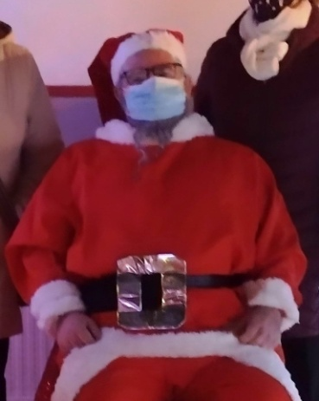
Christmas
Walk-Through Grotto

This year we were able to hold a walk-through Santa’s Grotto and we would like to thank the local Councillor Alexander Belic for arranging for Santa to attend the centre to meet up with the children and parents from the local area.

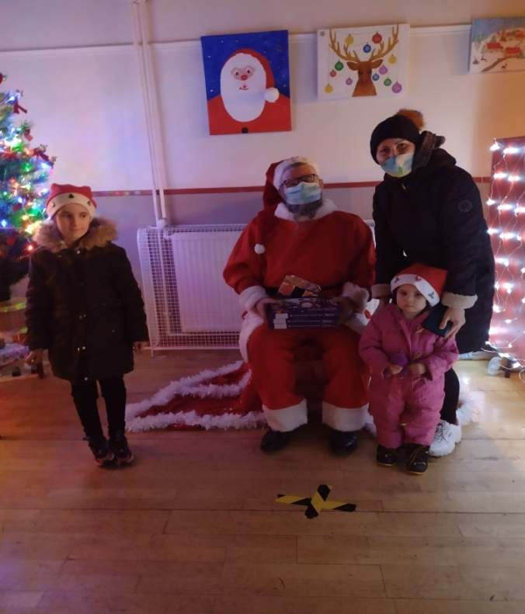
Events Continued

Christmas
Walk-Through Grotto Continued

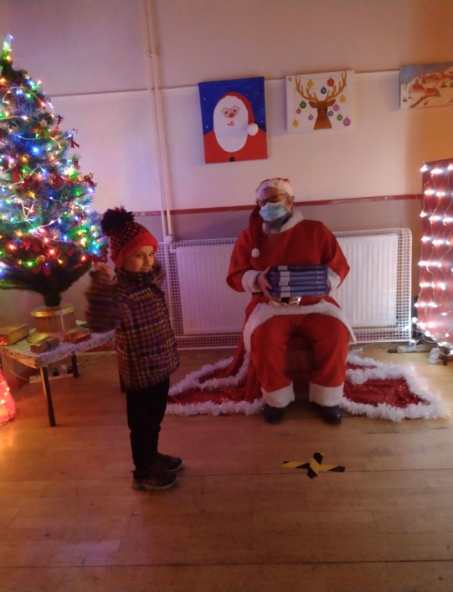
Here are some pictures from the event that was well attended given the issues around covid.
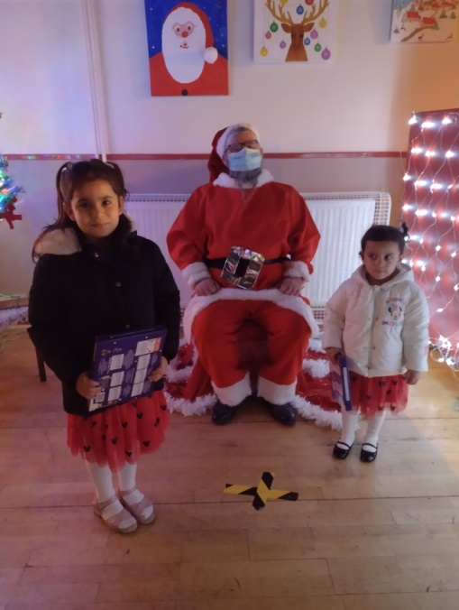

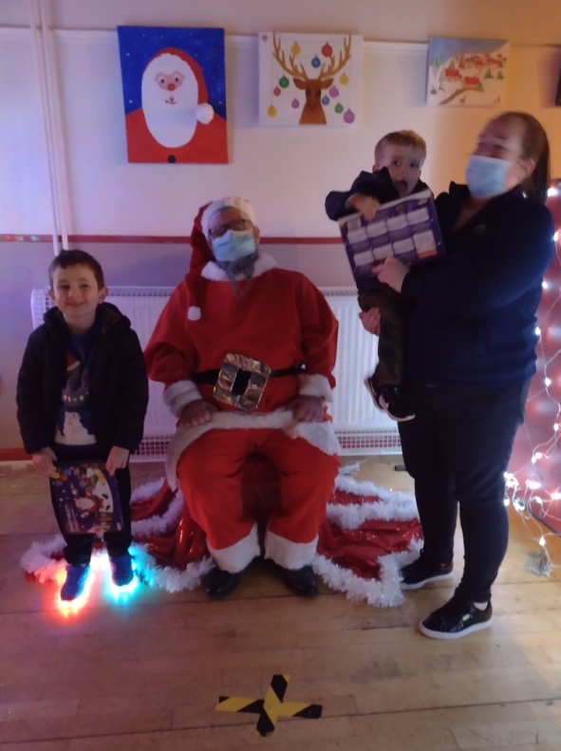

Events Continued

Christmas
Walk-Through Grotto Continued
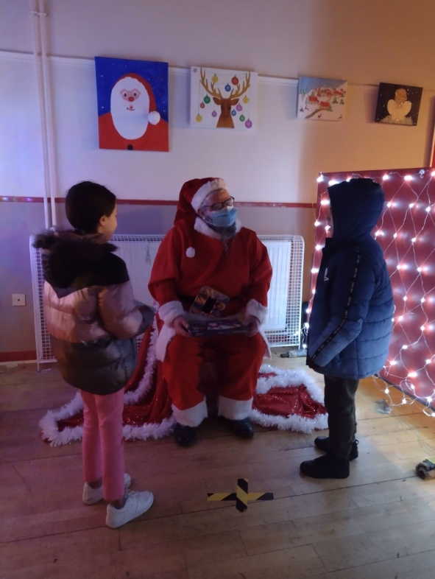
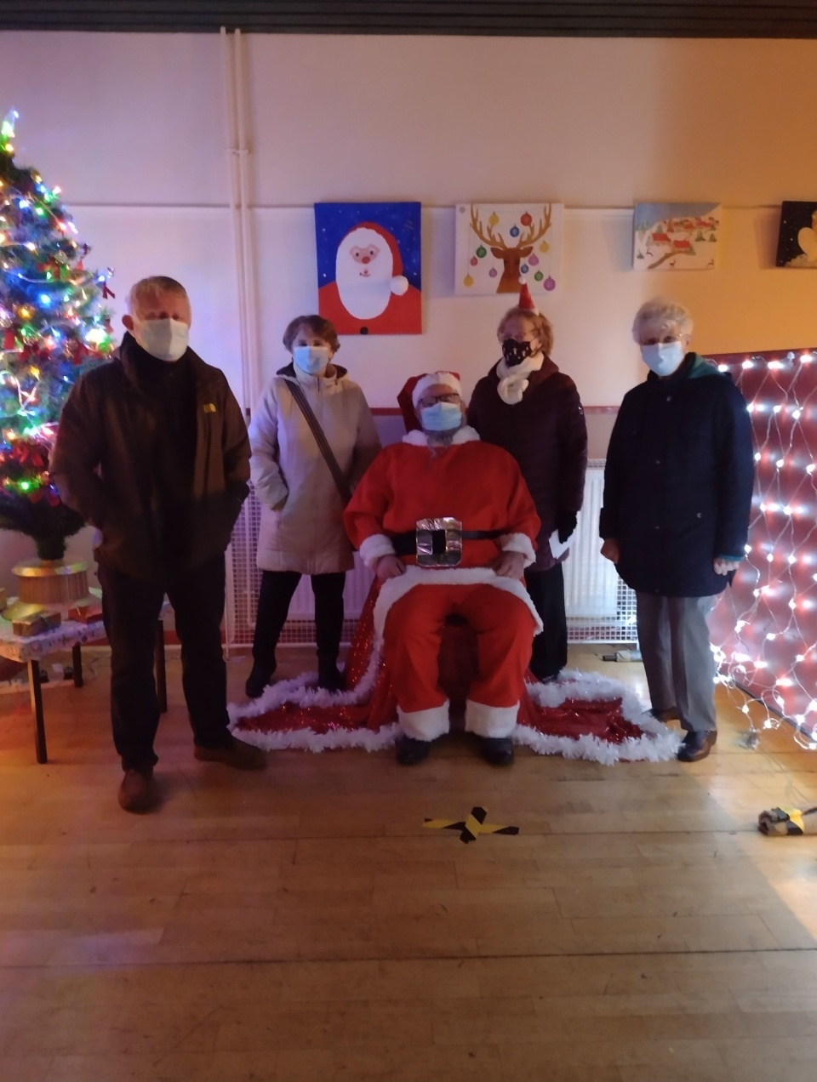

Board Members with Santa L-R John Peebles (Chairperson) Elizabeth Murray (vice-chairperson) Susan Mc Dougall (Board Member) and Louise Laing (Secretary)
Crossroads Women’s Group

We were contacted by the above group who are based over the bridge from Govanhill going into the Gorbals looking for outdoor space for their woman’s group to meet during the pandemic when you could meet up outside and be socially distanced. It turned out that some of the women lived in Govanhill too.

They met for a while outdoors fortunately the weather was kind to them and then they asked if they could paint a mural on our garden wall that they had been speaking about and creating at the sessions they advised that they would continue to respect the social distancing and only a couple of women would participate in the painting at any given time. This proposal was put to the Board and they agreed that they could paint the mural on the wall in the garden. Pictured below is a photograph of the end product.

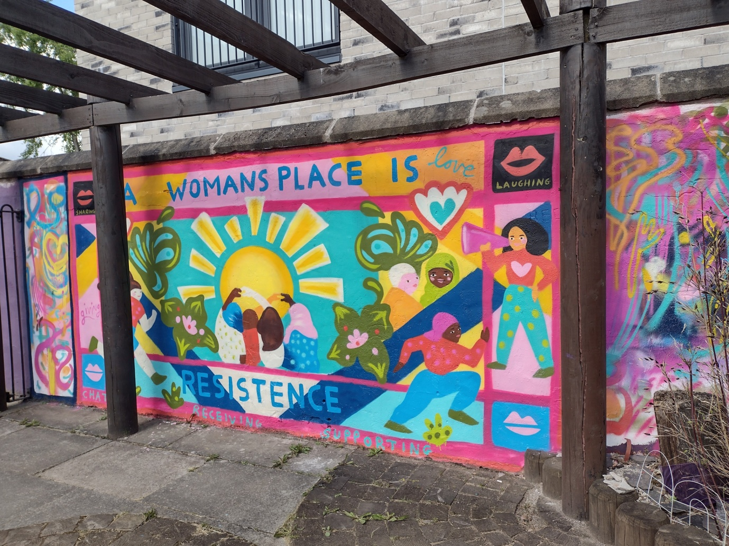

Greater Govanhill Magazine
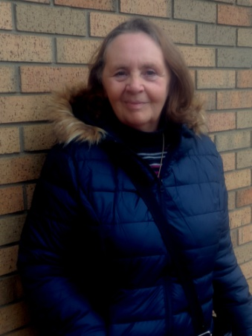
Our vice-chairperson Elizabeth Murray featured in the above magazine as she is a member of the Voluntary Management Committee that manages the centre and this is her story.

My name is Elizabeth Murray and I am a volunteer on the Larkfield Centre Management Committee, which a Community Centre and is based in Inglefield Street, Govanhill. The centre was set up by members of the local community back in 1992 and it has gone from strength to strength meeting the needs of the people in the local area over the years.

The Centre provides both Educational and Recreational classes/groups along with a number of Events over the course of the year. They also provide much needed space for people to access services delivered by other organisations to meet the needs of our diverse community and this is what makes the Larkfield Centre such an interesting place to be involved with.

I have lived in Govanhill my whole life and before the lockdown I attended several groups at the centre (Art Group, Photography, Tai-Chi & Women’s Group) where I was made to feel so welcome when I went along to my first group which was Digital Photography to get me out of the house and meeting other people and as a result of this I thought about giving something back to the centre as I know the good work that they do in the local community so when the opportunity came about when they were looking for people to join the Management Committee I had no hesitation in putting my name forward as without the voluntary management committee there would be no centre and I would encourage members of the community to come along and find out what is available at the centre and join in.

I love being involved with the centre particularly around the events they run as I enjoy making the tea and coffee or juice to serve to those attending the various events, its great as you get to meet new people and they are such happy times, especially the children’s Events as they are so excited when they come in and see the way the Hall is set up, in particular at Halloween with the open fire in the main hall (well the fire looks real but is made up of leaves and logs and battery Christmas lights) but its magical for the children.

The centre is like a family bringing the community together and here’s hoping they can do so for many more years to come.
Covid – 19 NHS Mobile Unit
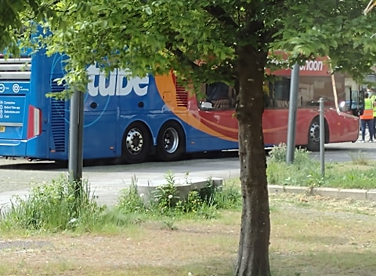

The centre was approached by the NHS during the pandemic to see if they could put a mobile vaccination bus on the Millennium Square and use the centre for staff at lunchtime and for toilet facilities.

After a discussion the Board agreed that as it would be of benefit to the local community and they gave permission for them to access the centre on the day the vaccination bus would be on the square.

The NHS advised that they would observe the social distancing and any other restrictions that we had in place at the centre and everything went as planned.

The bus was busy that day and the centre sign posted people to the bus on the square throughout the course of the day as many thought the centre was the place to go for vaccination. We felt it was a worthwhile thing to do as it was a drop in for local people and we are glad to say that it went according to plan.

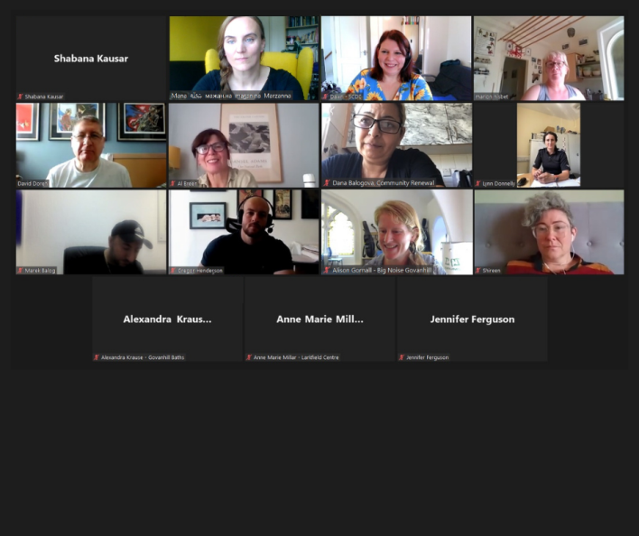
Thriving Places

The centre was asked if our centre/office manager could be part of the Thriving Places Board and after a discussion it was agreed by them that she could represent the Centre on this Board.

About Thriving Places

Govanhill is one of the ten areas of Glasgow that has been designated a ‘Thriving Place’ by the Glasgow Community Planning Partnership. Thriving Places is an approach aimed at bringing together residents and organisations to collaborate for the good of their neighbourhood

A Plan for Govanhill
Each Thriving Places area develops a Locality Plan that local communities, organisations, services and businesses will be able to use to guide their work towards positive change. A Locality Plan, as a vision for the future, must be informed by local people so that it can address the real needs of the community. By providing measurable goals, the plan will become a practical tool for people who are trying to make a difference in their neighbourhood.

The Govanhill Locality Plan includes the following strands:
Learning, Environment, Community Cohesion, Youth, Employment, Media Coverage, Housing, Safety, Economy, Health & Social Care, and Community Engagement & Information, the last of which is the key to all the other strands.

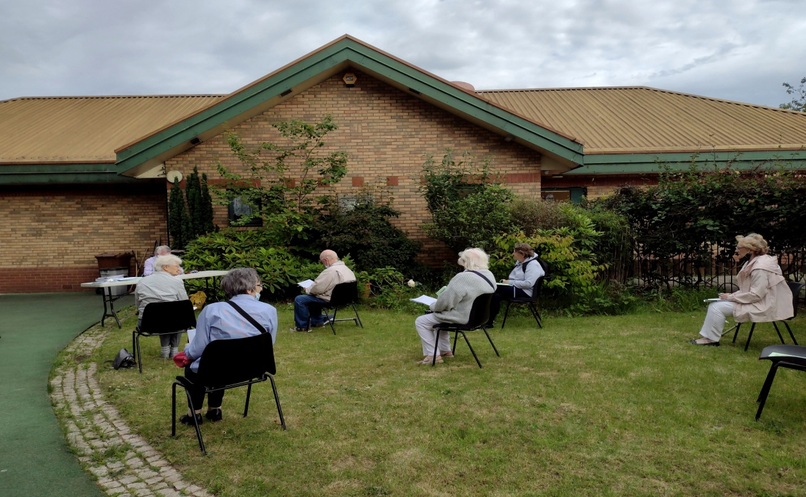

The AGM for 2021 was held outdoors due to Covid

Glasgow City Council
New Communities Fund

The Weir Charitable Trust

COOP – Crown Street

