Group News Continued

Drama Group Continued

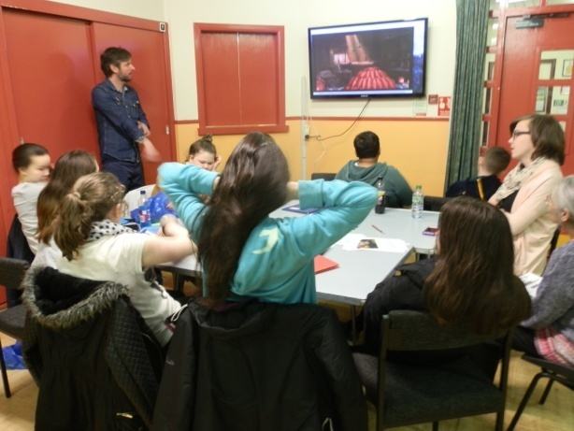
The Drama this year was in partnership with Theatre Ecole and Glasgow Life. Over the course of the year the young people created ‘Daffodils’ which was a short film about a doll.

Pictured on the left is the young people working together to plan the film and create its script.

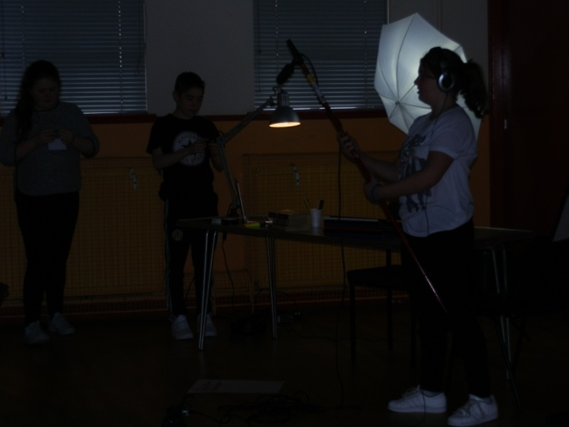
Pictured on the right are the young people filming. They learnt a lot over the period about writing and producing a film which was enjoyed by parents and some local people who came along to its viewing.

Pictured below are the young people learning about role play.

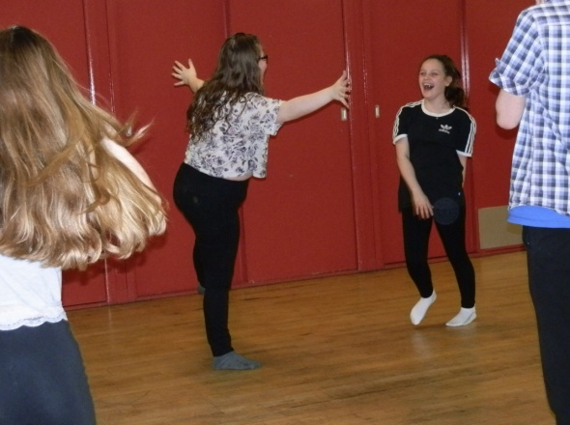
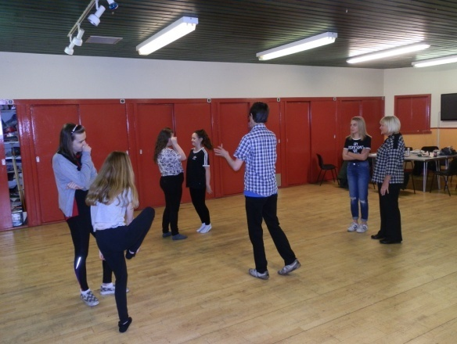

Group News Continued

Women's Group Continued

The women’s group this year participated in dancercise, aromatherapy, nails & beauty and a stress management course and a Stained Glass Project.

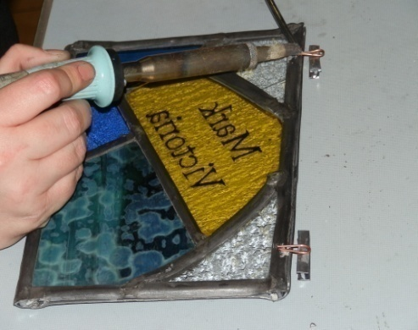
The group meet on a Friday afternoon from 1pm – 3pm and the door is always open to new members, so why not come along and join in the fun and get a cup of tea!

The pictures show the women participating in the programme over the last year.

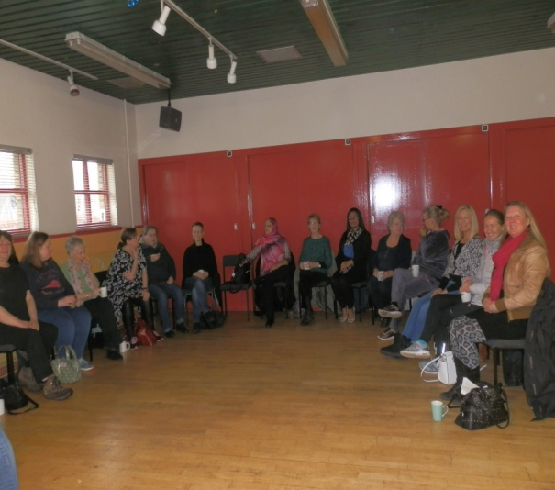
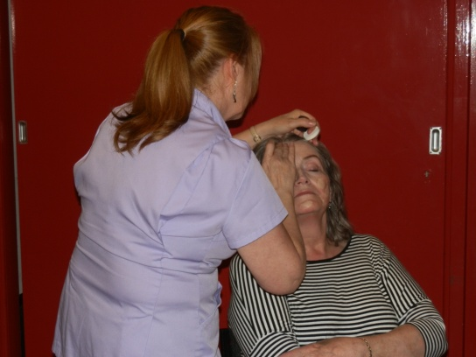
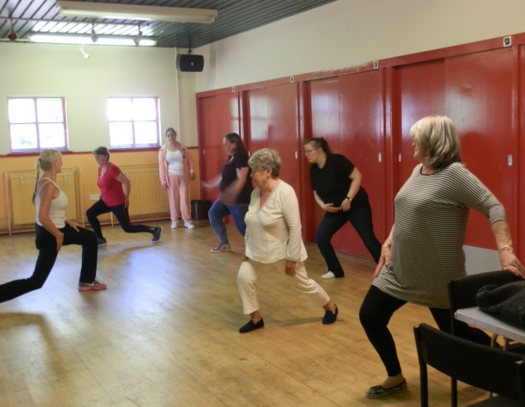
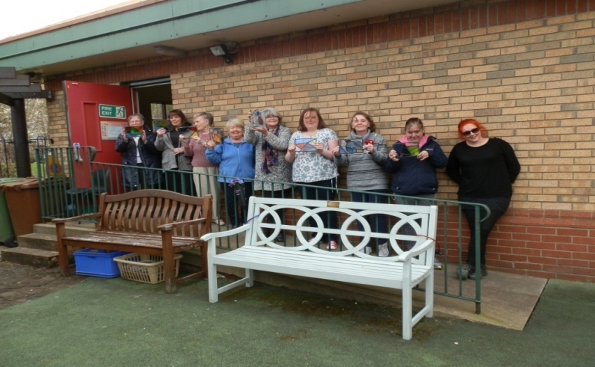

Group News Continued

AA Group

If you feel you are drinking too much and in need of support we have an AA group that meet at the Centre on a weekly basis on a Wednesday evening from 7.30pm – 10pm.

The group provides much needed support and assistance, has a core group of people who take to do with the day to day running of the group and then there is what we would call the regular group members but there are also many new faces dropping in and out each week. The group are welcoming and supportive to all who come through its doors.

Book Group

The Book Group continues to meet on the first Wednesday of the month from 2pm – 4pm and is actively seeking new members, so if you like to read then this group is for you.
The group are provided books on a monthly basis from Govanill Library and over the last year they have had some great books to read. As the books are not picked by the group sometimes they get books they are not too keen on but they always manage to read them through and give an opinion on them.

Group News Continued

Play Club

The ‘Play Club’ continues to meet at the centre on a Tuesday from 5pm – 7pm.
We are able to deliver the play club which caters for children between the ages of 5yrs – 2yrs and we have been working in partnership with Glasgow Life for many years delivering this service which offers many opportunities to children to come together to learn, play and socialise.

The club provides opportunities to play games and arts/crafts and the children just love it. It’s a great way of making new friends and also maintaining other friendships on a weekly basis. The centre is a safe and friendly environment and parents can drop off their children knowing they are in good hands.

Events 2016/2017

Marie Curie (Blooming Great Tea party)
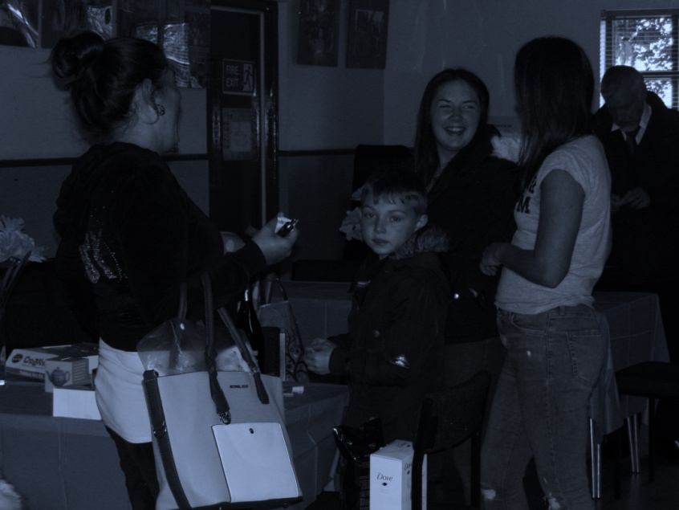
The Centre Management Committee agreed to hold a fundraiser ‘Blooming Great Tea Party’ in aid of Marie Curie as it is a truly worthy cause as cancer has touched the lives of many of our centre users if not them directly a member of their family and also its management committee.

