Events 2016/2017 Continued

Christmas Lights Switch-on
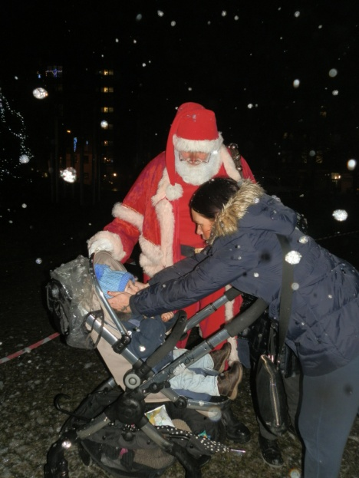
The Christmas Lights Switch-on was really busy this year as word is spreading around the community about the fun of Christmas at the Larkfield Centre.

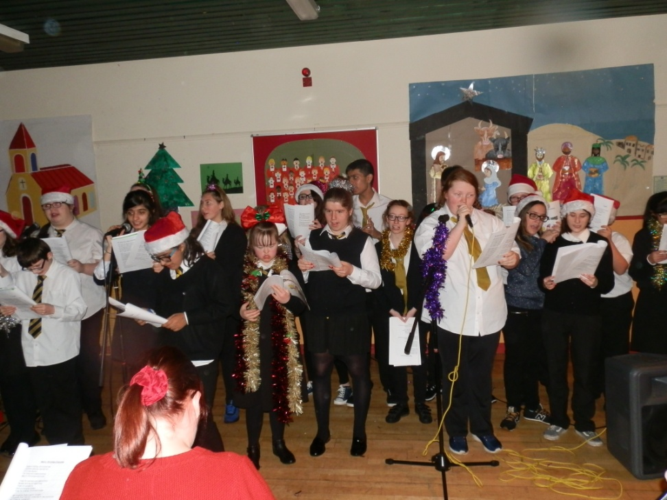
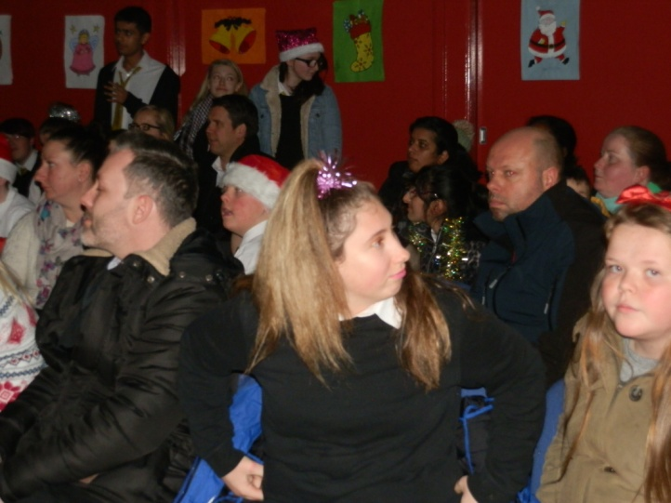
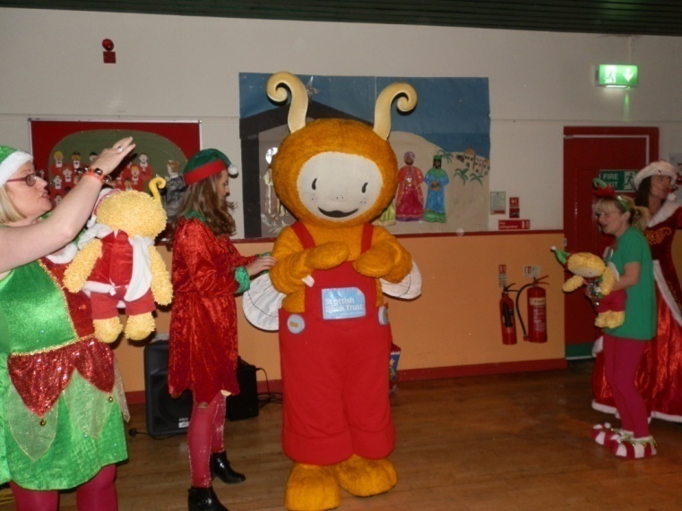
We had a visit from Santa and his two helpers the Elf & Fairy and they all spoke with the community giving out sweets and balloons, which went down well with the children as adults also. They were available to have pictures taken and the next page will show the fun people had in pictures. We also had the Bookbug along to do a performance of songs and rhymes about Christmas and after the lights were switched on we were entertained by the children of Hollybrook Academy School Choir.
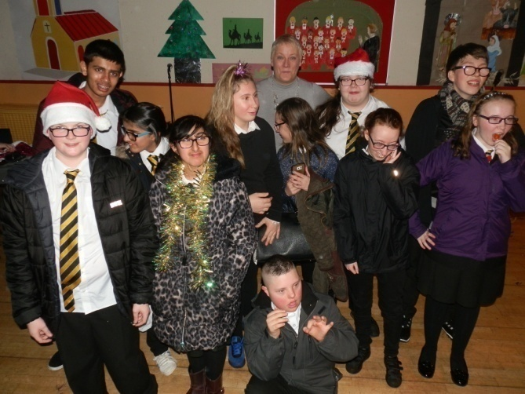
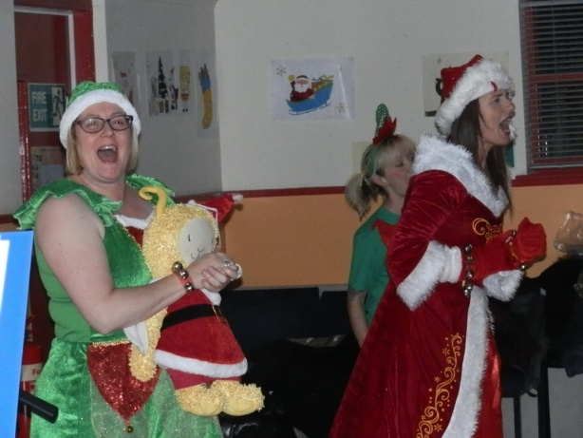
Councillor Hunter with the School Choir
Events 2016/2017 Continued

Christmas Lights Switch-on Continued
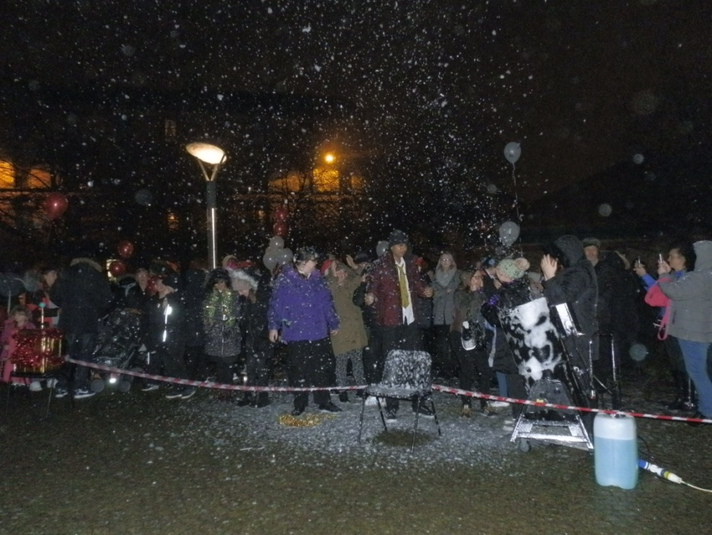
Getting ready for the countdown, 10, 9,8,7,6
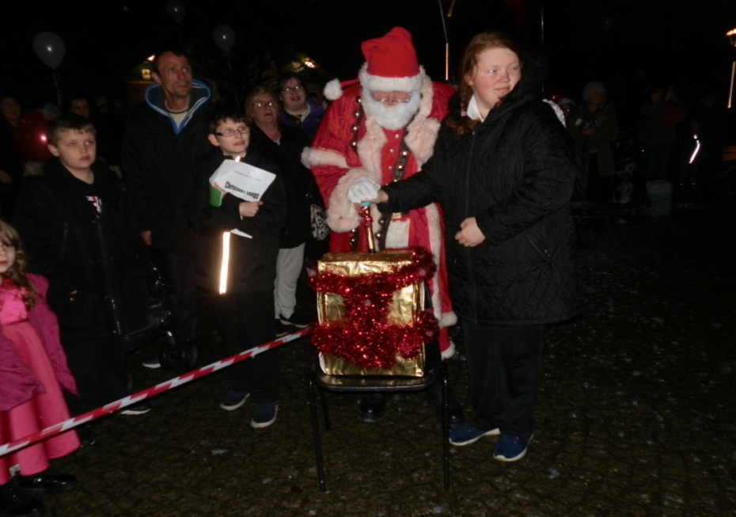

5, 4, 3, 2, 1
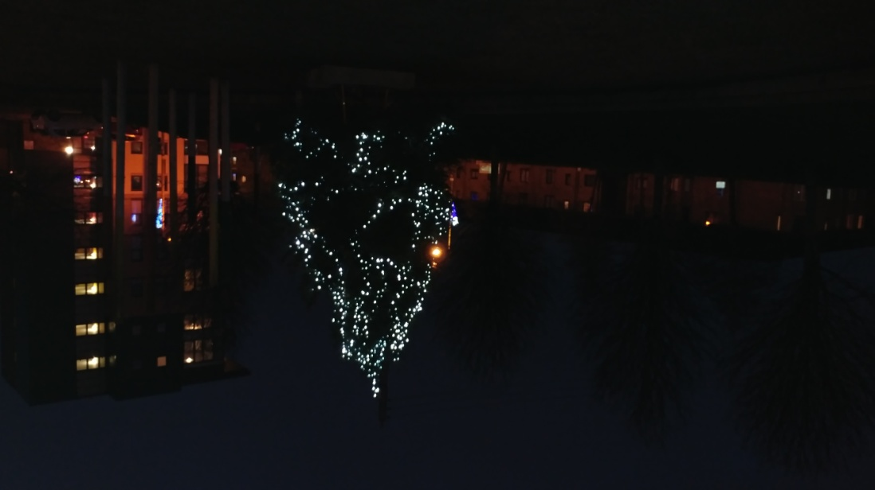

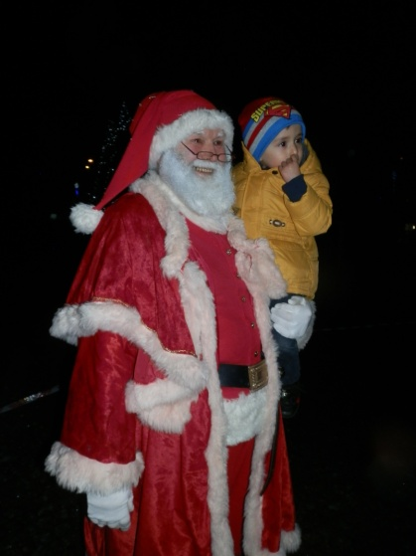
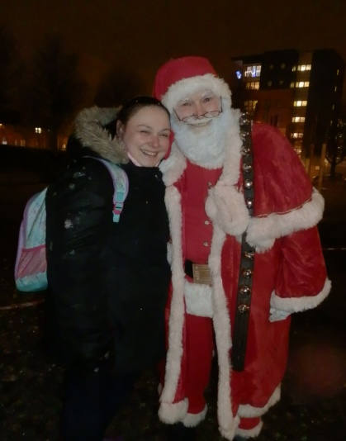
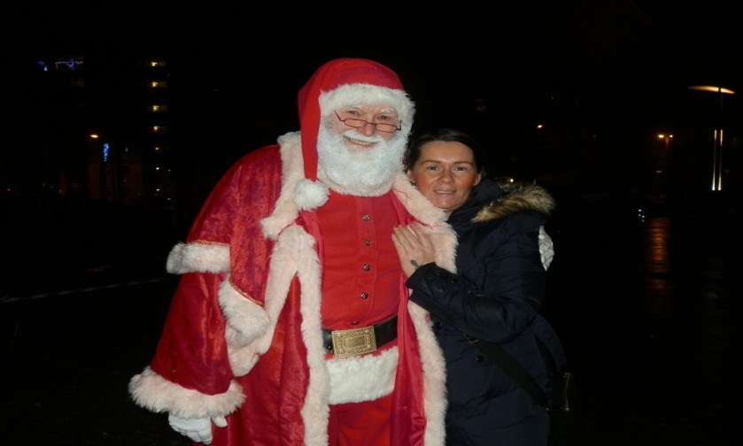

Events 2016/2017 Continued

Christmas – Pantomime

This year the Pantomime was Dick Whittington, oh no it wasn’t, Oh YES IT WAS.........
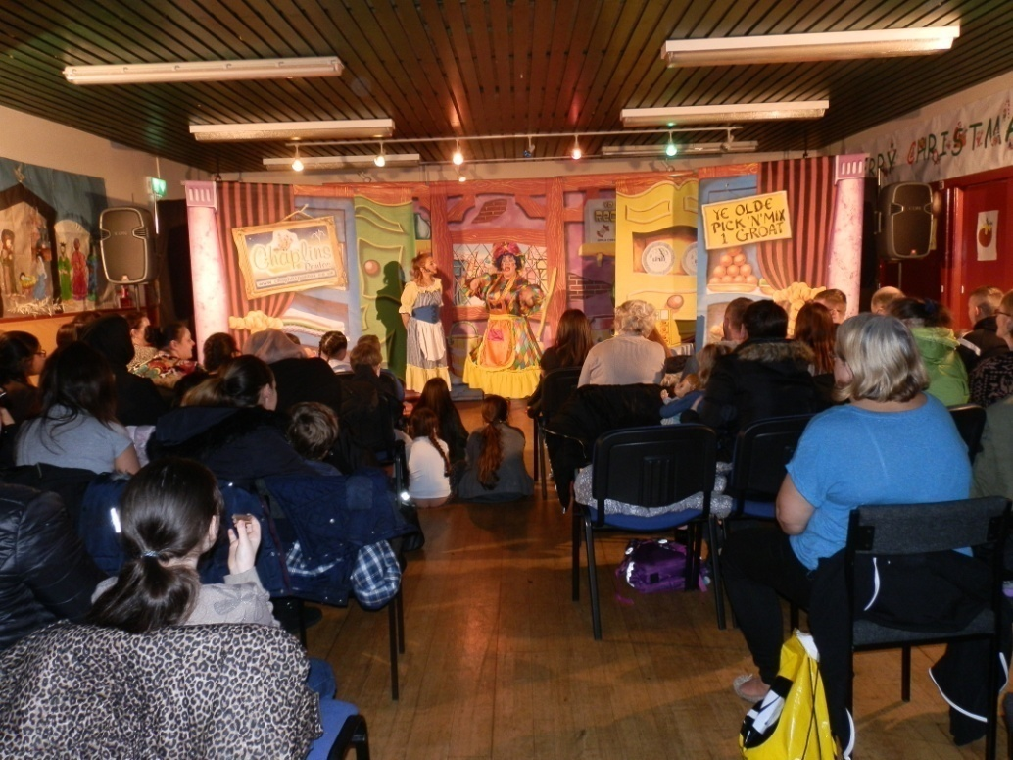

Let the fun commence!

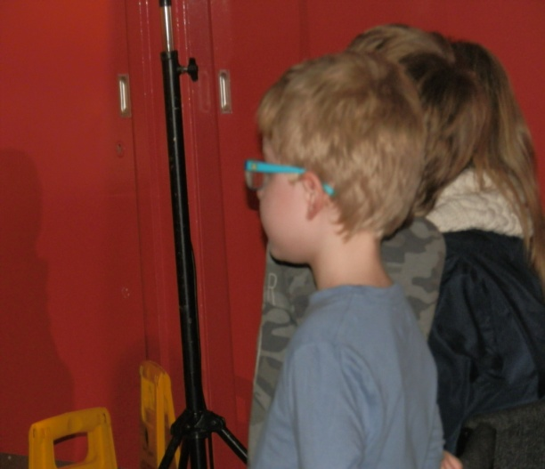
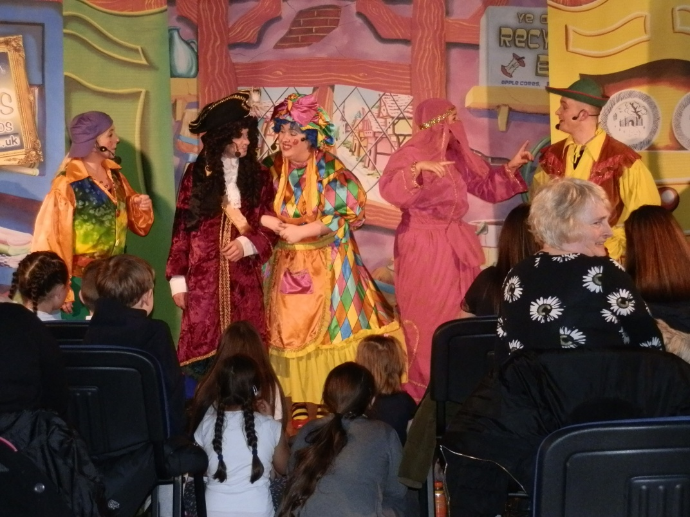

The pantomime was a full house and a great night was had by all!

See you all next year!
Events 2016/2017 Continued

Christmas – Santa’s Grotto

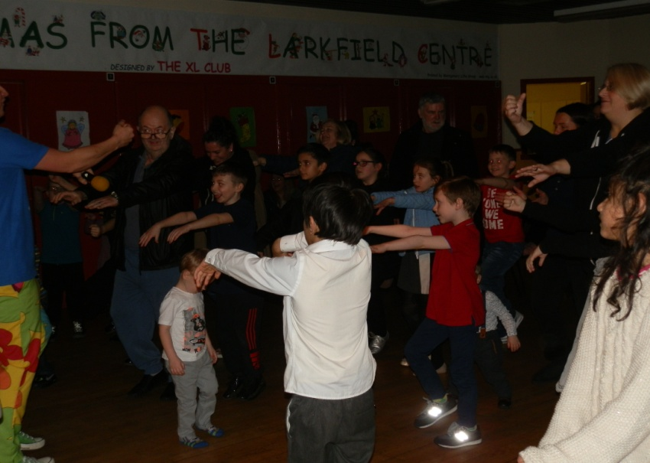
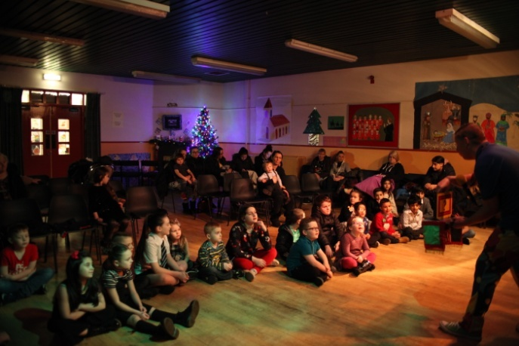
The grotto was very busy this year, keeping Santa and his helpers the Elf and Fairy working very hard at the Larkfield Grotto and the pictures will show everone having a good time. We had a new entertainer this year Magic Muddles who presented a magic show, games and dance to the children.
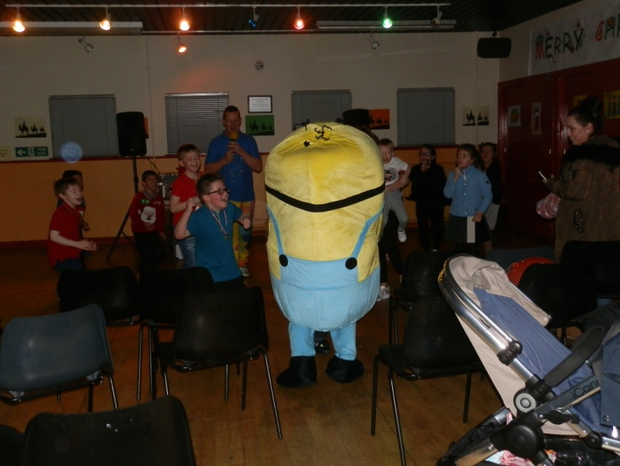
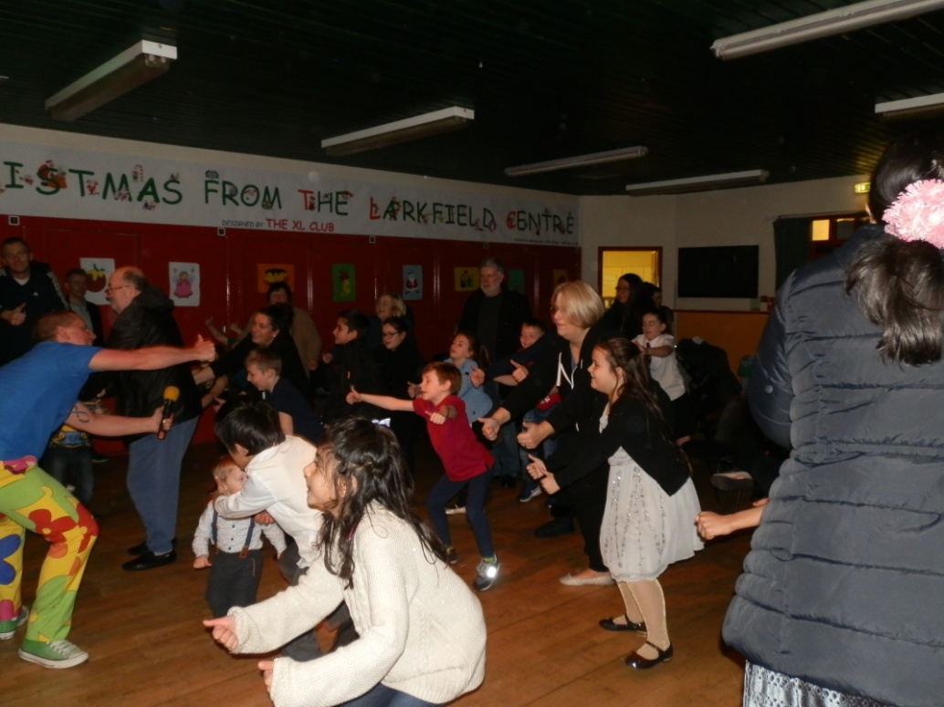
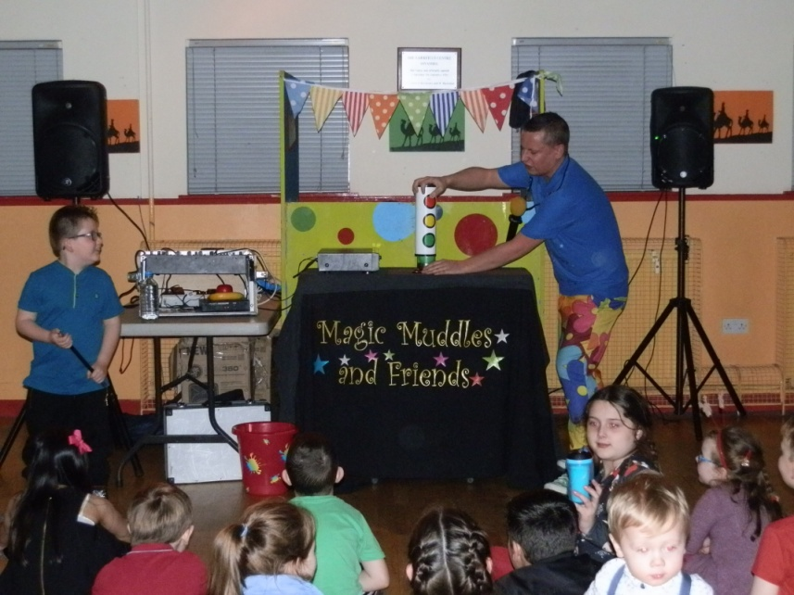

Events 2016/2017 Continued

Christmas – Santa’s Grotto
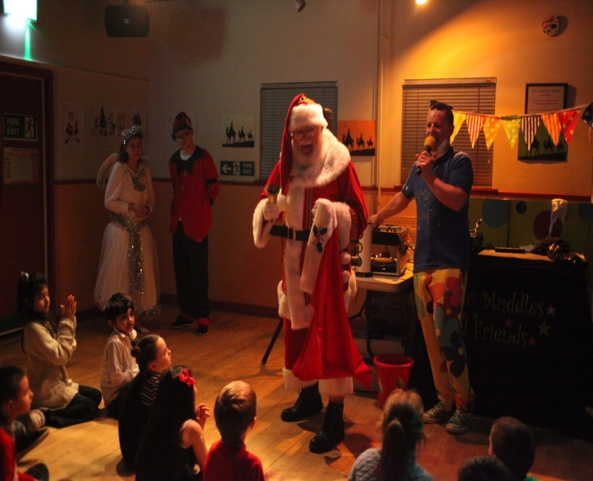
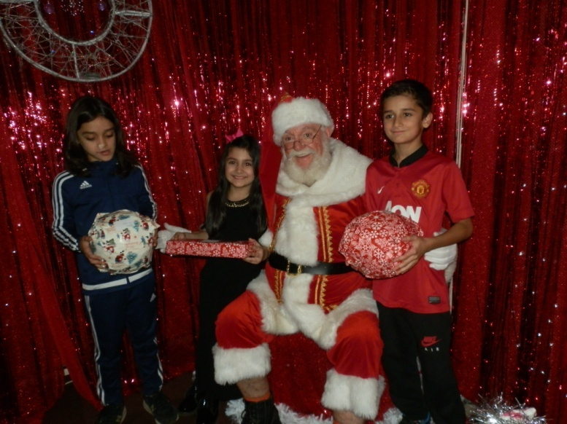

Santa arriving with his helpers

