Tea Dance
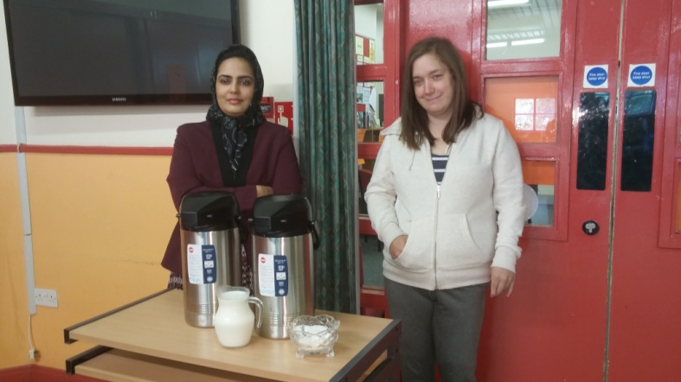
The centre secured funding from Comic Relief and SCOTMID to hold Tea-Dance-sing-a-longs for people aged 55yr plus. They have been enjoyed by many as you will see in the pictures that follow in the next few pages:
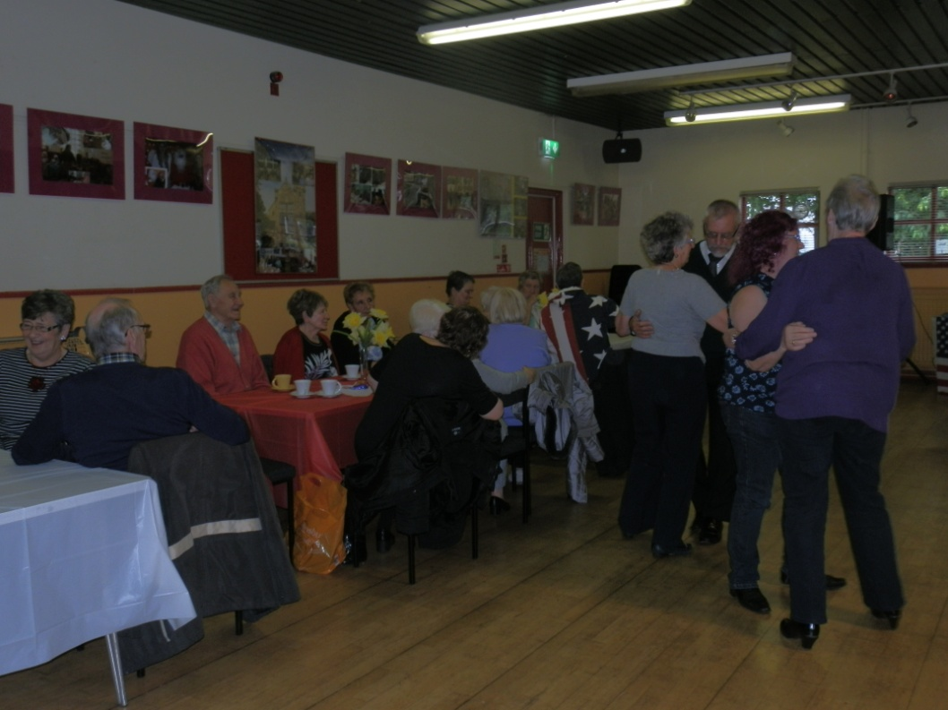
Pictured above is our volunteers Rafia and Charmaine

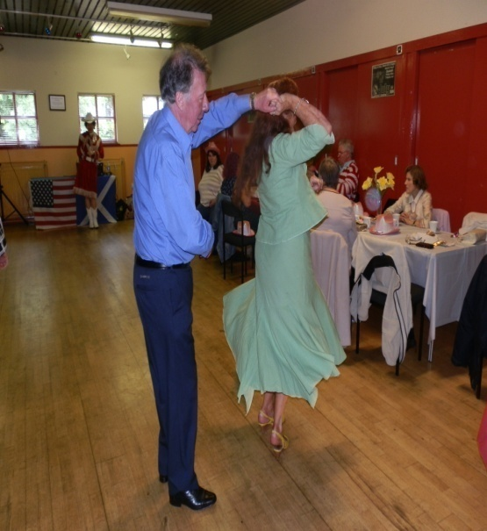
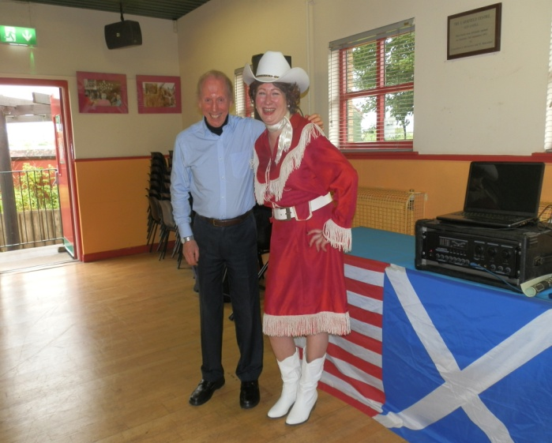

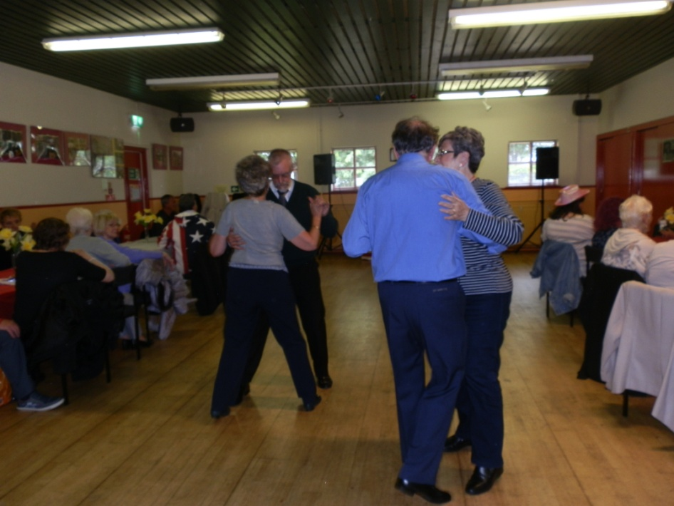
Patsy Cline Tribute, Suzie G and Eddie our musicians
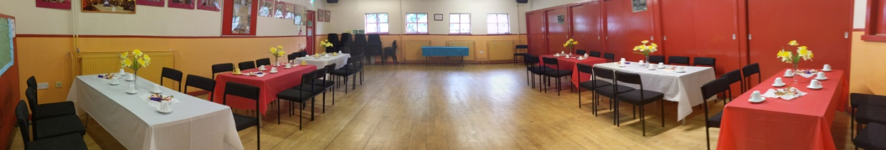
Tea Dance Continued

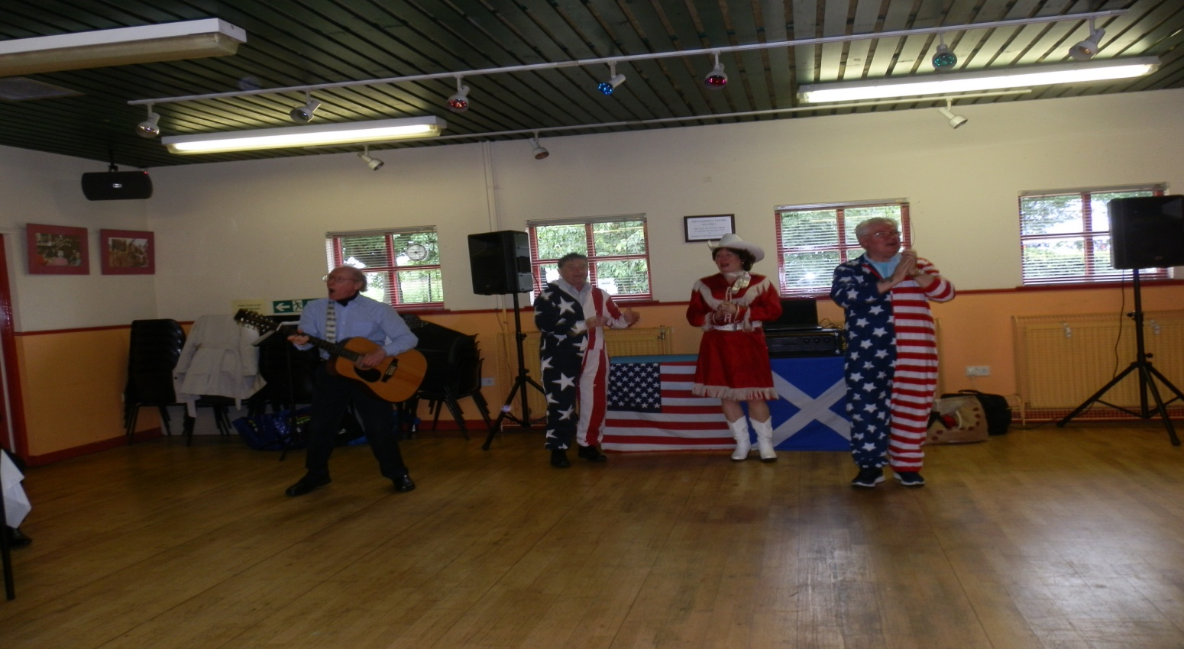

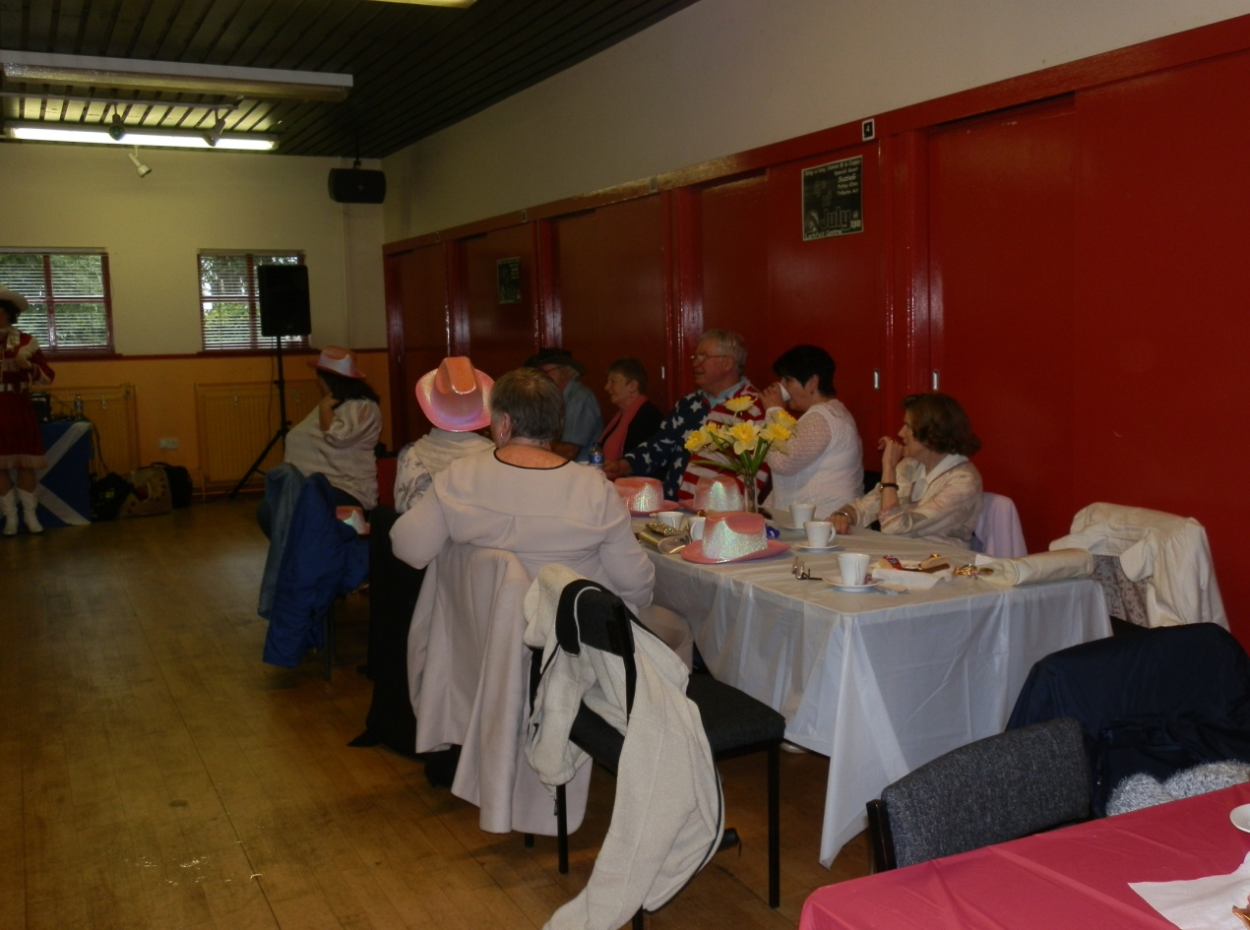

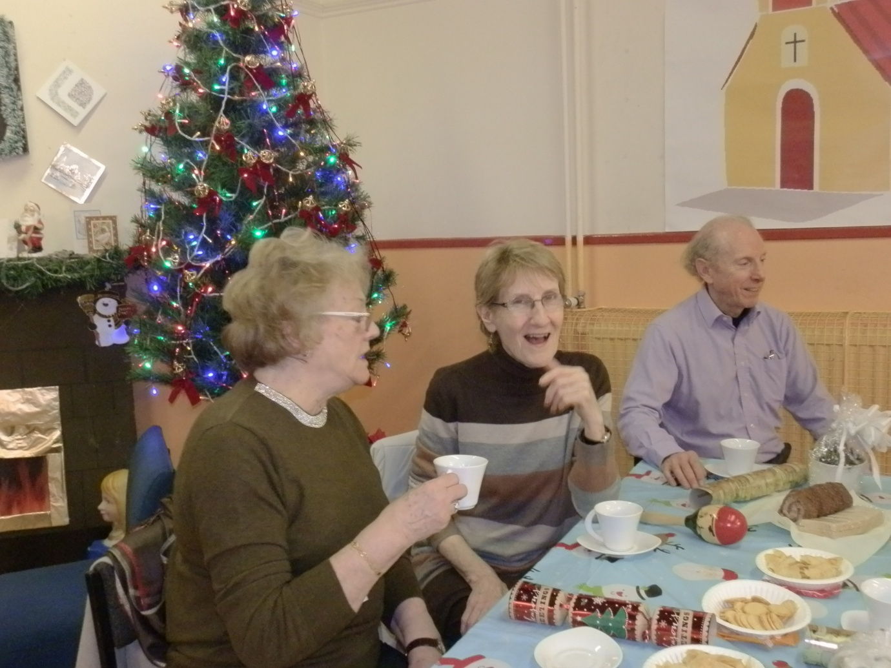
Tea Dance Continued

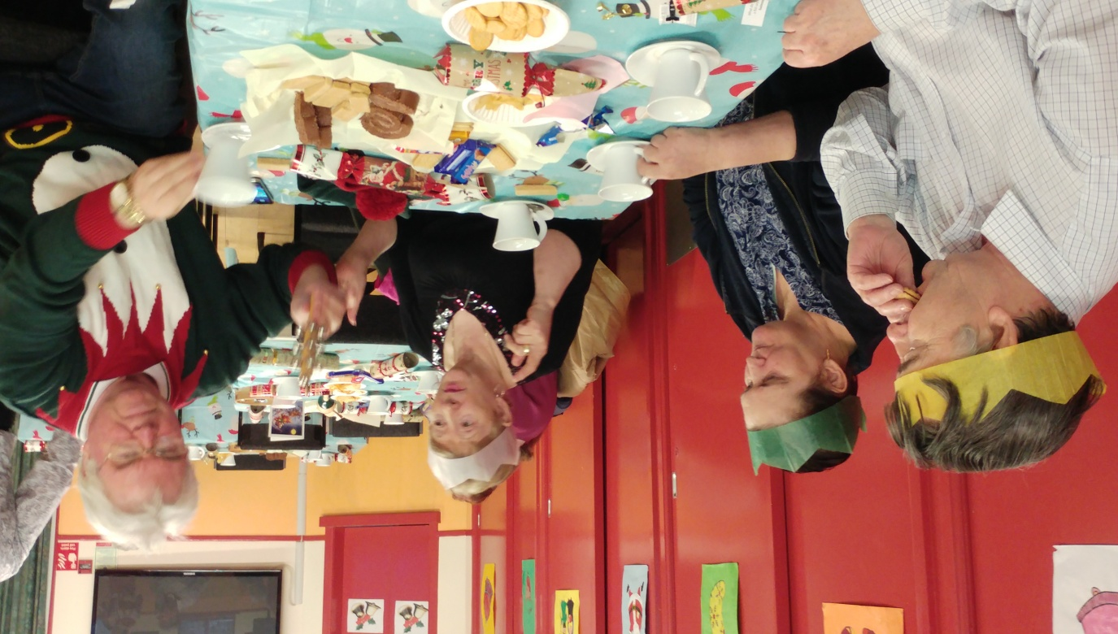
Christmas Tea Dance

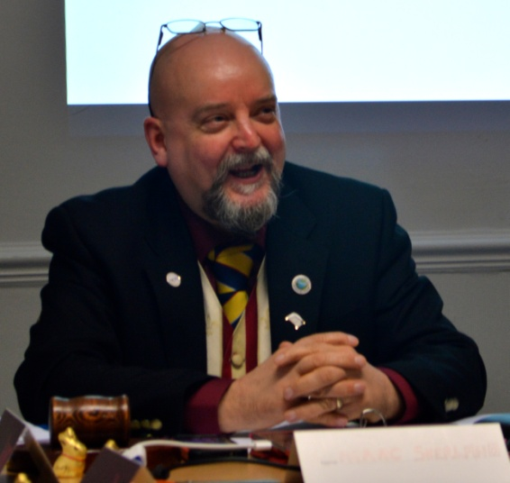
Chairperson Report

I am delighted to present this our twenty-fifth annual report. It is wonderful that the centre is still providing services to the community of Govanhill and its environs after all these years given the continual reductions to our budget even when it’s a standstill budget it is a cut as costs continue to rise year on year but somehow we have managed to maintain services to our community.

We had a vacant caretaker’s position this year as a member of staff left suddenly and fortunately it didn’t have an impact in the short term to the services we provide due to remaining staff picking up additional workloads and the management committee are grateful for this and we are now back running with a full complement of staff.

I would like to thank the staff team for the work they have done over the last year and also that of my fellow committee members for their continued support given not only to myself over the last year but also to the centre as without their help the centre would not be here.

I would also like to thank our partners named within the annual report as without their assistance we would not be in a position to offer such a varied programme. In particular I would like to mention Hollybrook Academy who continue to work with the centre particularly around Christmas time supporting our Christmas Lights Switch-on and to the four local primary schools Annette Street, Cuthbertson Street, Holycross and St Brides who join Hollybrook Academy at our Halloween Event and not forgetting our writers group who perform poems, short stories around the theme of Halloween and to the pupils form the schools who share their tales with us too.

Also I must highlight our funders Glasgow City Government 'Integrated Grants' for providing us with the funding to run the centre and to the various other funders who have enabled us to keep a programme going over the past twenty- five years without their support we would not be celebrating this our 25 Anniversary.

Marc Sherland , Chairperson M Sherland
Burns Supper
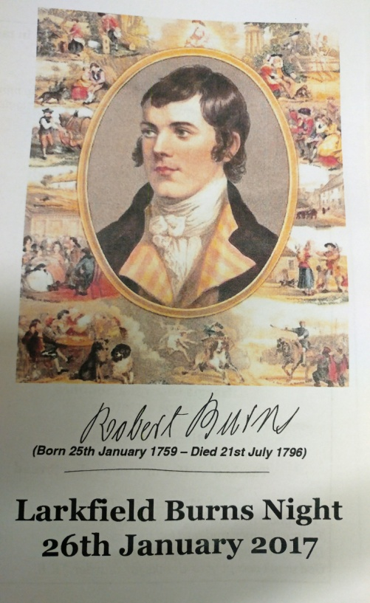
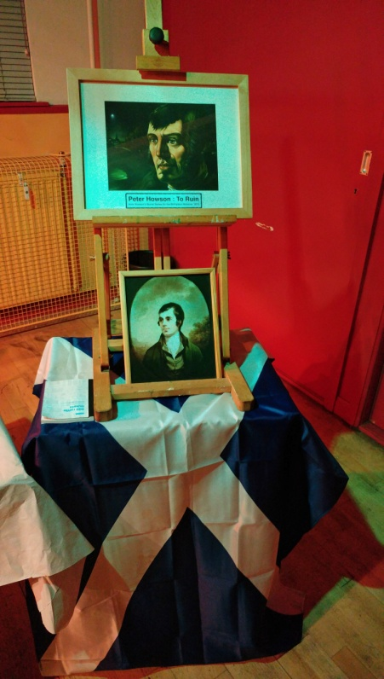

We had another successful Burns Supper again this year and a huge congratulations to our writers group for pulling the event together, local business 'Little Tasties' for providing the food and to the Piping & Drumming Group for piping in the Haggis!

