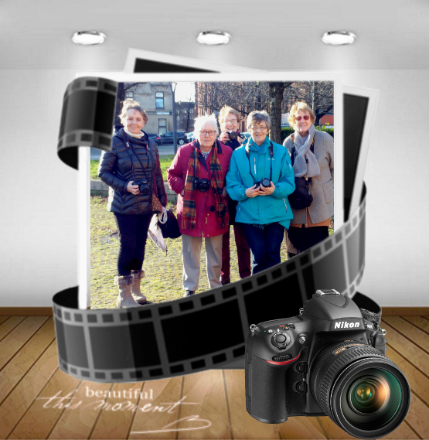
Groups Continued

Digital Photography

The Digital Photography Group continue
to meet at the centre on a Tuesday
morning from 10am – 12noon and
continue to operate at capacity with a
waiting list in place it’s such a popular
group.

The group also held an exhibition of their
work taken while they were out on
adventures of the City and further afield.

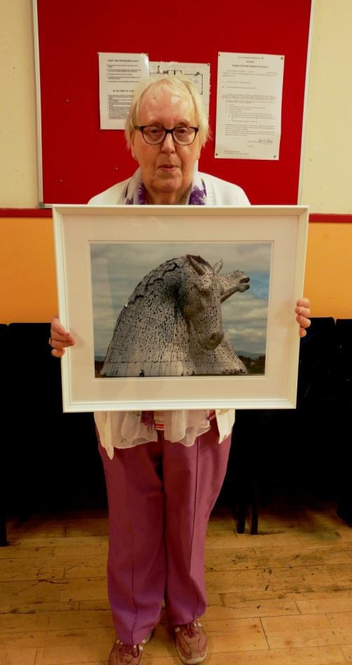
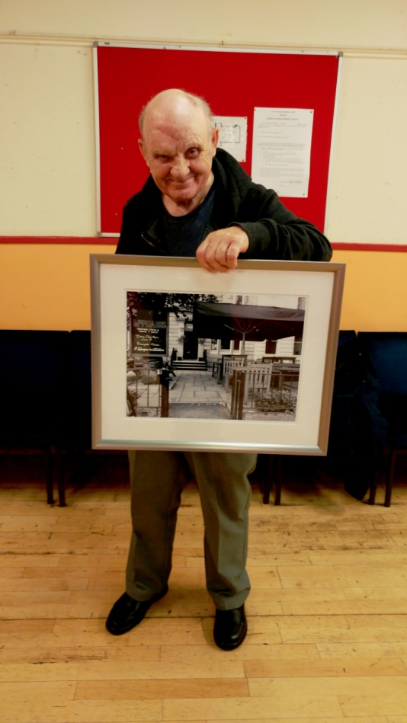
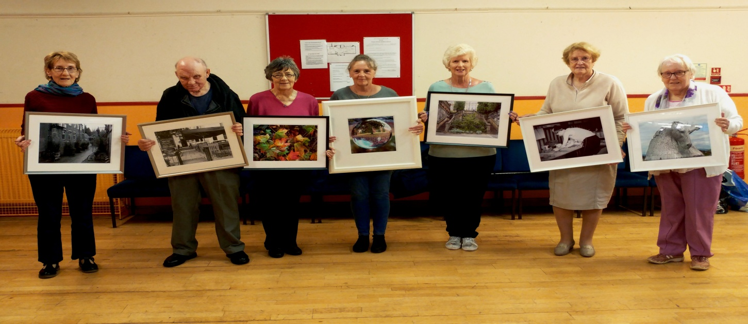
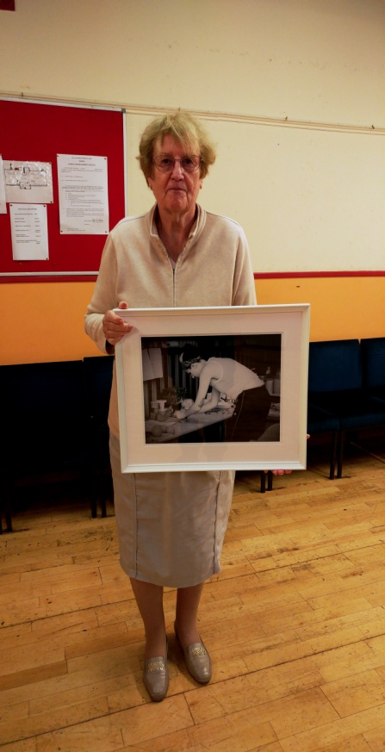

Groups Continued
Art Group

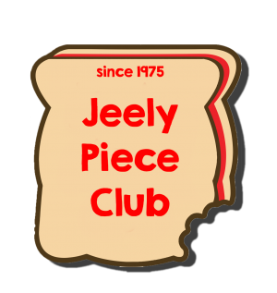
The Art Group continue to meet on a Tuesday afternoon from 1pm - 3pm. There are currently spaces in the group so if you have an interest in art please come along and speak to Susan.

JEELY PIECE CLUB

The Jeely Piece Club meet at the centre on a Wednesday after school delivering services to children 5yrs - 12yrs. from 3.15pm - 5.15pm. The children that attend thoroughly enjoy the sessions.

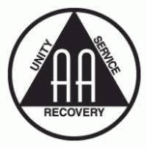
AA

The AA meet at the centre on a Wednesday evening from 7.30pm - 10pm. Providing a much needed service in the local area, it is a very busy group and is assisting many people on a weekly basis.

Piping and Drumming
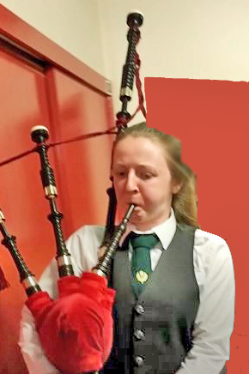
The piping and drumming group continue to meet at the centre on a Wednesday evening from 6.30pm – 7.30pm under the guidance of George who has been running the group for many years. There are currently places available to learn the chanter.
Groups Continued

Language Class

The Language class continues to meet at the centre Monday - Thursday each week from 4.30pm-6.30pm. It provides Young people the opportunity to learn Arabic and the Koran in a community setting. The age ranges from 6yrs - young adult.

Positive Action in Housing

Positive Action in Housing held 2 surgeries each week at the centre one on a Monday and also on a Thursday, providing the Romanian Community with much needed advice in housing and also in relation to their Status here in the UK. The surgeries were extreemly busy and they assisted many in the local community.

Men’s Group

The men's group continues t meet at the centre on a Thursday afternoon from 2pm - 4pm and is a lifeline for those using it. Though numbers have dwindled over the year but it still plays an essential part in the community and we will do all that we can to keep it going.

Word Factory

The word factory meets at the centre on the 2nd, 3rd & 4th Fridays of the month at 1pm - 3pm were they read/perform what they have written. They are always on the lookout for new members to add to their group.

Groups Continued

Women’s Group

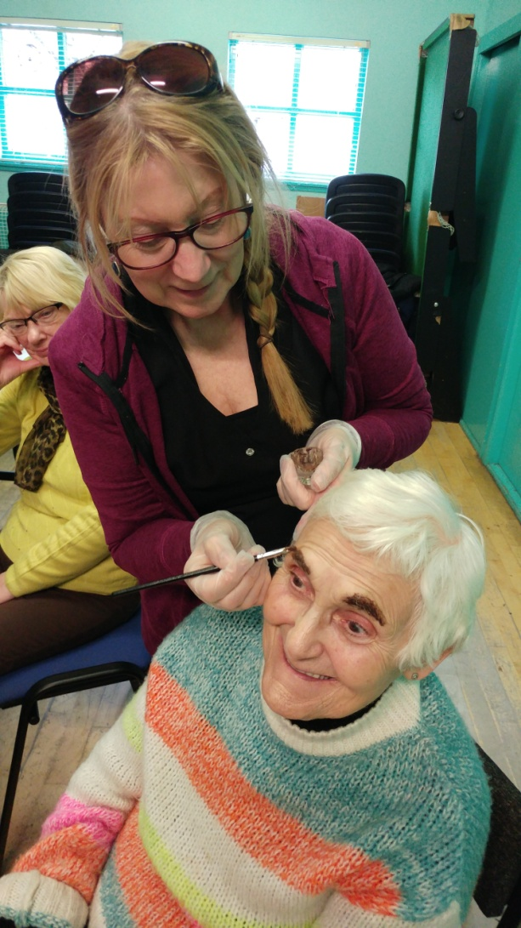
The women's group meet at the centre on a Friday afternoon form 1pm - 3pm, they do gentle exercise class for the first hour and the second hour they learn about makeup, relaxation, eyebrow tint and lots more as you can see the pictures show happy faces!

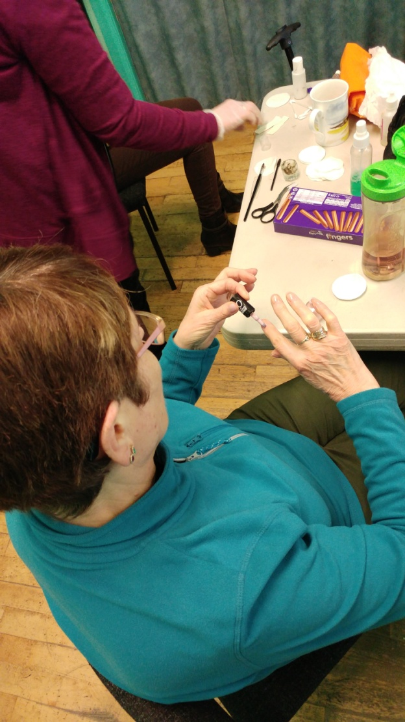

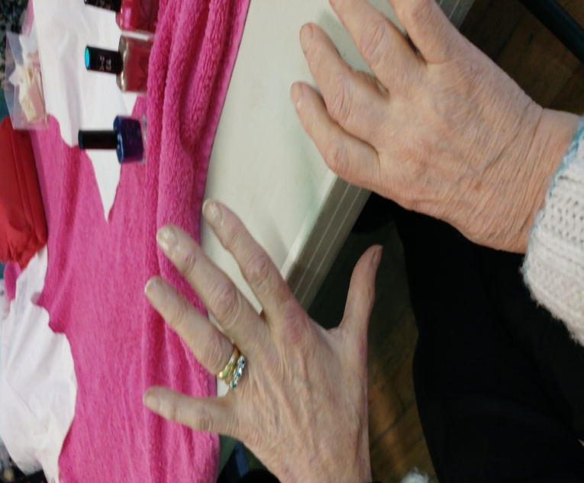

Centre Events

Easter Event
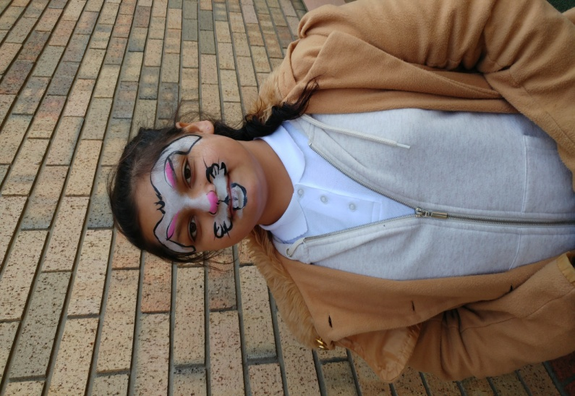
The Easter event saw our four local primary schools and the Assisted Learning secondary school participate in this annual event. It was a full house and lots of fun and happy faces as you will see in the pictures: Face Painting by Laura from 'Let's Face It' went down well with the young people as you can see in the pictures:
