Events Continued

Christmas Continued

Santa's Grotto

The Santa's Grotto i s the third of our Christmas Events and the children are entertained by a Magic Show, games and dancing. They are each given a goody bag on arrival and juice is provided throughout the event. Then they go to meet Santa in his magical Grotto.
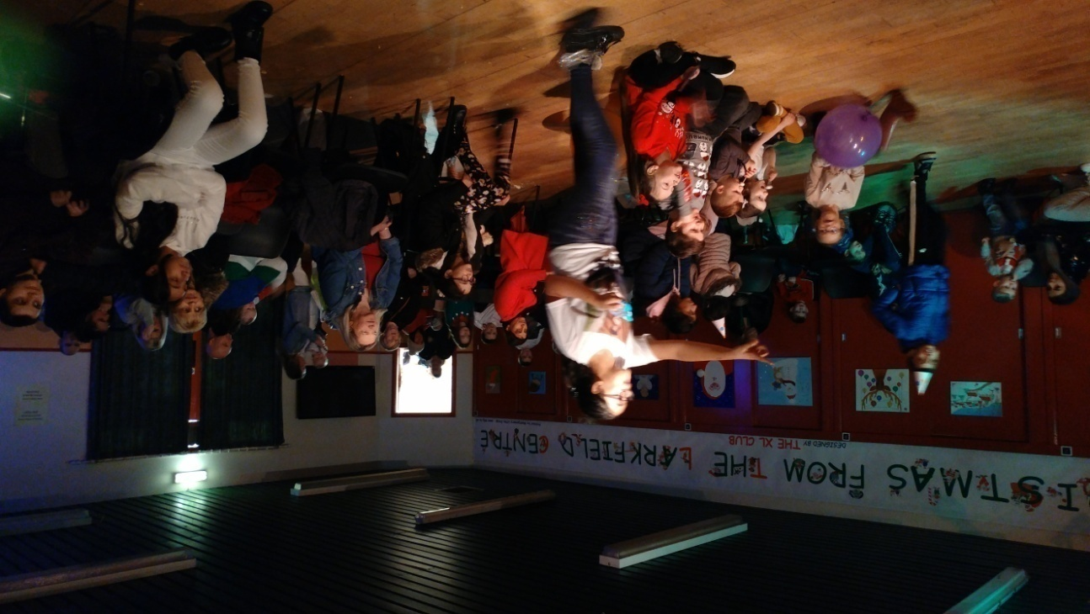
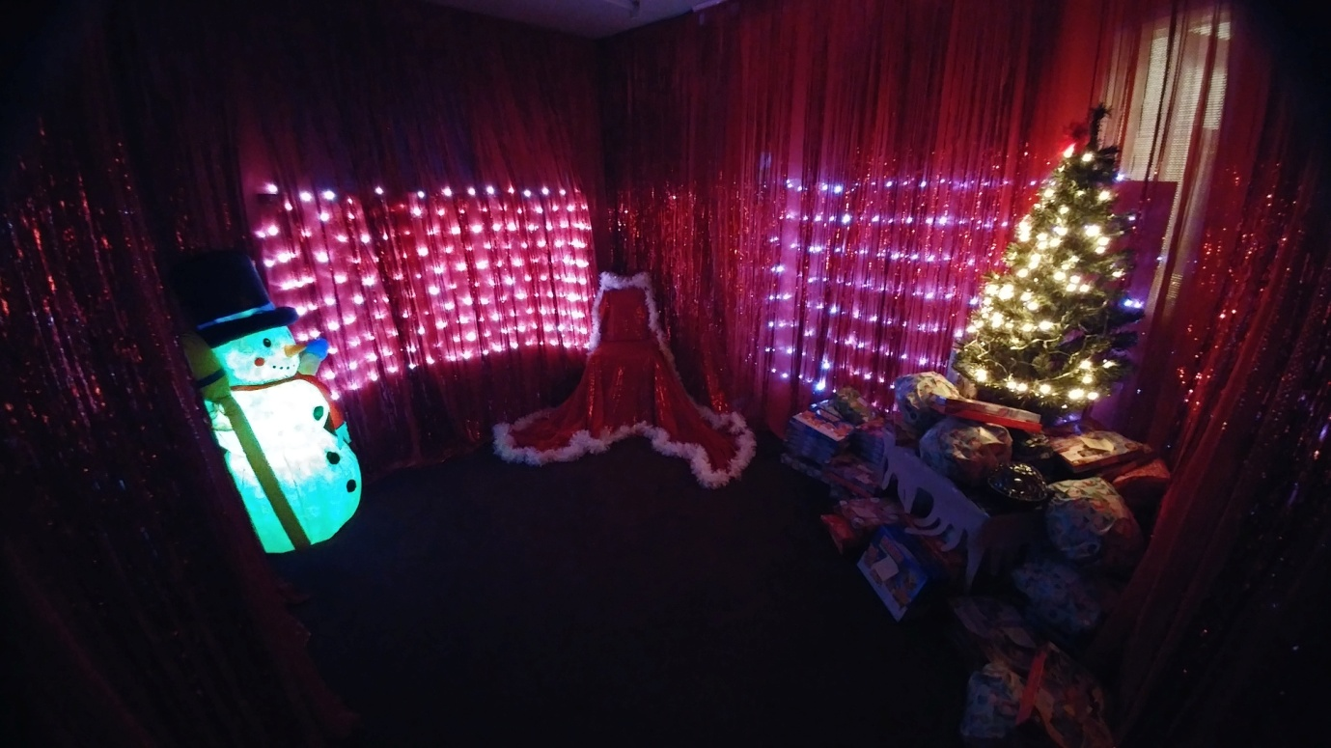

Events Continued

Christmas Continued

Santa's Grotto Continued

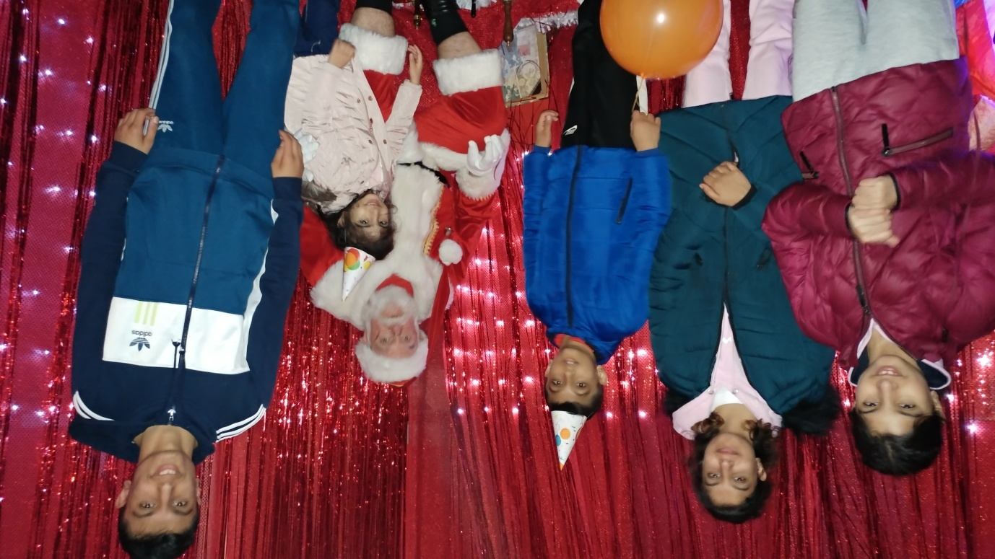
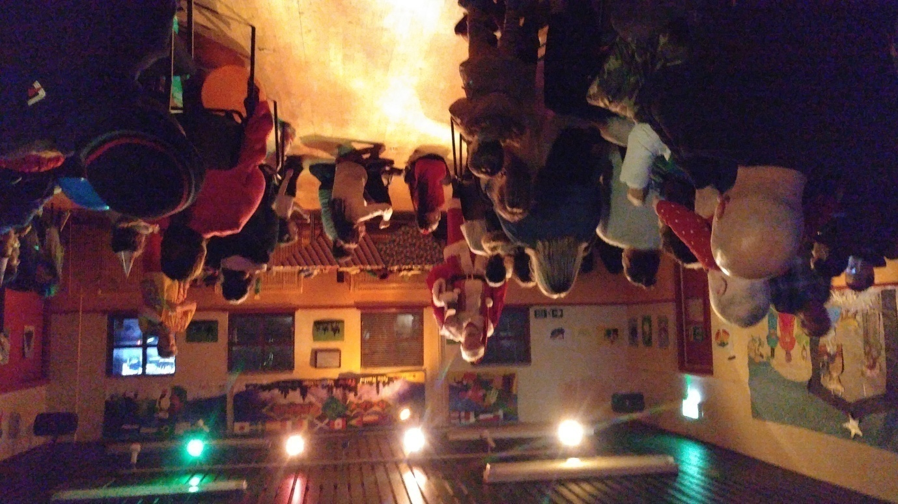
Santa has arrived

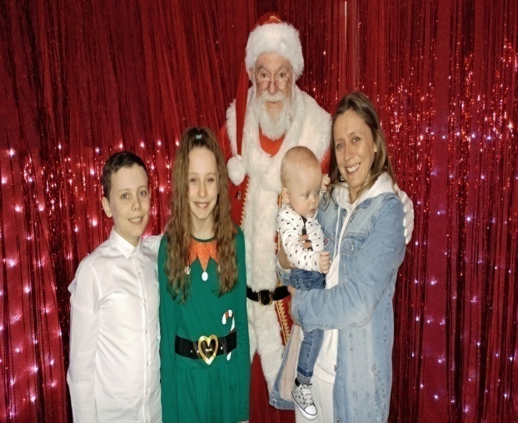
Events Continued

Christmas Continued

Santa's Grotto Continued

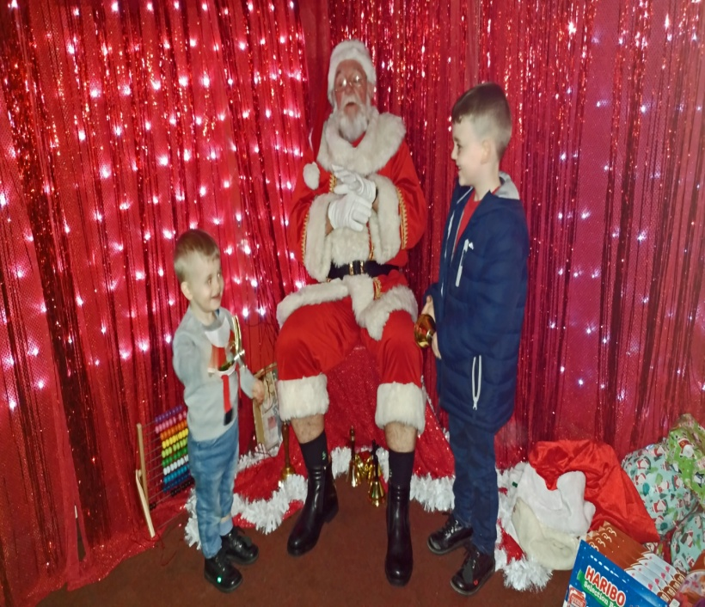
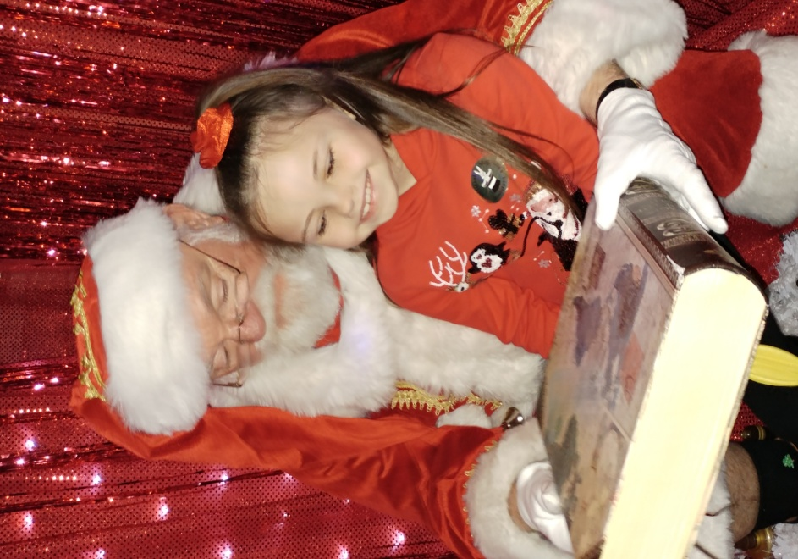

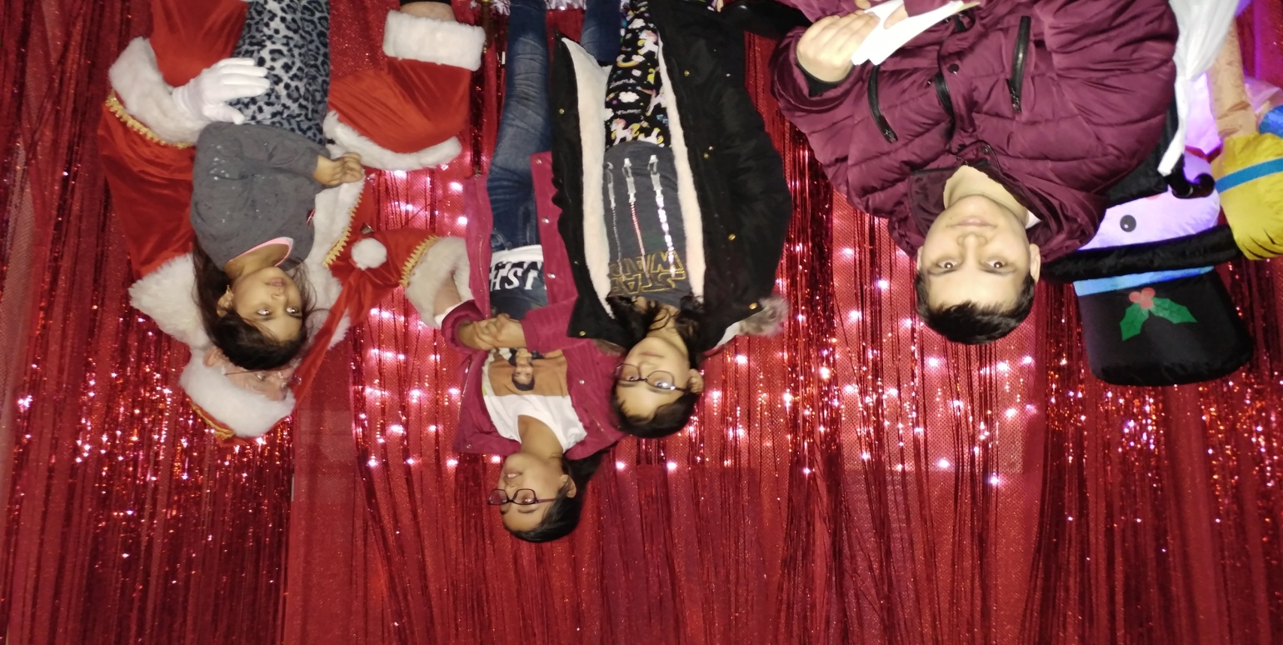

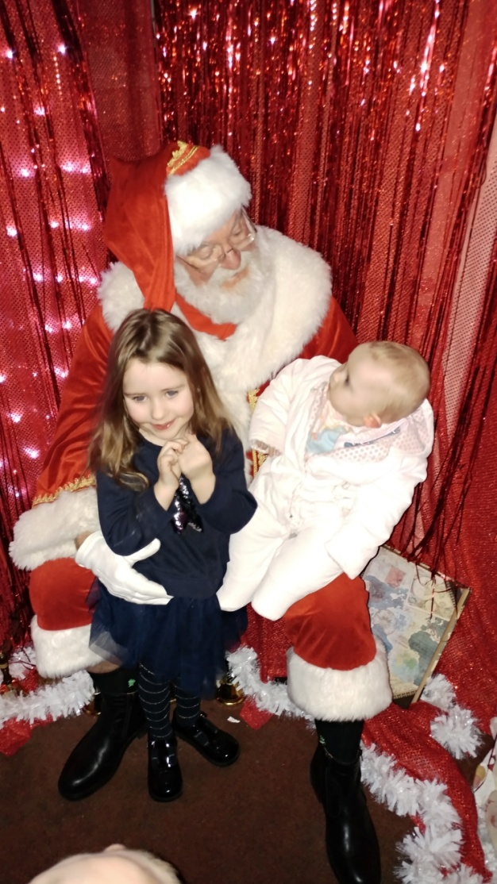
Events Continued

Christmas Continued

Santa's Grotto Continued

