Group News

Larkfield Writers Group
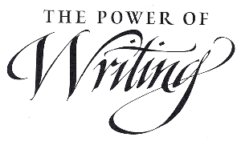
The Larkfield Writers' Group continue to meet in the Larkfield Centre, 39 Inglefield Street, Govanhill, Glasgow G42 7AY, on Monday afternoons 1-3pm

The group are looking to recruit new members to enhance the talent already there and all you need is a love for writing to come and join the group.

Music Rehearsal Group

The centre continued to provide much needed local rehearsal space for this group which enables them to come together to play music and rehearse as to do it in the home would cause a nuisance to neighbours. They meet up on a weekly basis and are a delight to listen to especially when Management Meetings are on!

ESOL (English as a Second Other Language)
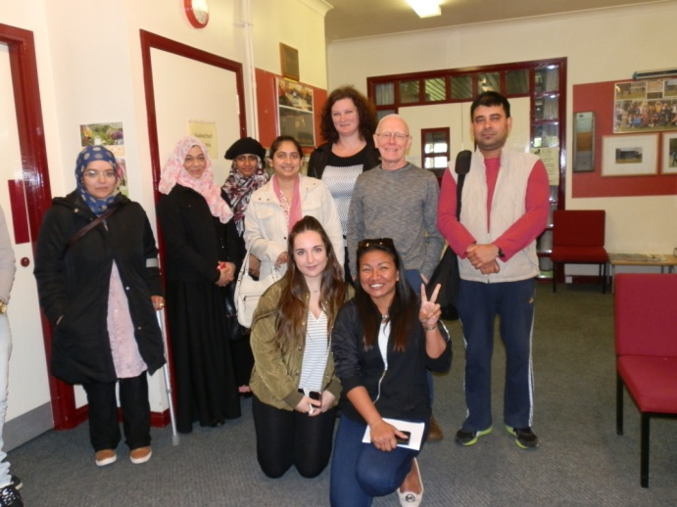
We were delighted that our partnership with Clyde College (Langside Campus) continued this year enabling the College to deliver services in the local community and as always it was good to see the students gain not only in confidence over the year but how much their English skills improved which would go some way to enhance their prospects for employment also. Group News Continued
ESOL Continued

Pictured below are some of the students from the afternoon class who were going to the Peoples Palace for their end of term treat after working so hard throughout the term.
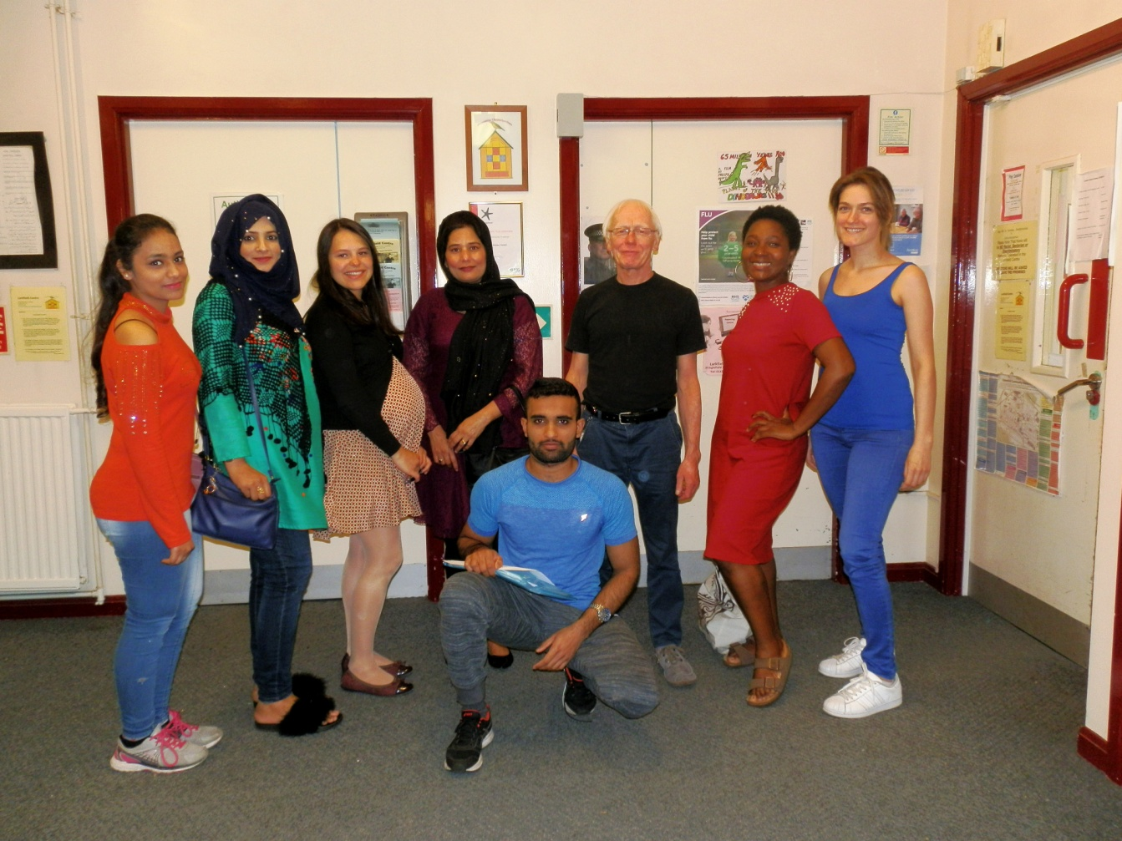
Digital Photography

The Digital Photography Group continues to meet at the centre on a Tuesday morning from 10am – 12noon

Group News Continued

Digital Photography Continued

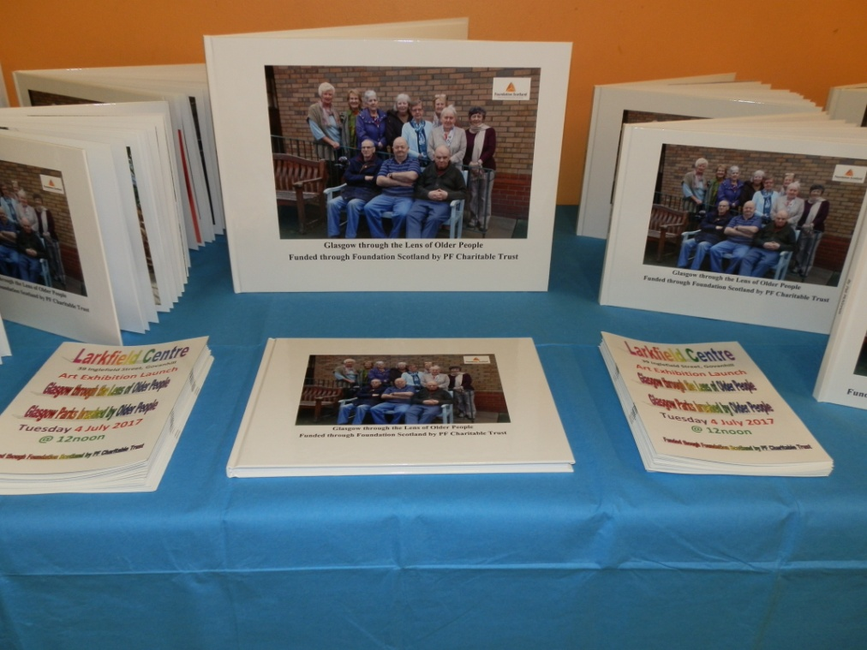
This year the group were dealt two heavy blows by the sudden death of their Tutor and the death of one of their members too. However they have rallied and are keeping the group going with the assistance of another local man Michael Mc Cann and their learning continues. Over the year the group saw the completion of the art project which had two strands to it (i) ‘Glasgow through the Lens of Older People’ & (ii) ‘Older People Brush Glasgow Parks’. They captured their childhood memories of growing up in Glasgow and compiled them into a photobook that were displayed at the Art Programme Launch!

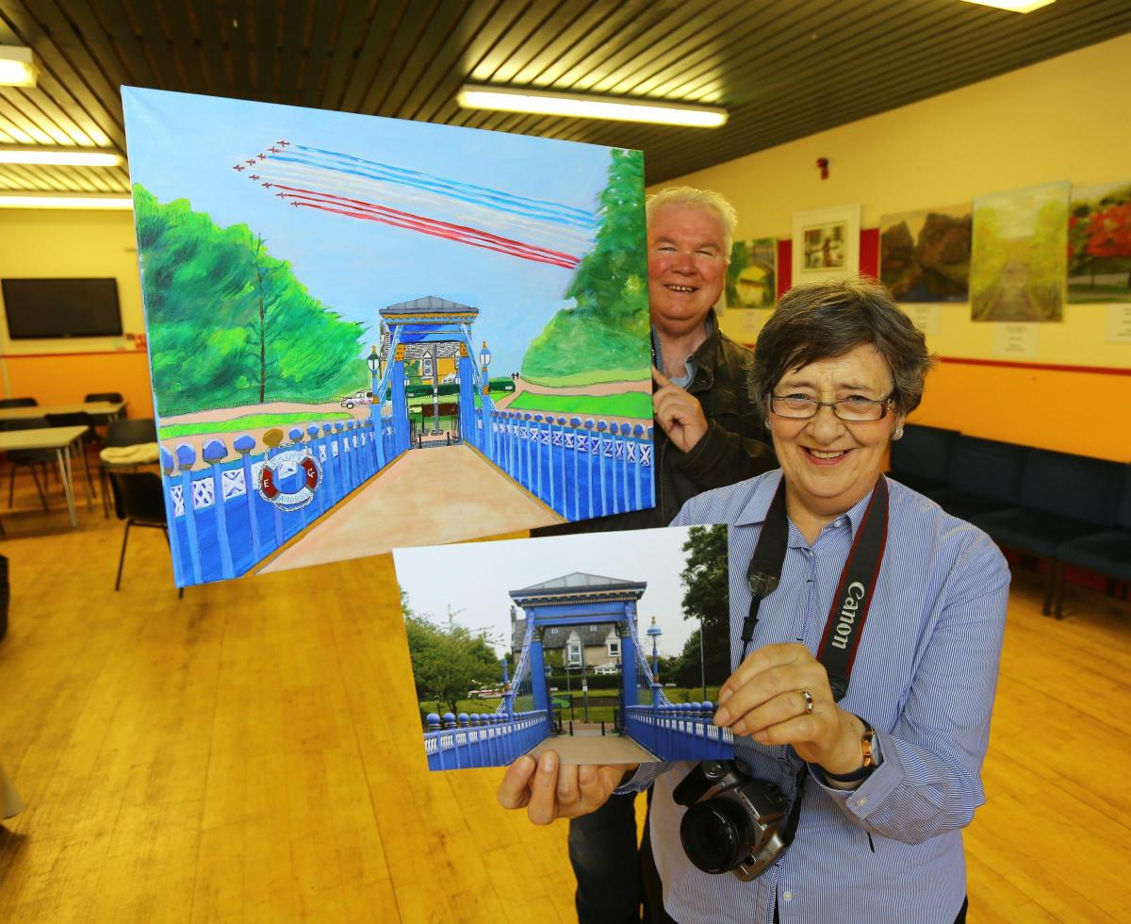
Hopefully the pictures on the next few pages will capture the feel of the event as both the artists and photographers were so excited about exhibiting their works.

Pictured on the right of the
page is Margaret Walker
who took the photograph
which was then selected
and painted by artist
Eddie Graham.

Group News Continued

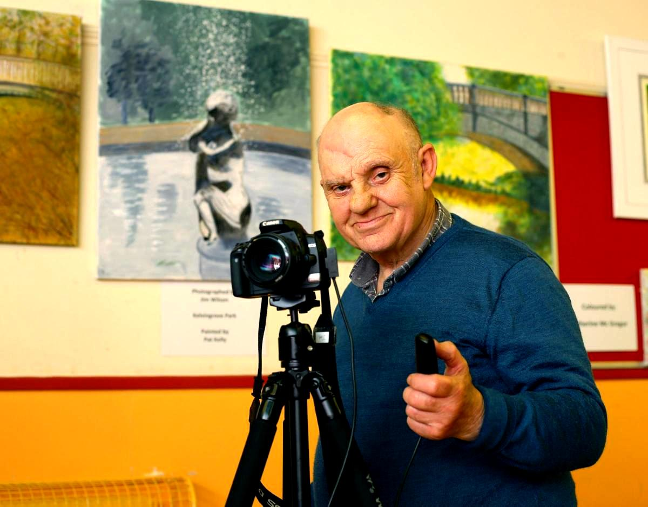
Digital Photography Continued

Pictured on the right is Jim Wilson who is a keen photographer Pictured

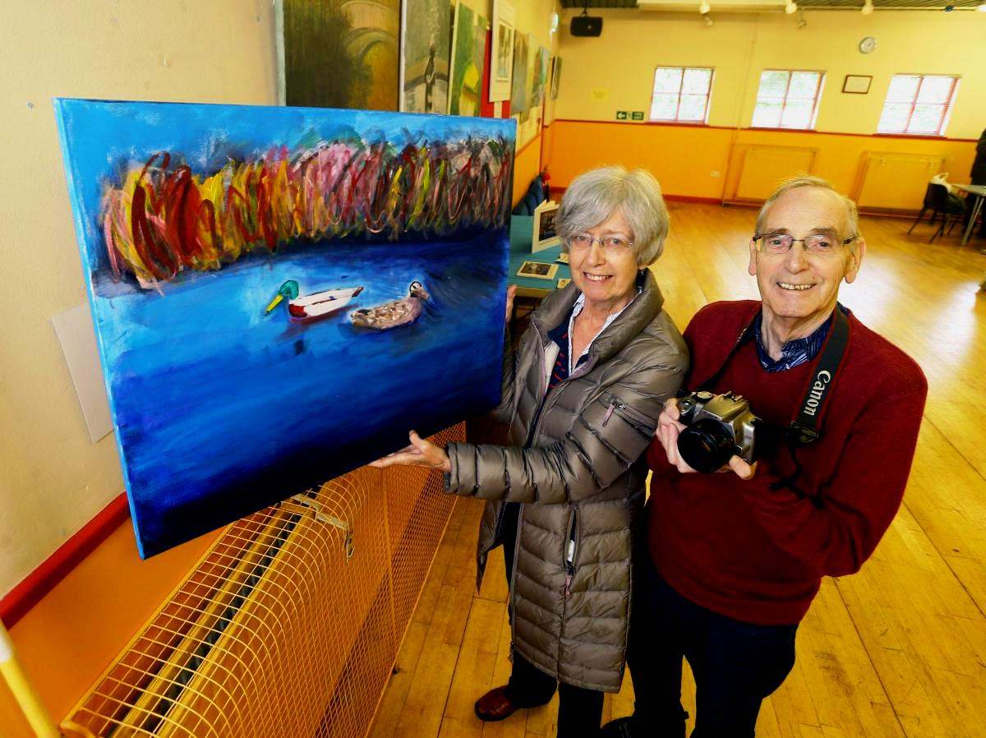

Pictured on the left is
John Walker who took the photograph that was painted by artist Mary Campbell. Sadly John is no longer with us as he passed away in December 2017 and has left the group fond memories of him going forward.

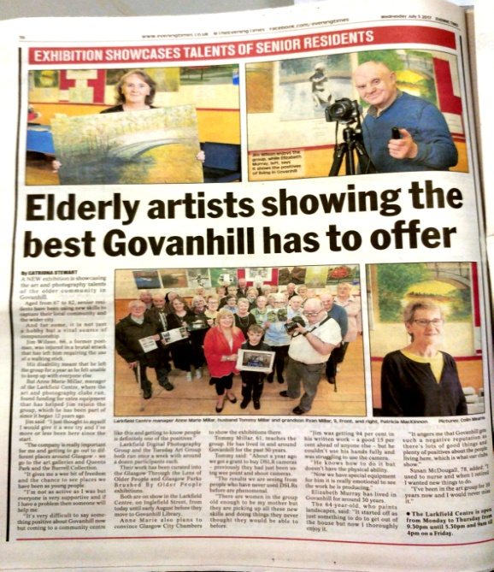
The evening times gave publicity to the Arts Programme funded by Foundation Scotland (Where Philanthropy meets the Community, which brings us on nicely to the second strand of our Art Programme. ‘Glasgow Parks Brushed by Older People’

The Arts Programme was funded by
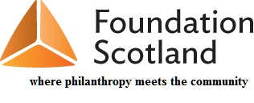
Group News Continued

AGAP Art Group

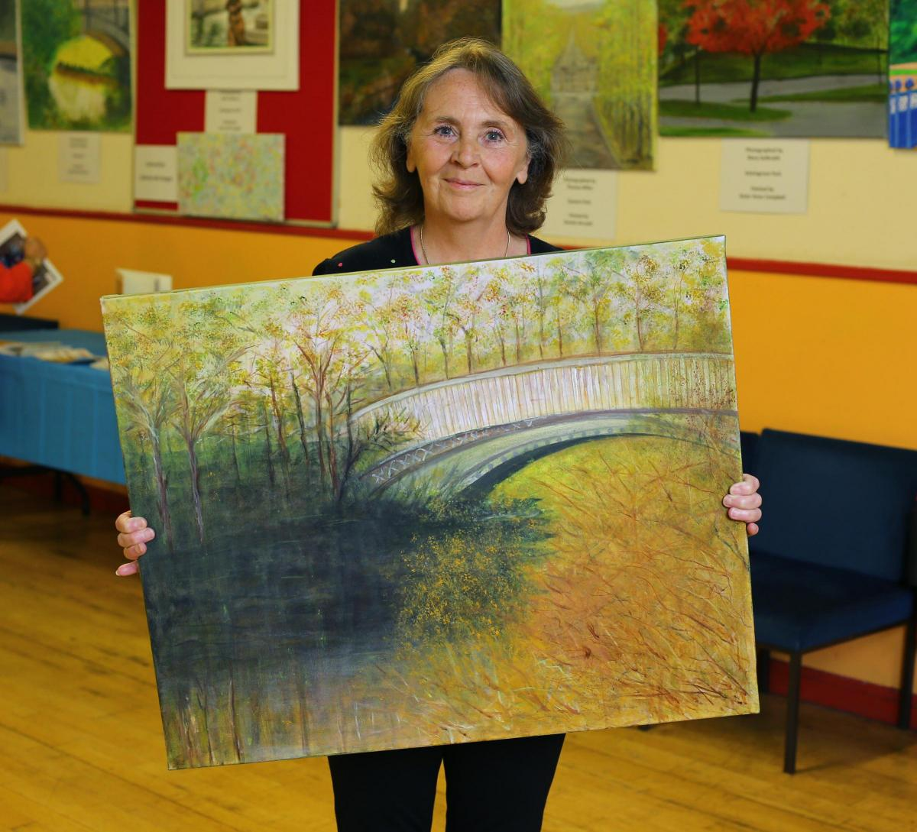
The art group continues to meet at the centre on a Tuesday afternoon between 1pm – 3pm. They are supported by the Archdiocese of Glasgow.

Moving on to the second strand of the Art Programme ‘Glasgow Parks Brushed by Older People’

Pictured on the right is local artist Elizabeth Murray....

And pictured below is artist Pat MacKinnon with her painting in the background!

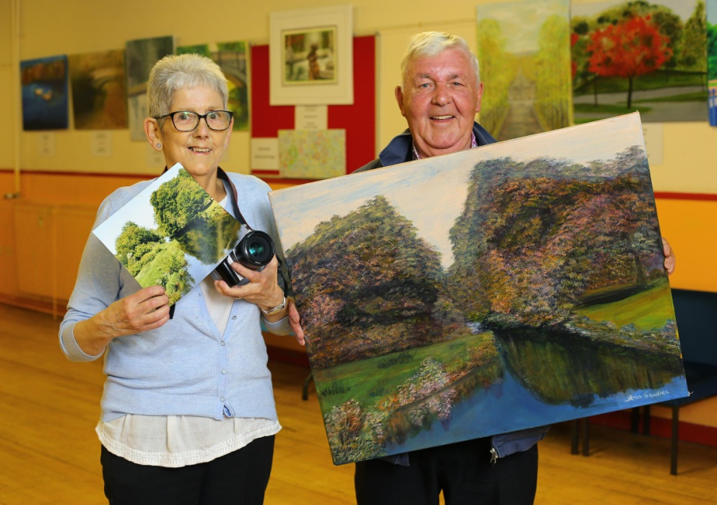
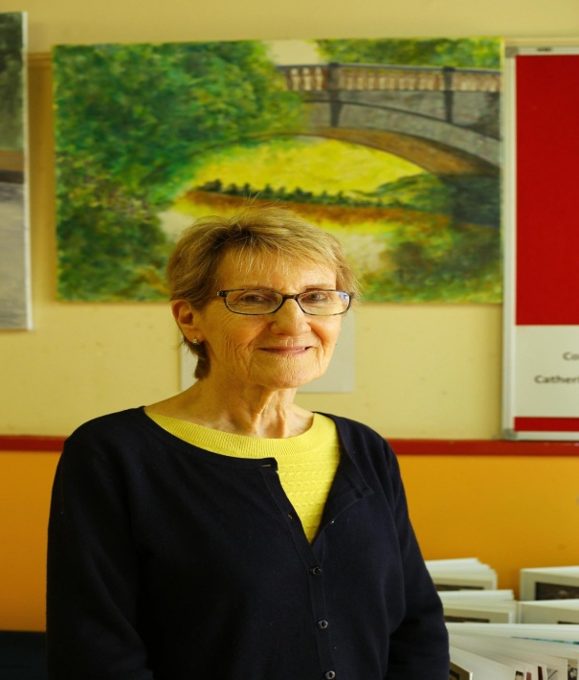

Pictured above is photographer Agnes Murdison and artist John Gardner.
Group News Continued

Art Group Continued

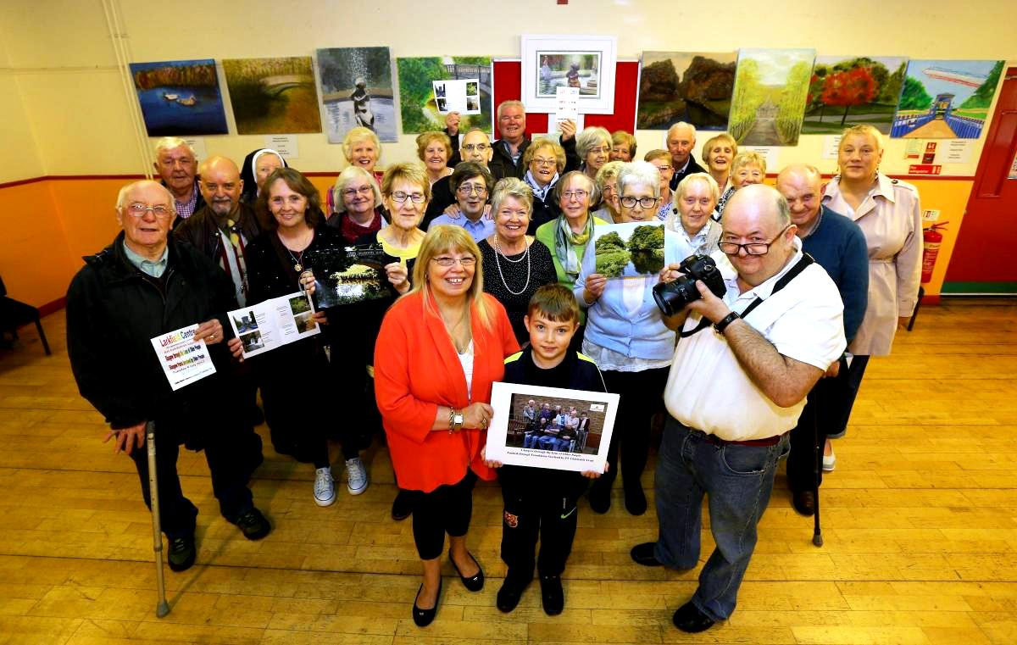
Pictured below is the Centre Manager with members of the Art Group and Digital Photography Group who participated in the Art Programme ‘Glasgow through the Lens of Older People’ & ‘Older People Brush Glasgow Parks’ also in the picture is Councillor Mhairi Hunter back row right of picture .
