Events 2017/2018 Continued

Halloween Schools – Event
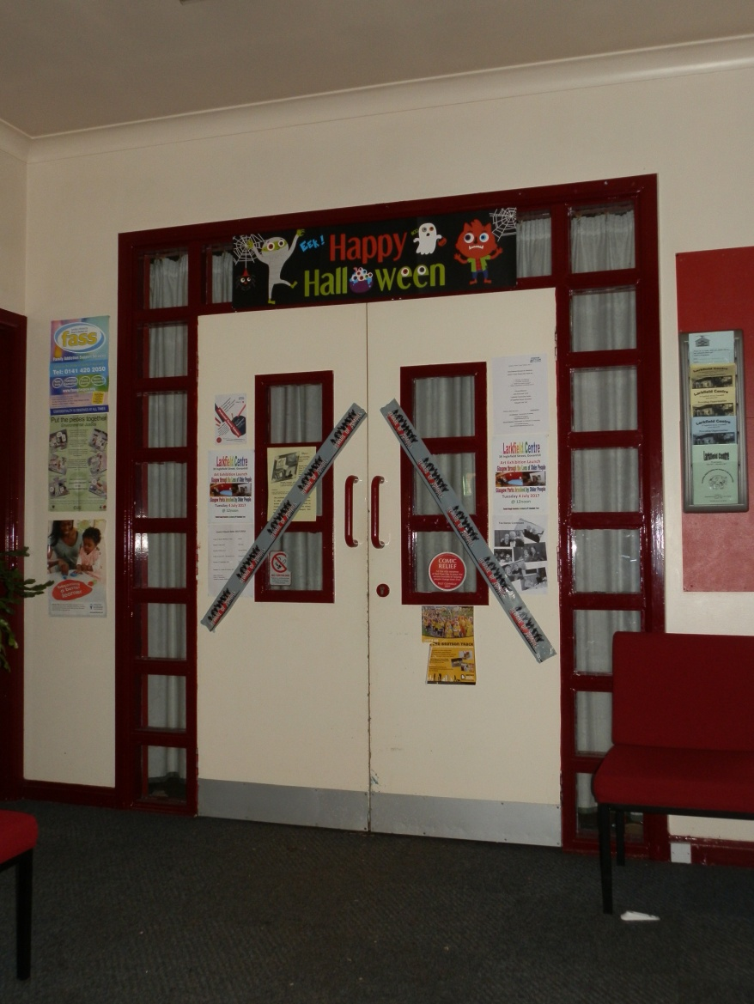

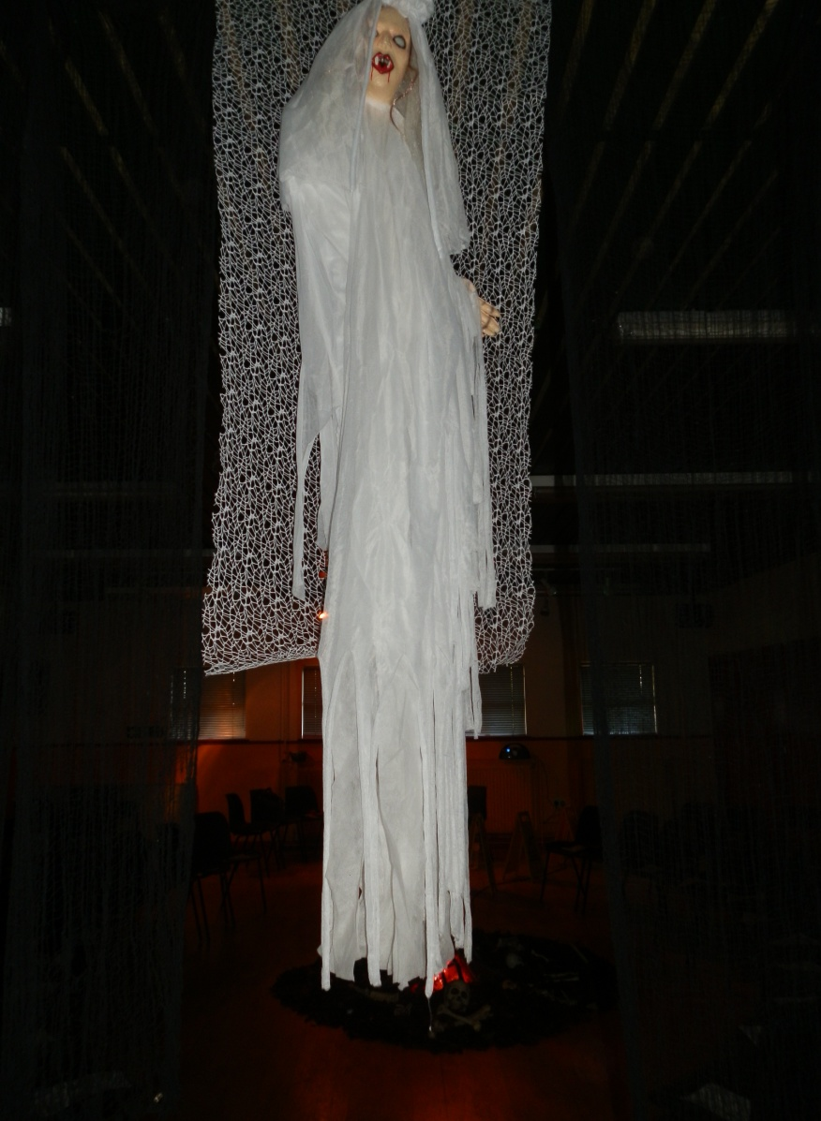
Enter if you dare!

BOOOOO!!!!

Events 2017/2018 Continued

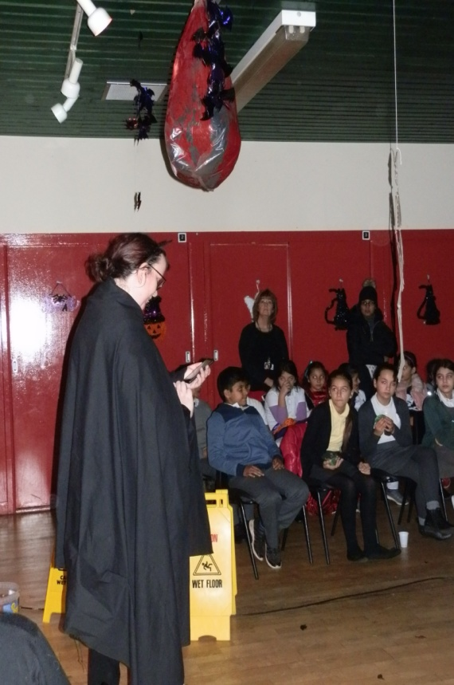
Halloween Schools – Event Continued
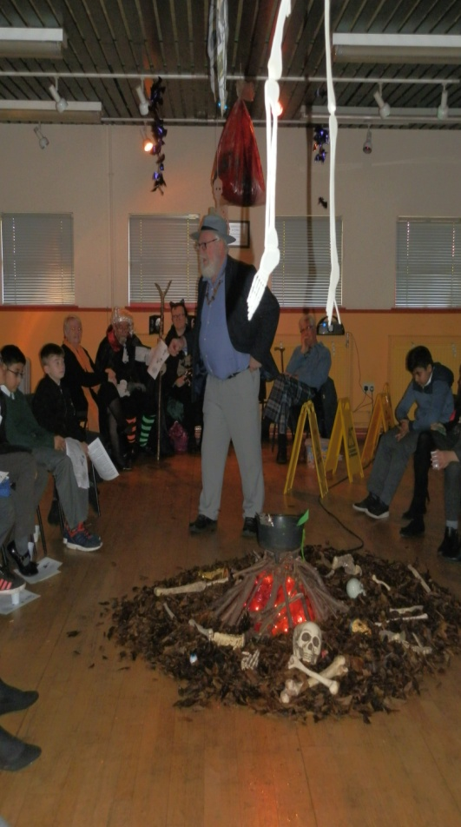
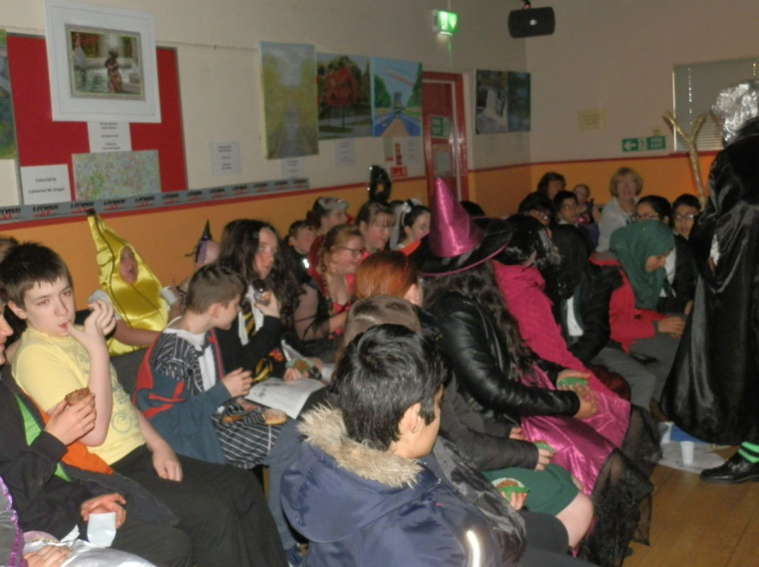
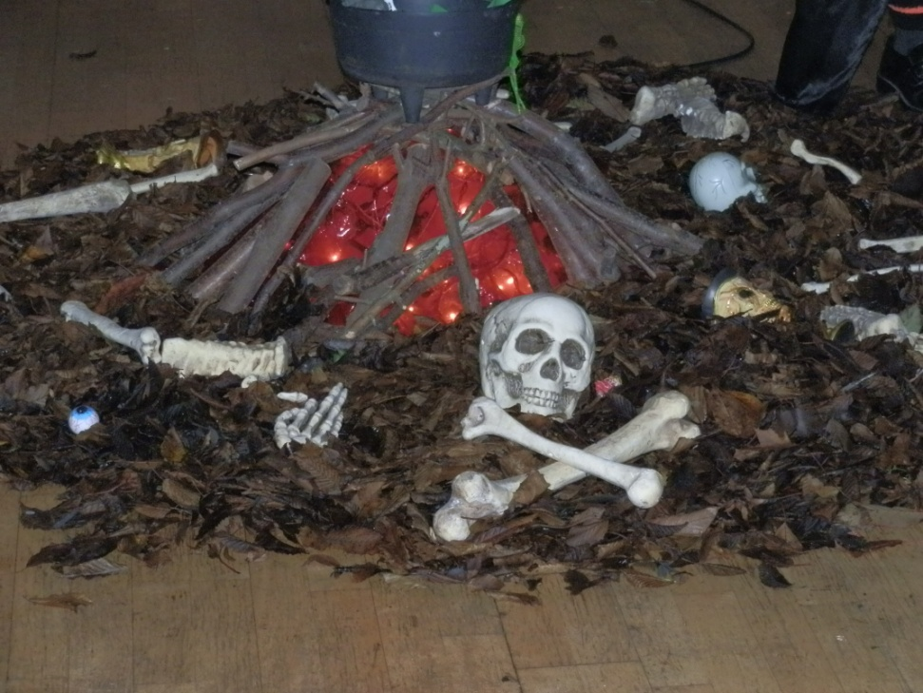

Events 2017/2018 Continued

Halloween Schools – Event Continued
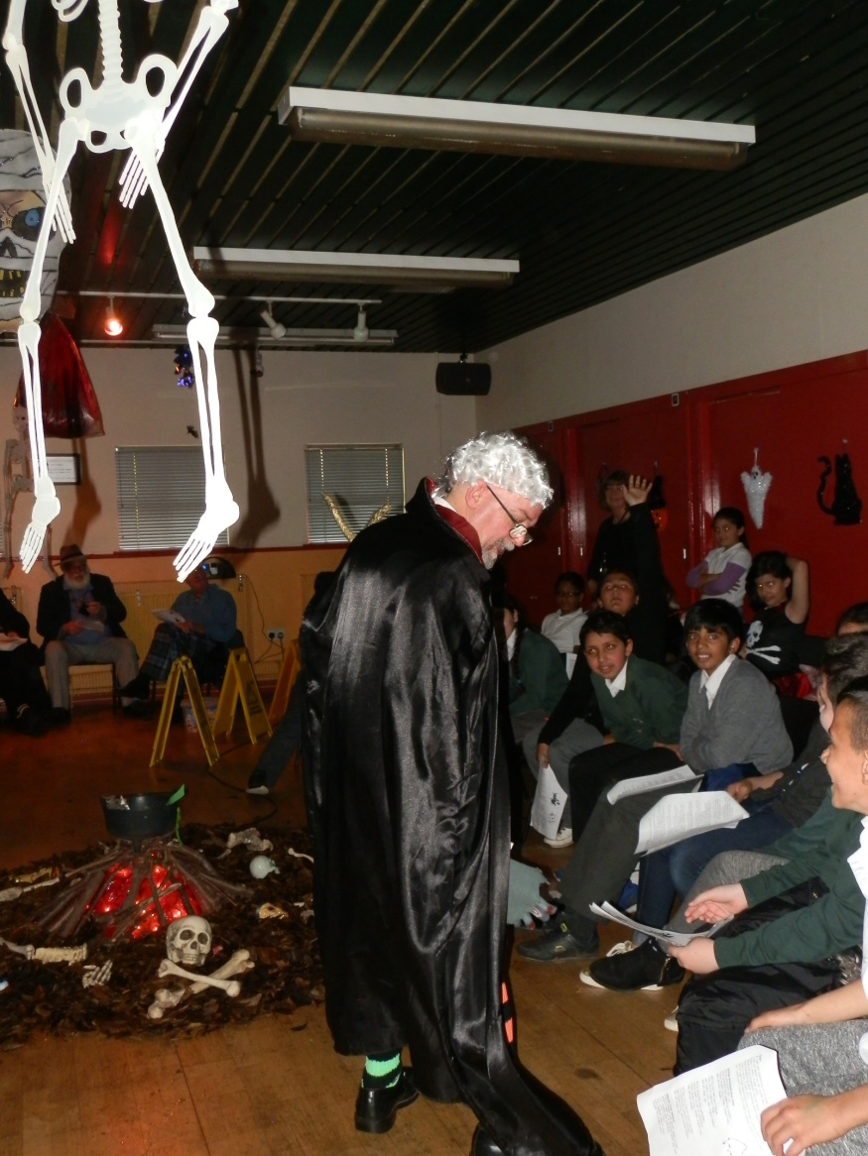
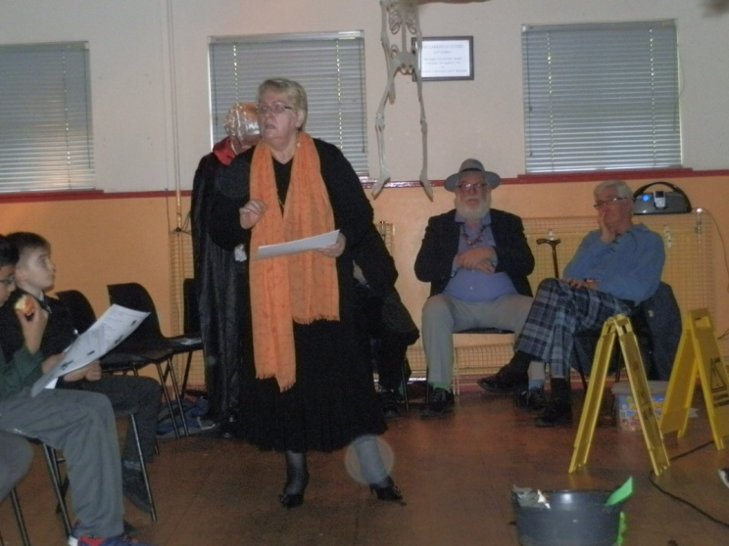

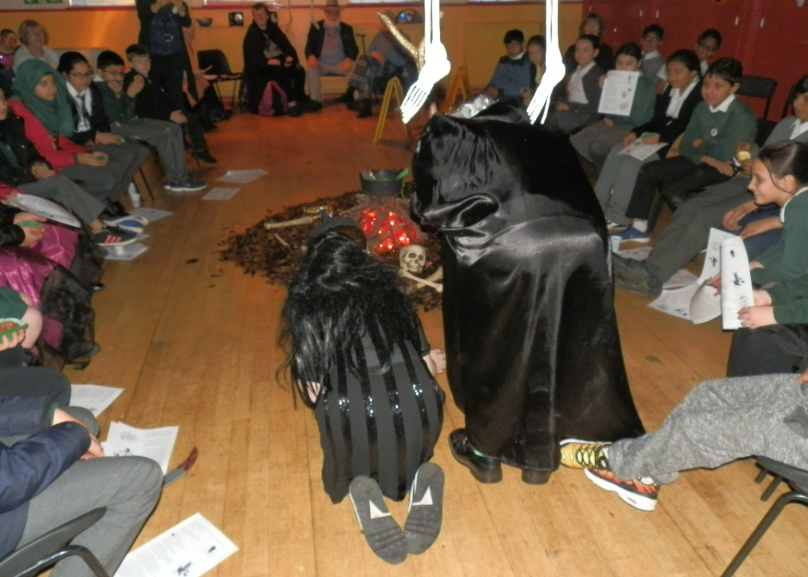

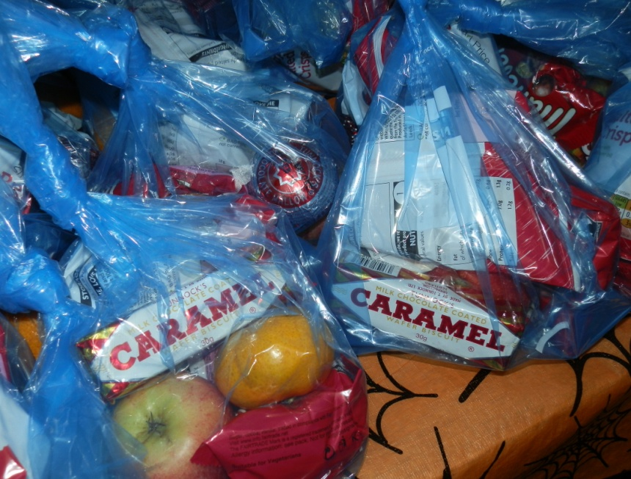

On the way out each child
received a goody bag to take
home and enjoy!

We would like to thank our
Sponsors for this event, Greggs
and Tunnocks for their kind
donations which were greatly
received by the children and
young people.
Events 2017/2018 Continued

Remembrance Event
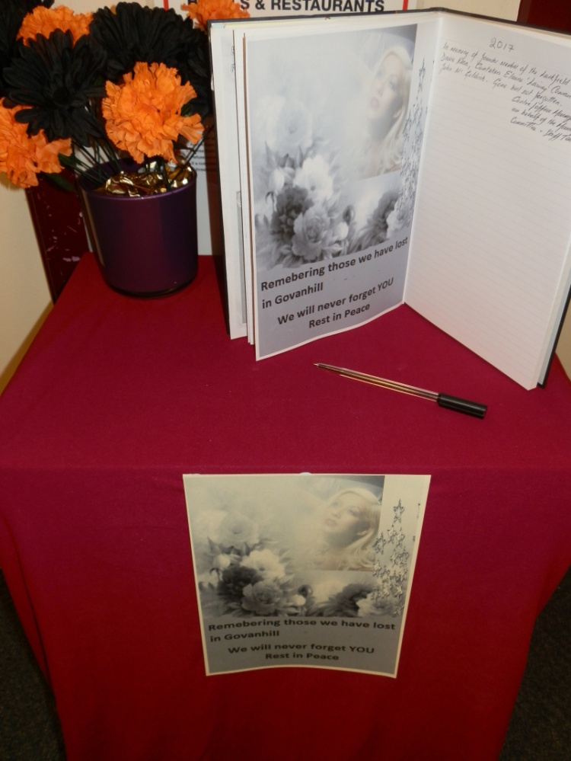
The centre continues to hold its Remembrance Event to give people in the local area the opportunity to come together to remember loved ones who are no longer with us and to celebrate their lives.

Our Chairperson recites words of comfort and remembrance that he has written and candles are lit and balloons released in the memory of those we have lost.

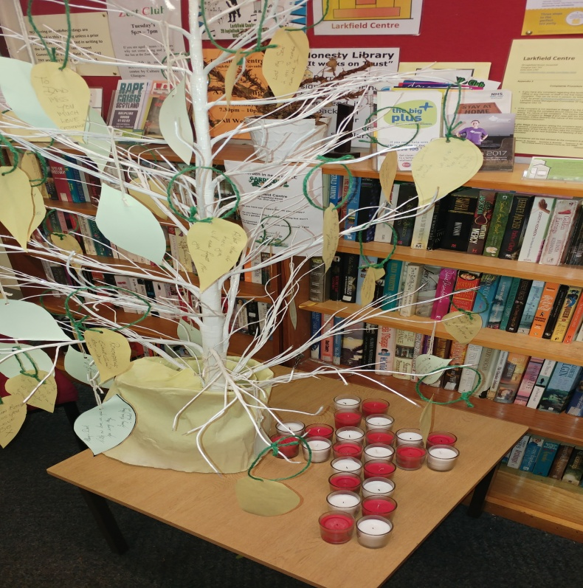
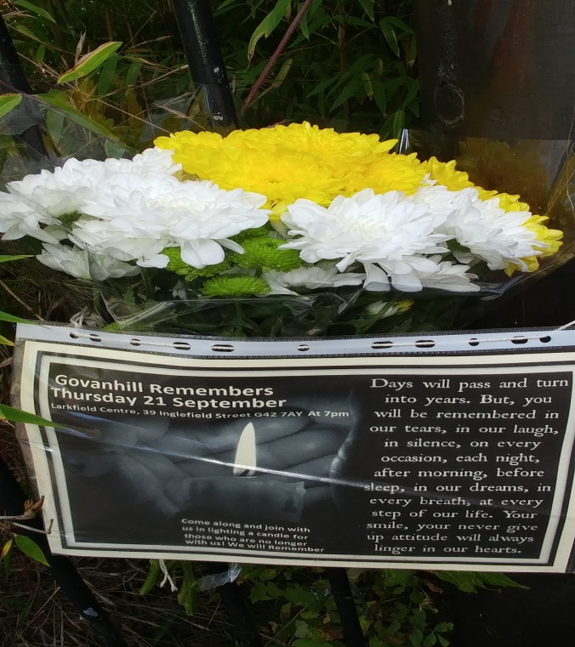
We also continue to have the Book of Remembrance Open for 2/3 weeks prior to the event so that people who are unable to attend can still keep their loved ones memory alive in the book of remembrance.

Events 2017/2018 Continued
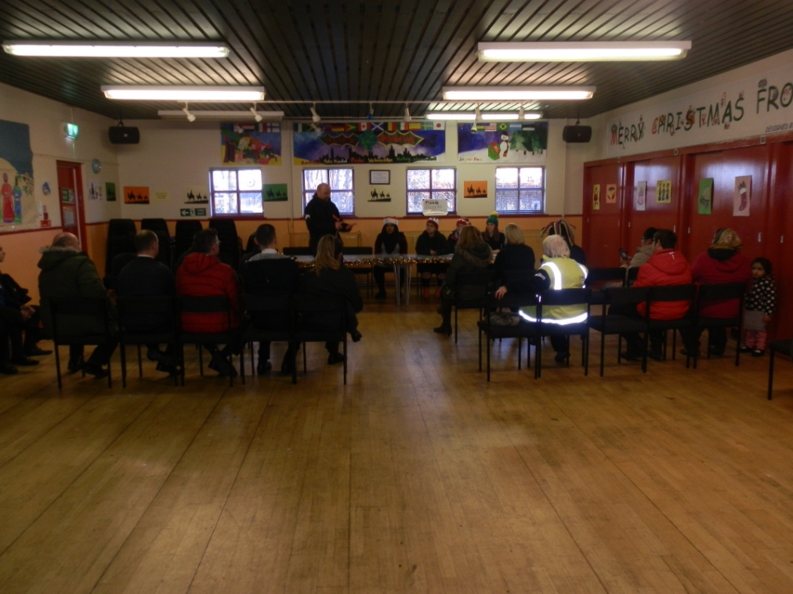
Litter Pick

This was an event run by the local secondary schools over a weekend period to help them to achieve the John Scott award as they had to do something to enhance the community they lived in to achieve this award. The young people from Holyrood Secondary and Shawlands Academy Schools got together and decided to clean up the environment in which they lived over a weekend period. The event was opened by the First Minister and local MSP Nicola Sturgeon.
