Events 2017/2018 Continued

Christmas – Hollybrook Academy Seniors Christmas Disco

The centre are delighted to be able to provide a venue that meets the needs of the local assisted learning secondary school for them to hold their Christmas Senior years Disco. The young people are familiar with the centre due to the partnership work that we do with them so are comfortable in the centre and we can also offer a chill out space if it gets too much and the young people need a quiet space.

Local Garden Group Fundraiser

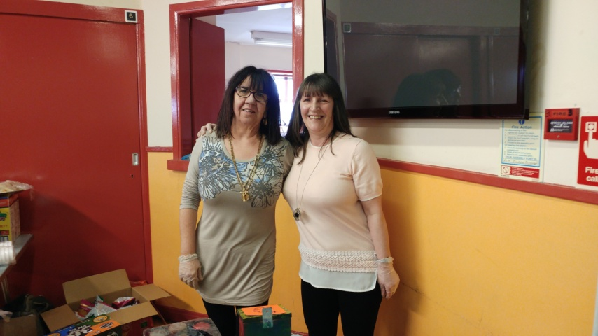
The centre were delighted to be able to assist this local gardening group by providing the accommodation free of charge the are based at the Govanhill Housing Association and they were raising funds to make the garden and equipment accesible to all.

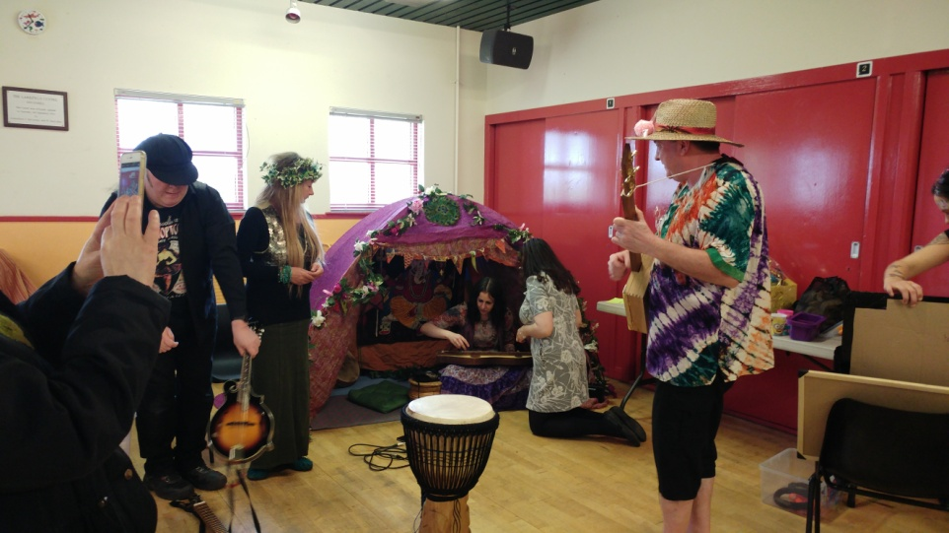

The Larkfield Centre Management Committee would like to take this opportunity to thanks those who funded the centre during the financial year 2016/2017 and also those who worked in partnership with us.

Funders/Donations

Glasgow City Council Integrated Grants

Comic Relief
SCOTMID

Awards for All

Foundation Scotland

Southside Central Area Partnership

Govanhill Housing Association

Gregg’s Tunnock’s

Partners

GG&C NHS Health Improvement Team
Clyde College
Glasgow Life Communities
SEVSN
Glasgow Life Play Club
Govanhill Youth Project
Active Life Club
Hollybrook Academy
Annette Street Primary School
Cuthbertson Primary School
Holycross Primary School
St Brides Primary School

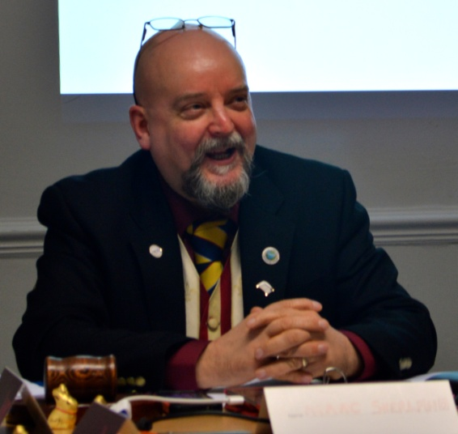

Chairperson Report

That was a quick year; fortunately the centre has been able to continue to deliver services to the local community on a standstill budget and the committee have been notified that we will be funded for the following financial year too, which is good news for the community.

We continue to work in partnership with other local agencies enabling us to provide more services for the local community in their community.

We provide a vast array of events also over the year too with several of them taking place around Christmas time and they are well attended by the community.

Sadly this year two of our members from the Digital Photography Group
passed away, Tommy Millar and John Walker who both supported the work that we do at the centre and they will be sorely missed by all.

I would like to thank the staff team for the work they have done over the last year and also that of my fellow committee members for their continued support given not only to myself over the last year but also to the centre as without their help the centre would not be here.

Also a huge thank – you to our core funders Glasgow City Government 'Integrated Grants' for providing us with the funding to run the centre and to the various other funders who have enabled us to keep a programme going over the last year as without their support it would not have been possible.

Marc Sherland, Chairperson
