Group News

Larkfield Writers Group

The Larkfield Writers' Group meets in Larkfield Centre, 39 Inglefield Street, Govanhill, Glasgow G42 7AY, on Monday afternoons 1-3pm
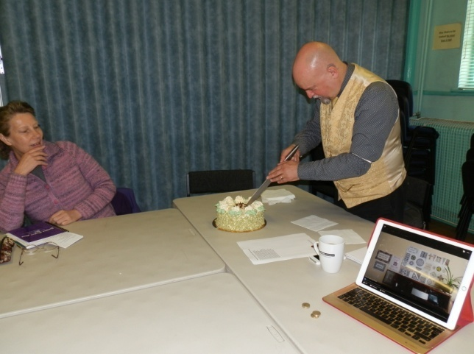
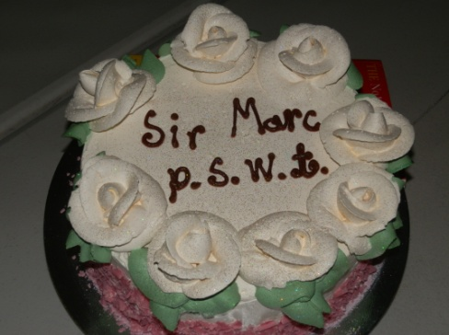
The group are currently recruiting new members and all you need is a love for writing to come and join the group.

From time to time one of the group members gets a cake made for the group to enjoy with a cup of tea to assist the creativity of words to flow!

Music Rehearsal Group

The centre provides this group with the space to come together to play music and rehearse as to do it in the home would cause a nuisance to neighbours and they meet on a weekly basis and its music to the ears when they are in on a Monday evening

ESOL (English as a Second Other Language)

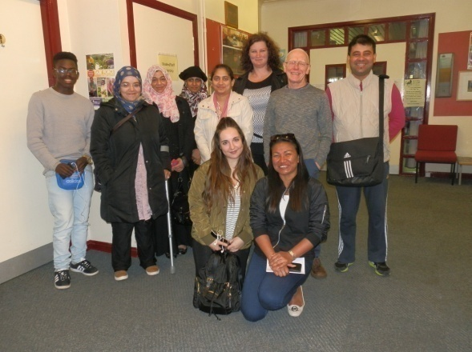
We continue to work in partnership with Clyde College (Langside Campus) and have had 30 Students come through the door to learn English over the course of this year which will enhance employment prospects and also improve participants communication skills, boosting their confidence.
Group News Continued

Digital Photography

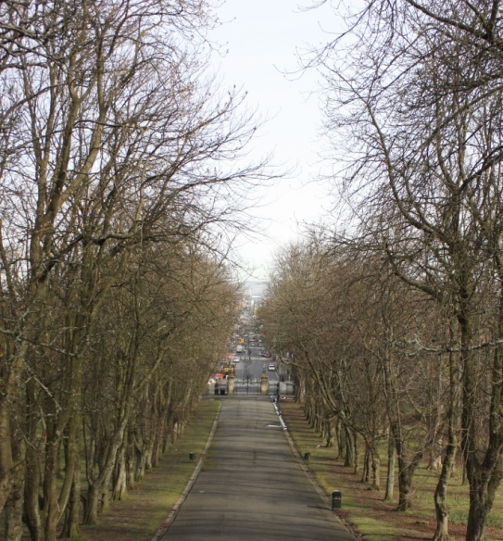
The Digital Photography Group continues to meet at the centre on a Tuesday morning from 10am – 12noon and continue to be a very popular group with a waiting list to join.

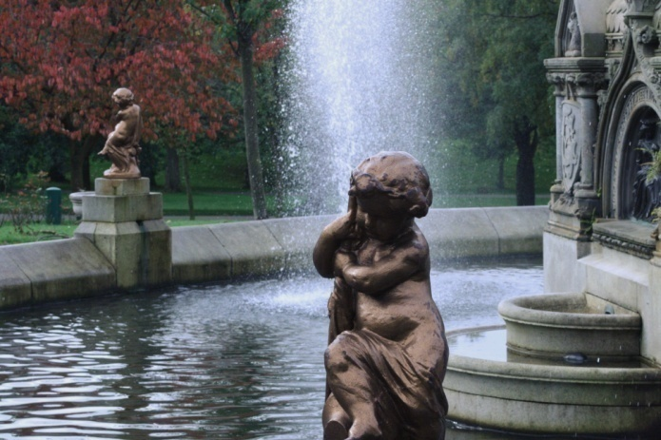
This year the group began an online course in Digital Photography and have a couple of sessions to complete before they have completed the course.

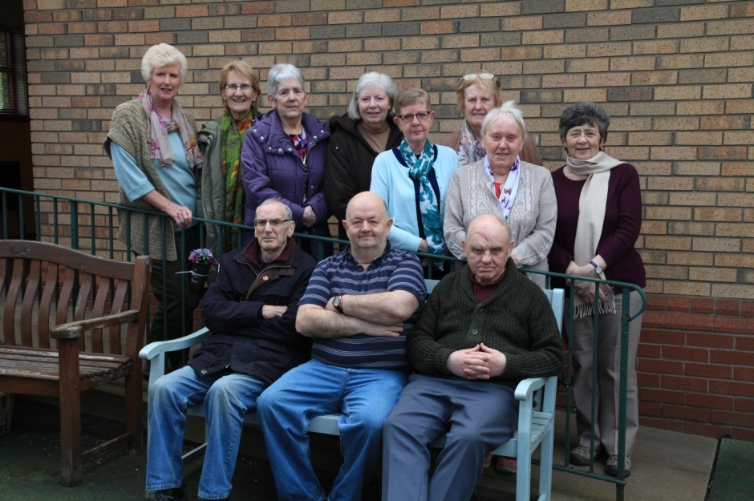
They also embarked upon an art project which had two strands to it (i) ‘Glasgow through the Lens of Older People’ & (ii) ‘Older People Brush Glasgow Parks’. The Group are currently in the process of compiling photobooks with their memories of growing up in Glasgow which they will keep after the project comes to an end. They will also compile a larger photobook of memories of Glasgow which will contain from each group member some of their memories that they will share with the wider community and will be displayed initially at the centre then in other venues across the local area.

Group News Continued

Digital Photography Continued

The second strand of the project is called ‘Glasgow Parks Brushed by Older People’ in which the Digital Photography Group went out into the parks of Glasgow taking photographs which they then printed off and gave to the art group who would then deliver the second strand by choosing one of the printed pictures to paint onto a large canvas.

This art project was able to happen with the support of Foundation Scotland Express Grants. Also as part of this project which had a

AGAP Art Group

The art group continues to meet at the centre on a Tuesday afternoon between 1pm – 3pm. They are supported by the Archdiocese of Glasgow.
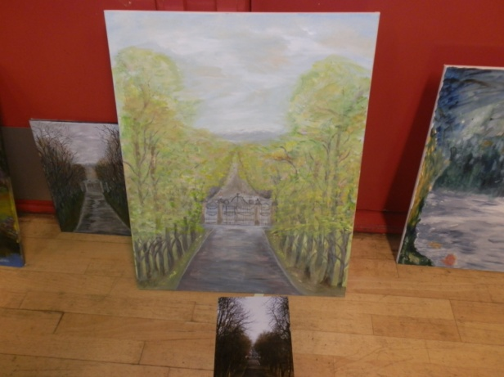
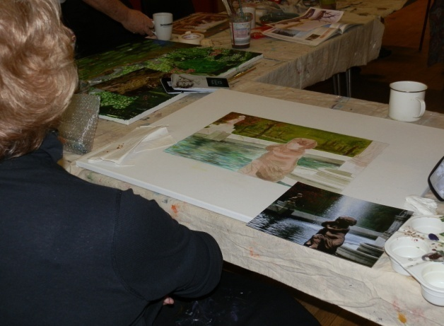
Over the past year the group have been part of an Art Project that will be launched in the first quarter of the new

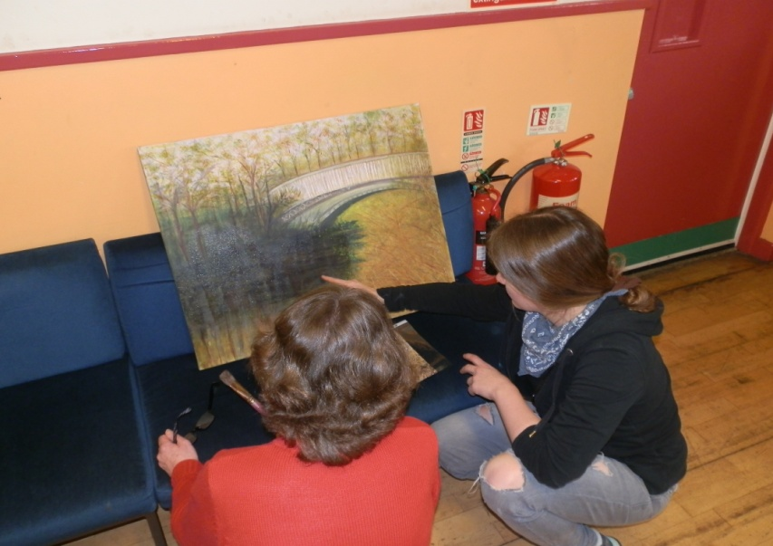
financial year as they have been working hard learning new skills to transfer photographs that were taken by the Digital Photography Group for them to paint onto large canvas which has been a challenge for the group and taken them out with their comfort zone.

Group News Continued

Art Group Continued

This was the second part of the Art Project called ‘Glasgow Parks Brushed by Older People’
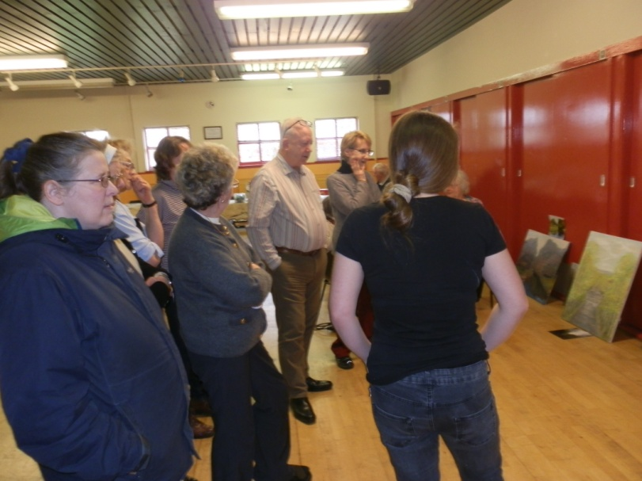
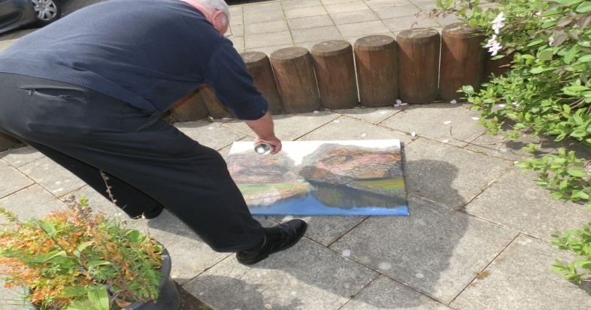
The art project will be completed in the next financial year and we look forward to showing off their works of art in next year’s Annual Report
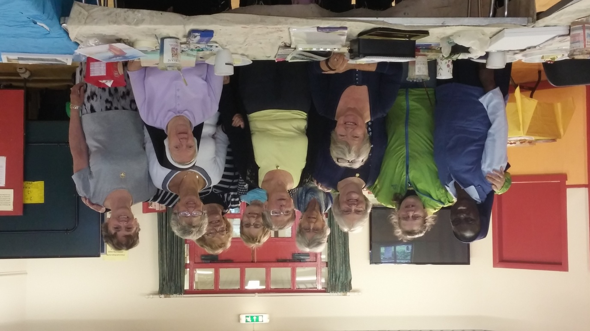

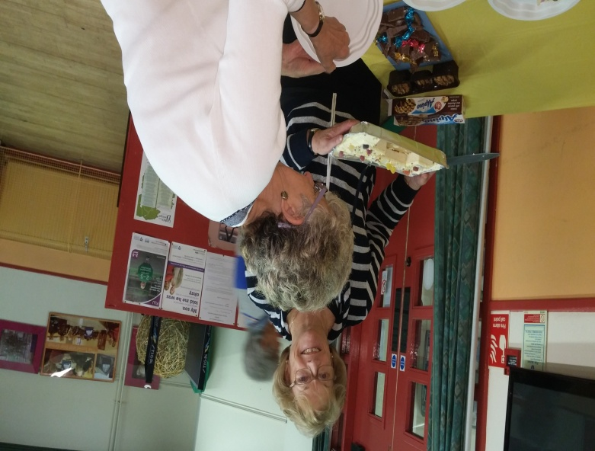
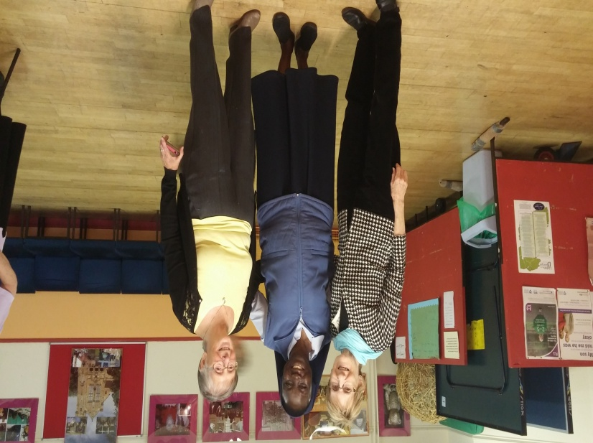

Piping and Drumming
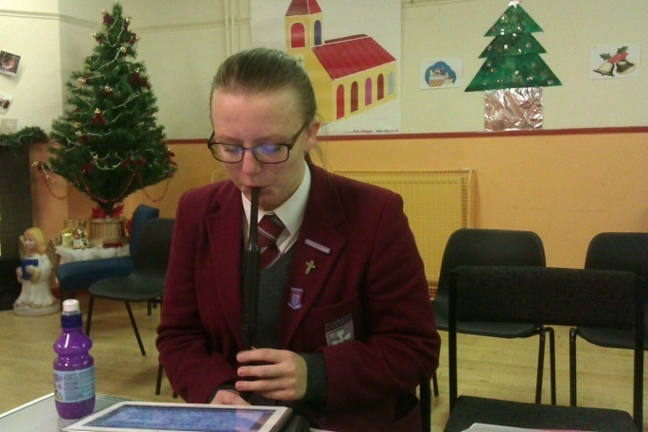
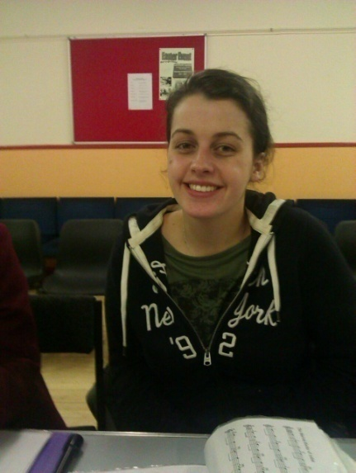
The piping and drumming group continues to meet on a Wednesday from 6.30pm – 7.30pm teaching young people how to play the chanter and progress onto the Bagpipes. It is one of the centre’s oldest running groups.
The young people learn how to read and play music and we have a dedicated group who want to learn and progress to the pipes so they practise on a regular basis at home.

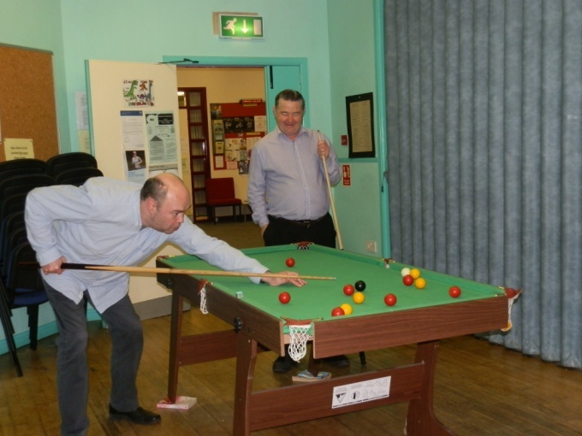
Men’s Group

The men’s group continue to meet on a Thursday afternoon from 2pm – 4pm. They are always looking out for new members to come along and join them especially for a game of pool/snooker or chess.

Language Class (Arabic)

The Language class is very popular with 14 young people from around 6yrs – 16yrs of age attending four times per week. They enjoy learning together and are very polite young men and a credit not only to their

Teacher and also to their parents. The group are keen to continue their learning and always turn up early for class too.

The group is that popular they have a waiting list to get a place in the class.

