Events 2016/2017 Continued

Marie Curie (Blooming Great Tea party) Continued
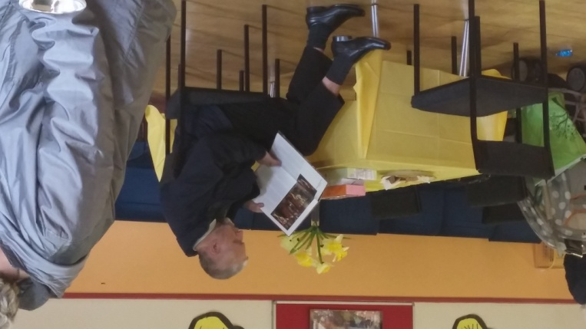
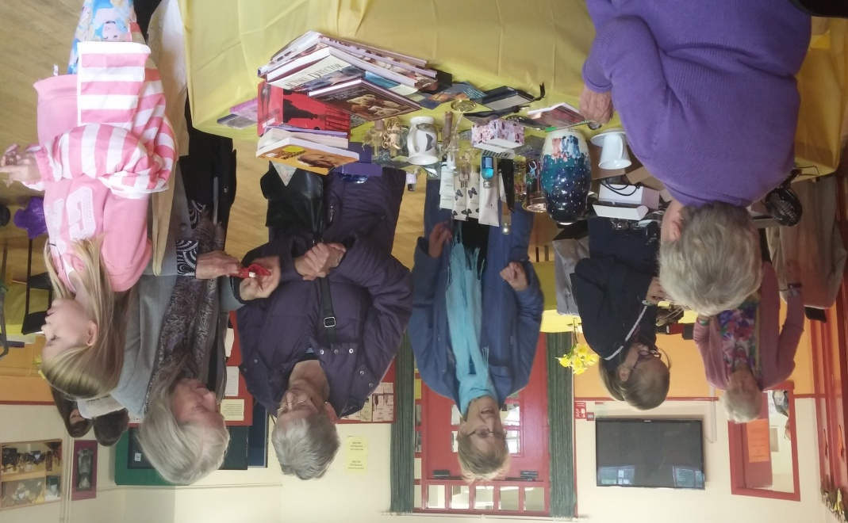
We raised £227.40 and the management committee agreed to round it off to £230.00
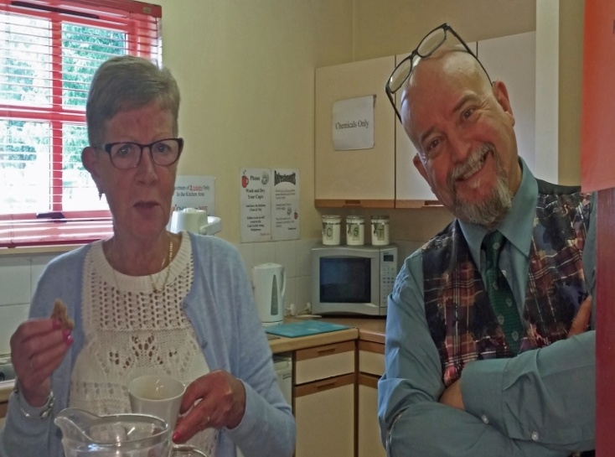

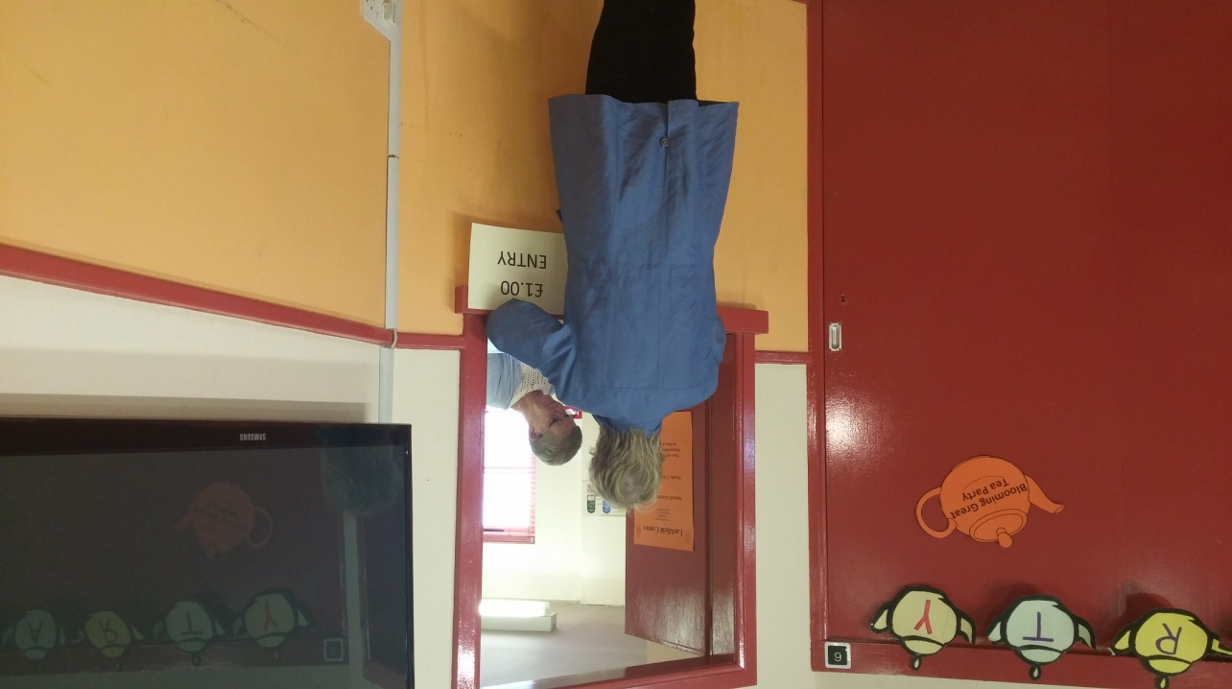

Events 2016/2017 Continued

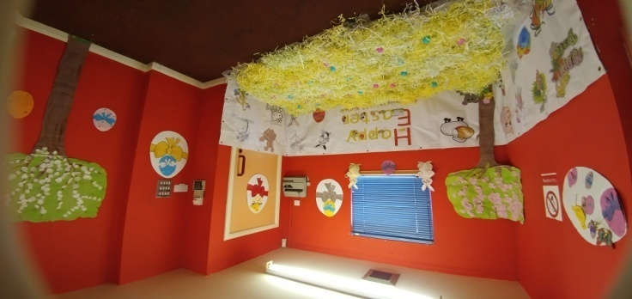
Easter

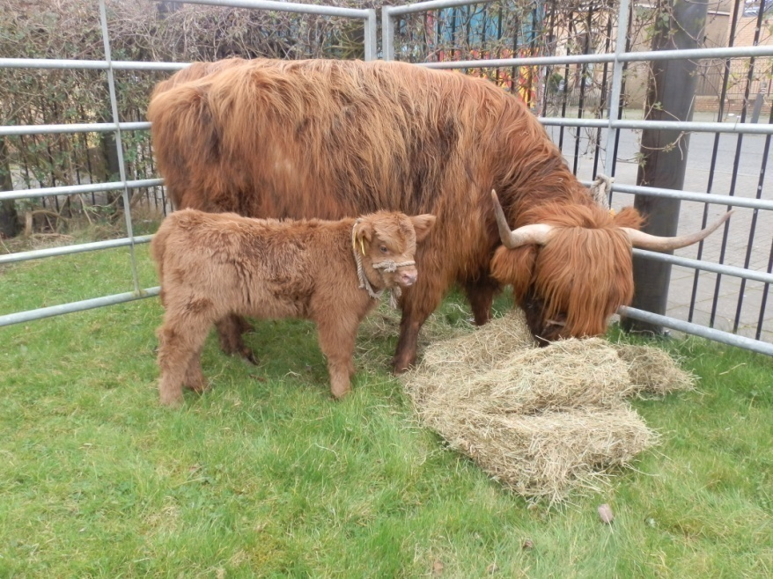
The Easter Event this year was the busiest we have seen it since its inception over a decade ago. We gave out 144 Easter Eggs to children who attended under the age of 12 while everyone else enjoyed tea, coffee, biscuits, juice or crisps. The pictures will show just how much fun the children and the community get out of the Easter Event.

Pictured on the left of the page are the Highland cattle from Pollok Park.
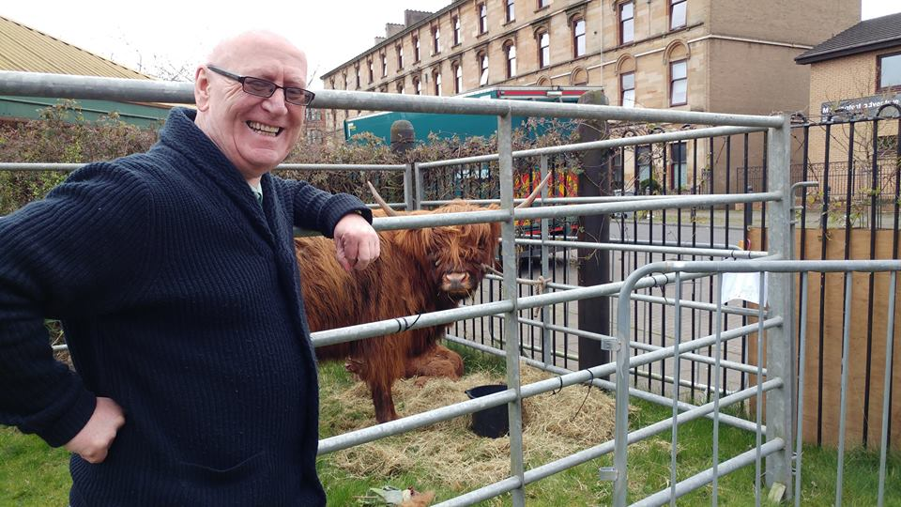

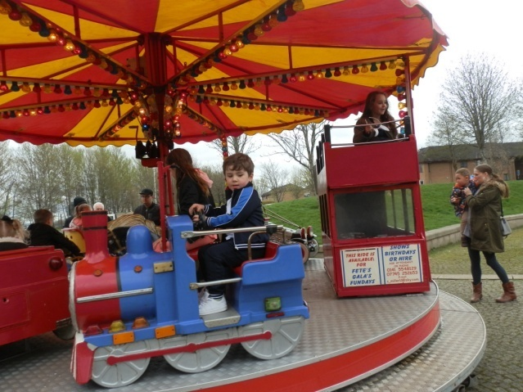
By bringing along the Highland Cattle from Pollok Park provides the local community the opportunity to see them close up as many would not have seen them before. On the left is local Councillor James Scanlon pictured next to the Highland Cattle

We even had the fun of the fair at the Easter Event which went down really well with the children and pictured below Events 2016/2017 Continued

Easter Continued

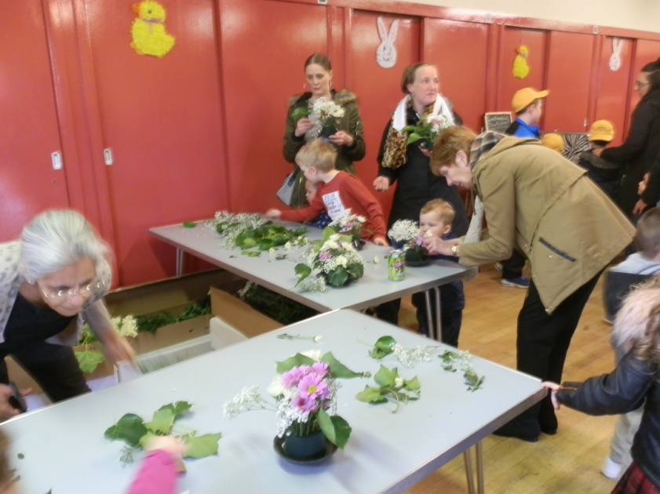
bottom left is Kumkum who kindly volunteered to run our posy making stall.

Below are children participating in the Zero Waste stall, finding out how to be creative with rubbish!

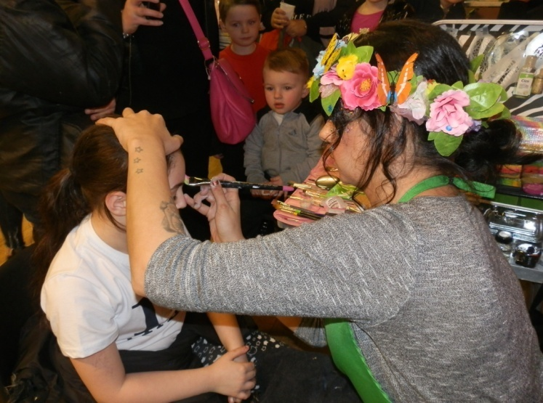
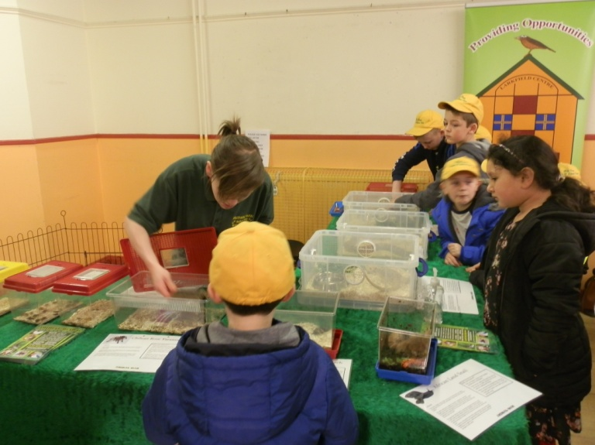

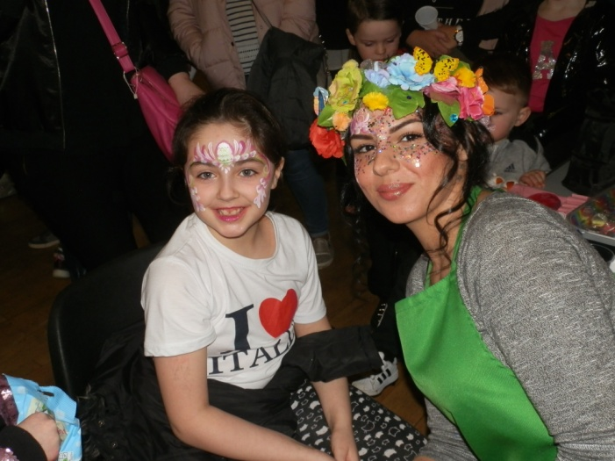

Luna Sparkles
Face Painting
Events 2016/2017 Continued

Easter Continued

We also had the Animal Man Mini Zoo at the event and the children met lots of different animals and were able to touch and hold them and learn about them too. And the pictures that follow will show the various animals on show on the day.
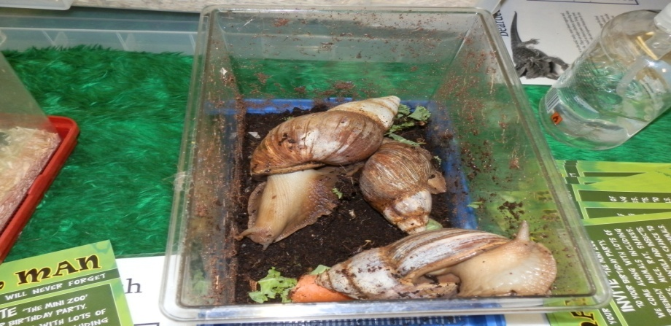
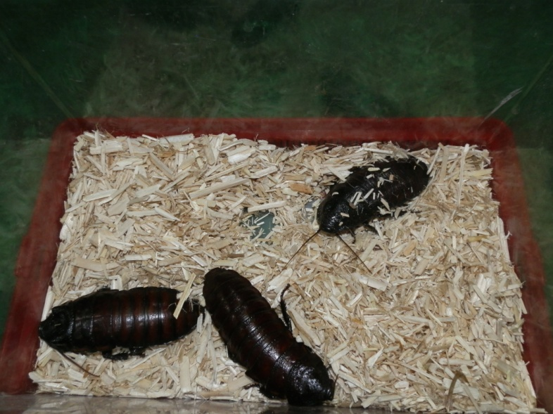
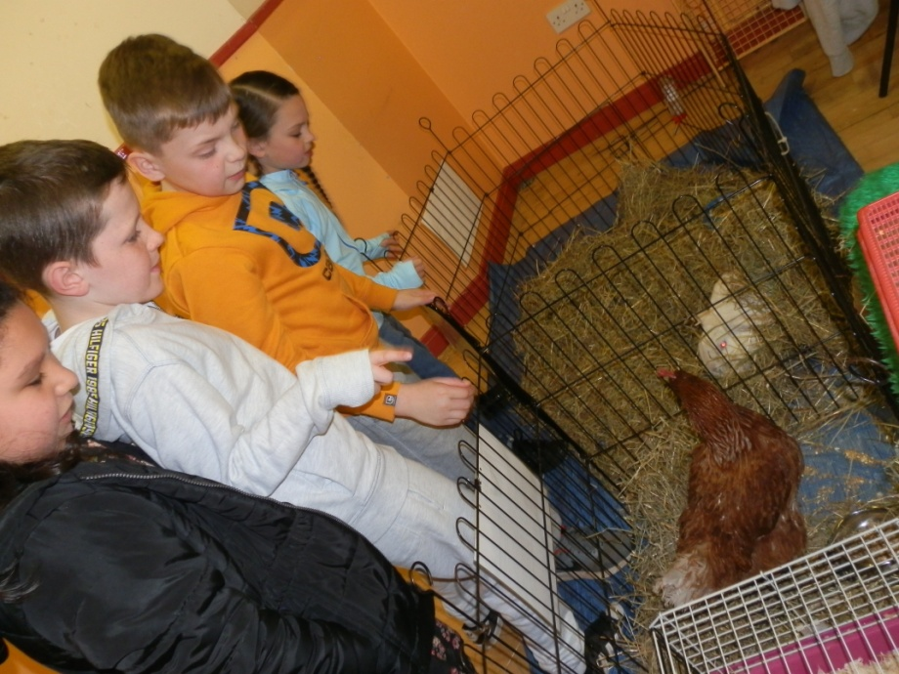
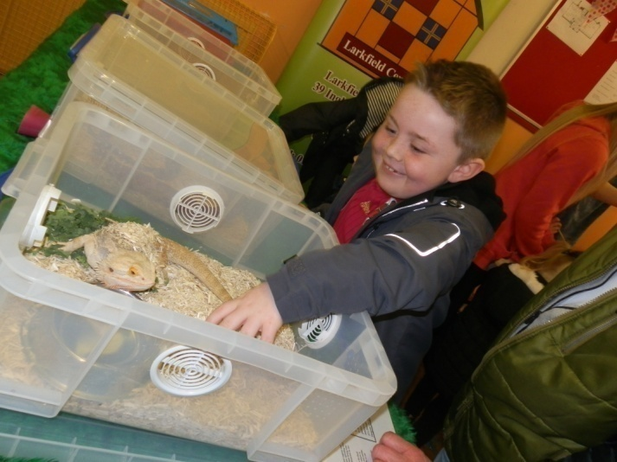

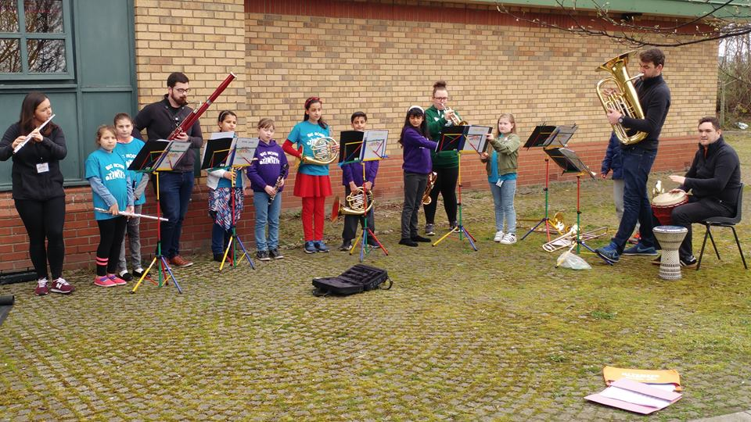
On the left are some children from the ‘Big Noise’ Project who came along to entertain the community on the day. Big thank-you for your support , it’s appreciated.
Events 2016/2017 Continued

Easter Continued
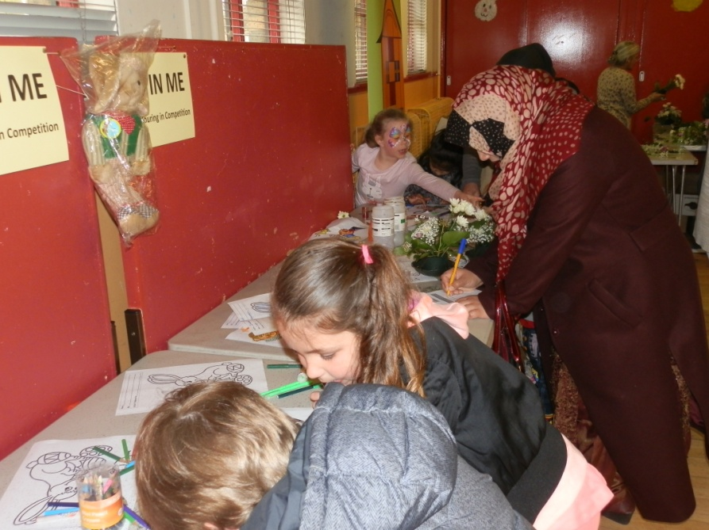

It’s all happening at the Easter Colouring in Competition table as an Easter Bunny was the prize.
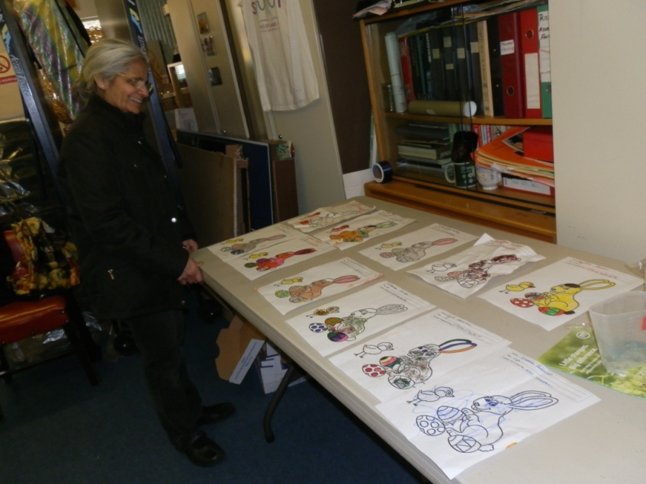
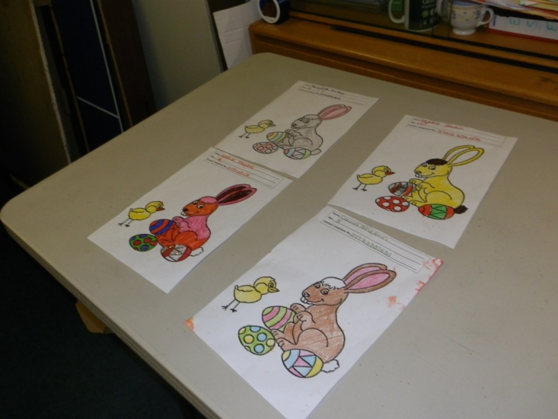
Our volunteer Kumkum agreed to select the winner of the Colouring in Competition. The picture on the right sows her having selected them down to 11 then the next picture it’s down to 4

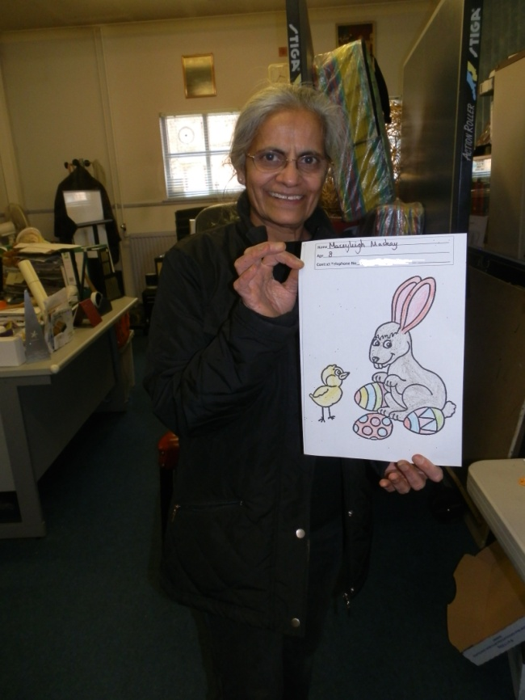

And the Winner is:
Maceyleigh Mackay Aged 8yrs

Events 2016/2017 Continued
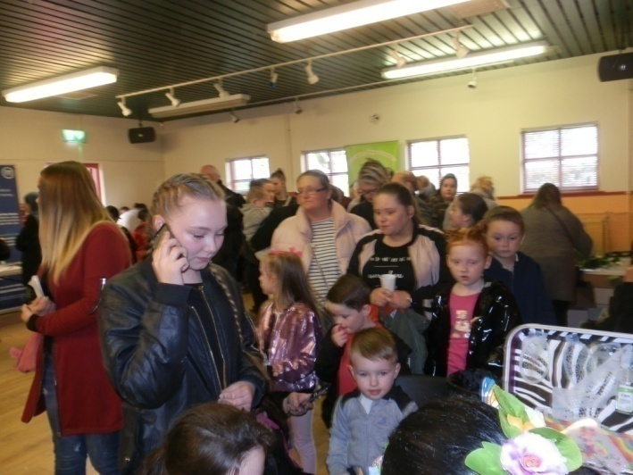
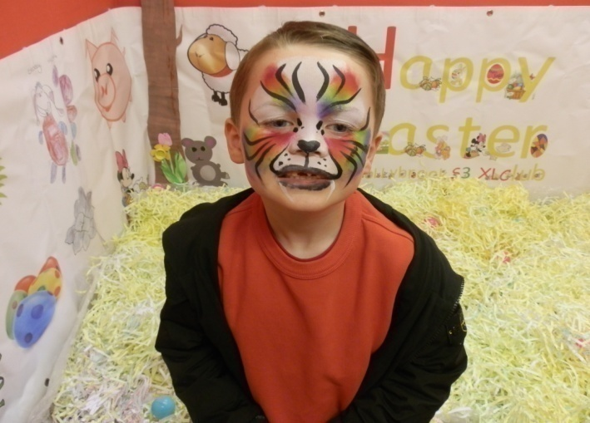
Easter

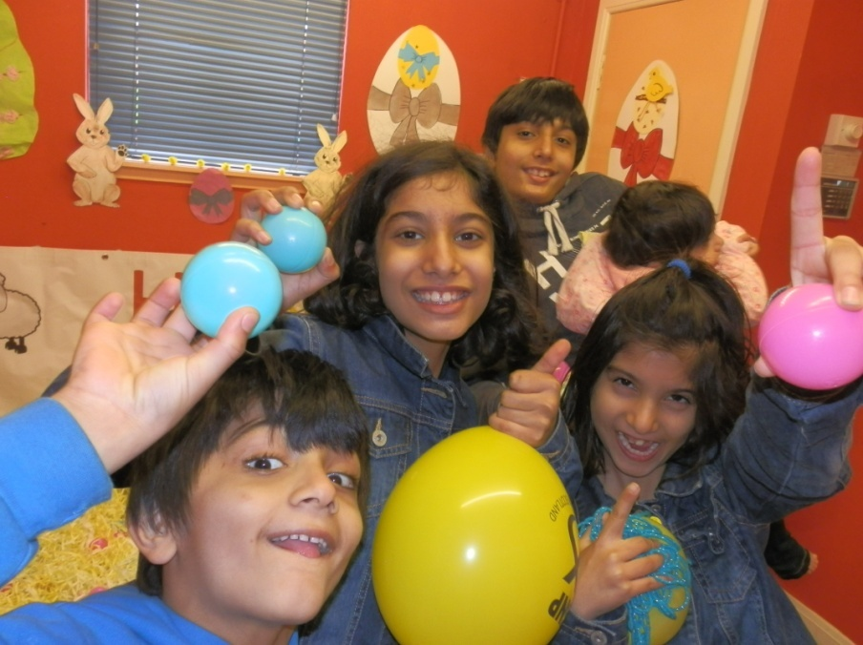
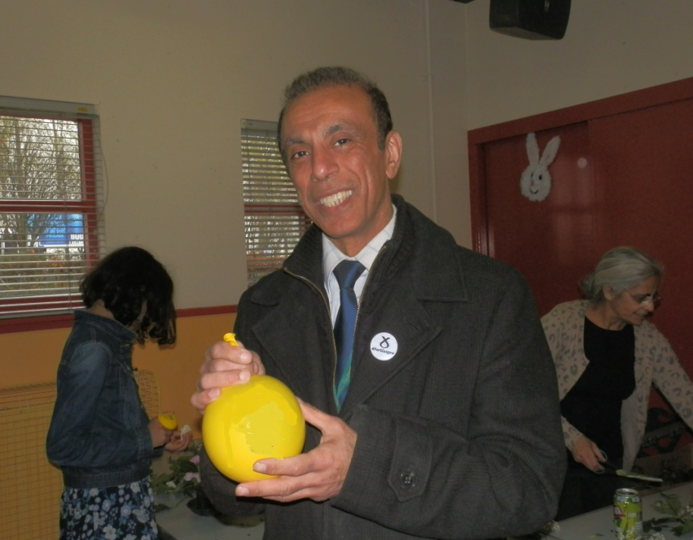
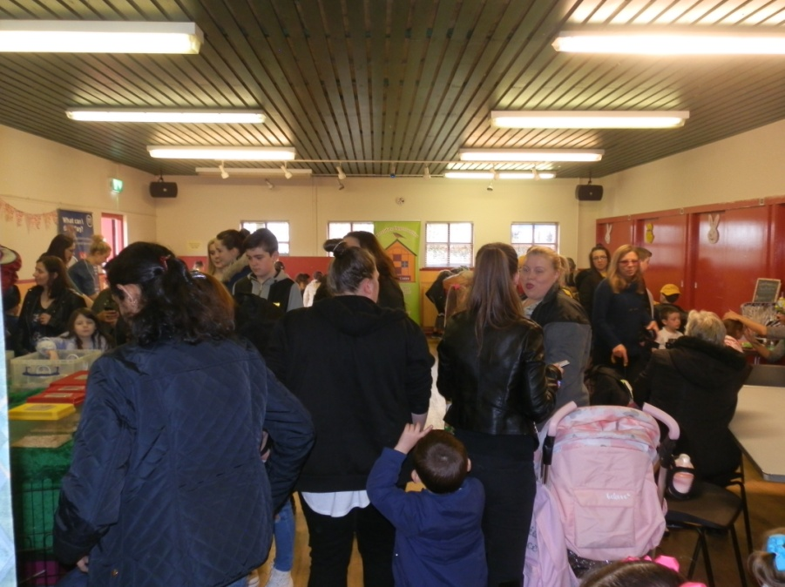
Pictured on the left is Cllr Jahangir Hanif who supported the centres Events during his term in office and this was one of his last duties as a Glasgow City Councillor as he stepped down from politics in May 2017.
