Events 2016/2017 Continued
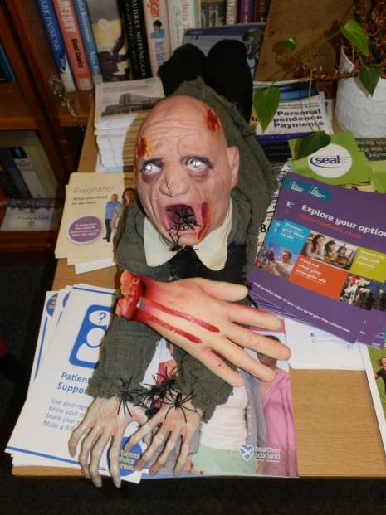
Halloween - Schools Event

This was a busy event this year with 86 pupils and staff attending. We are delighted with the response from the schools for this event and makes it worthwhile doing. The pictures will give you a flavour of the event that our writers group perform at.
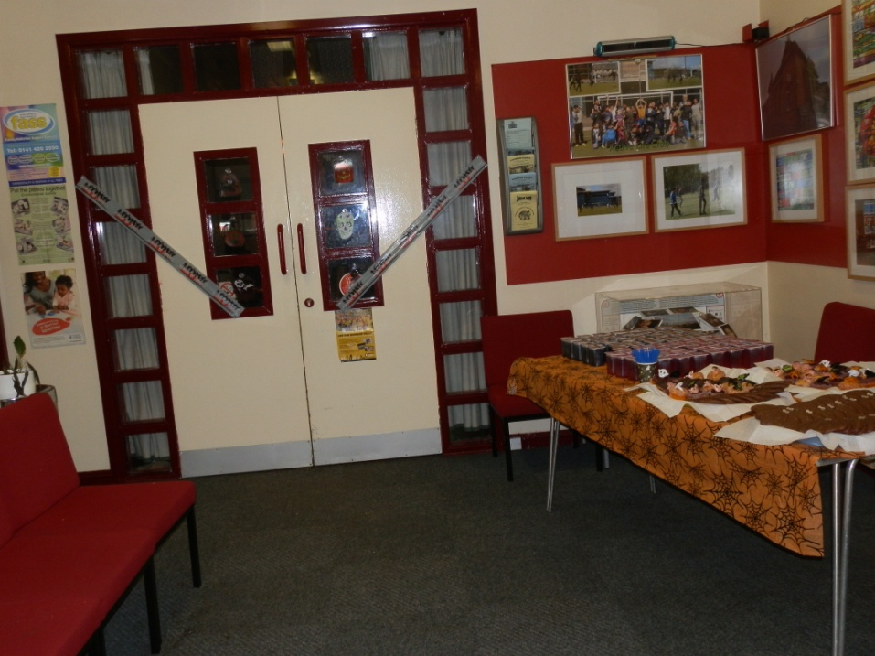

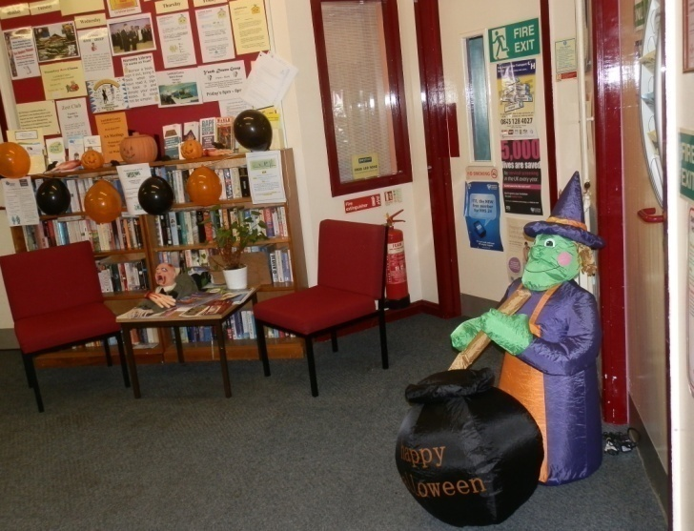

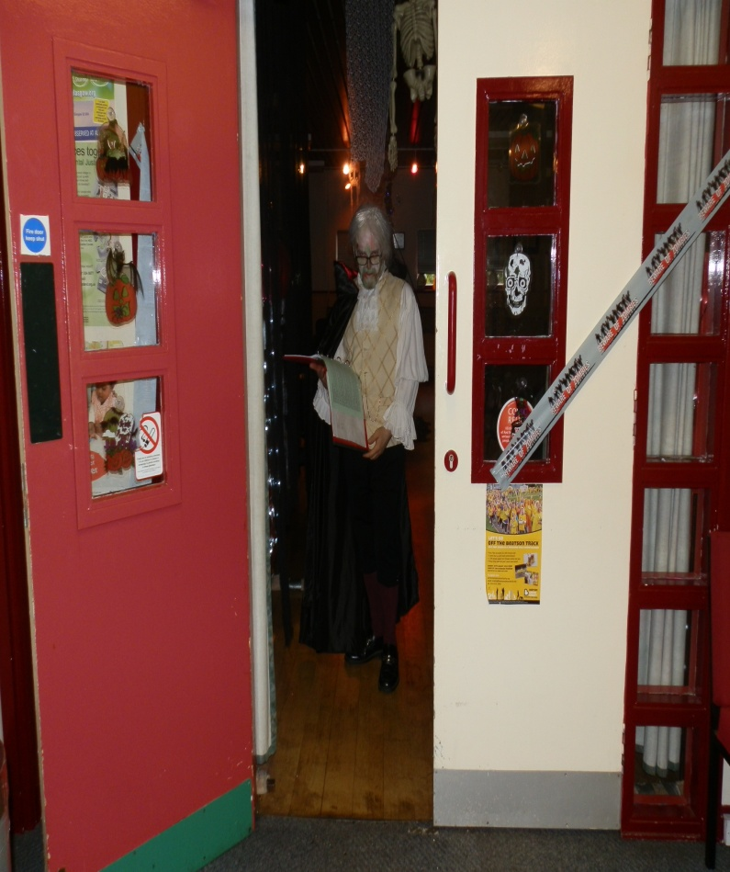
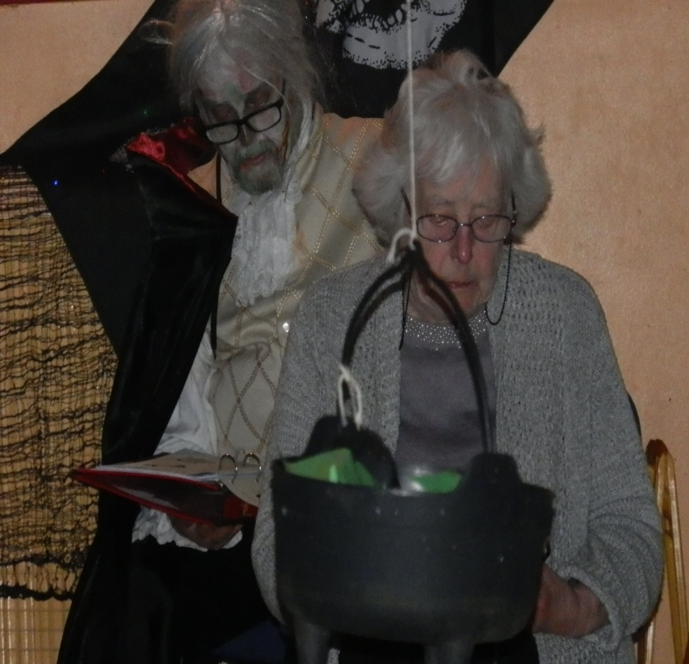

Events 2016/2017 Continued

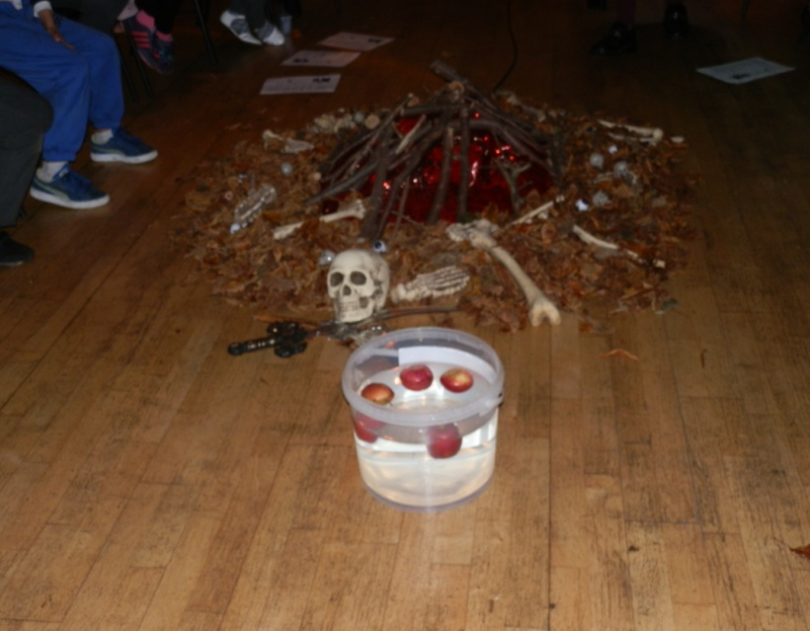
Halloween - Schools Event - Continued
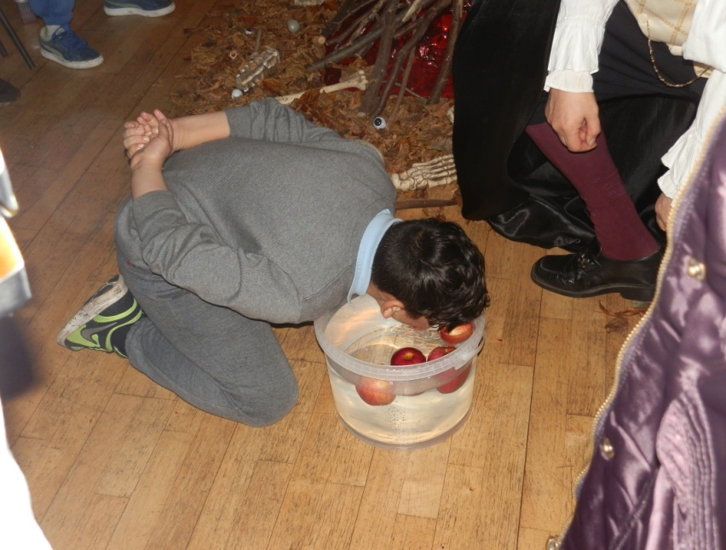
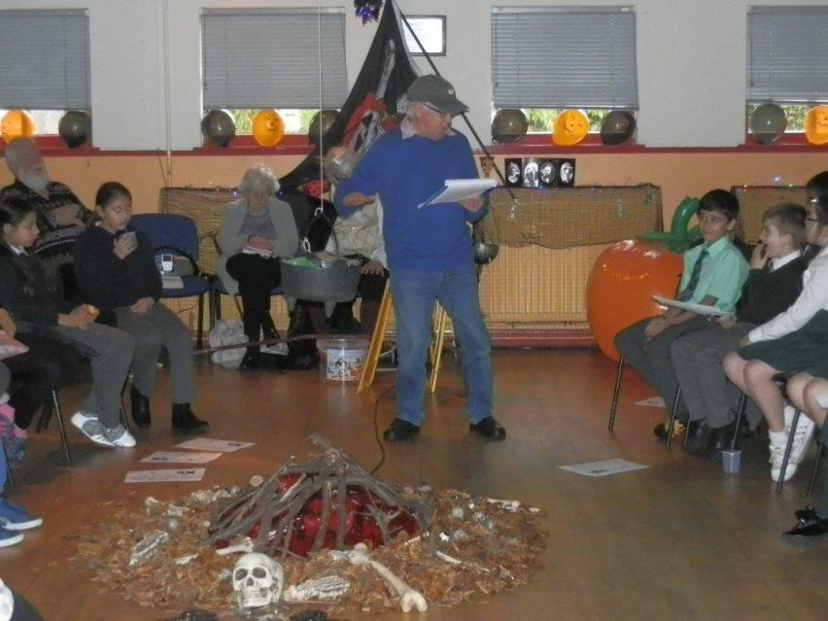

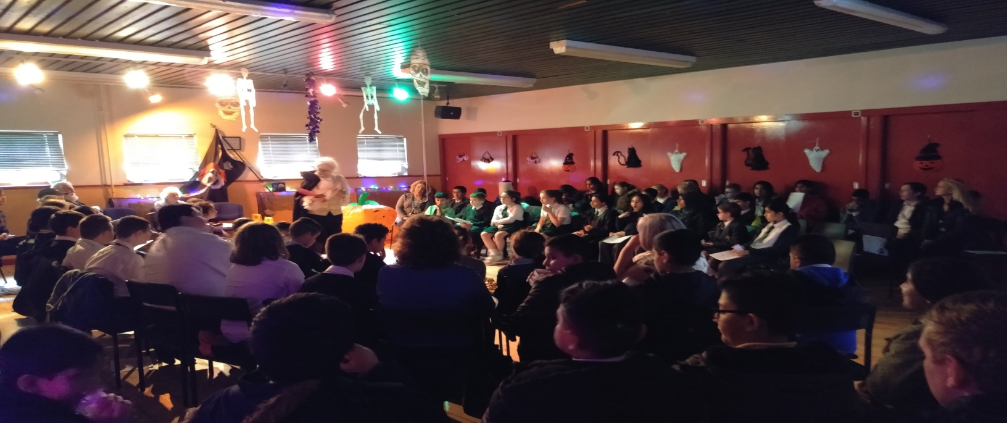

Events 2016/2017 Continued

Halloween - Schools Event - Continued

On the way out each child received a goody bag to take home and enjoy!
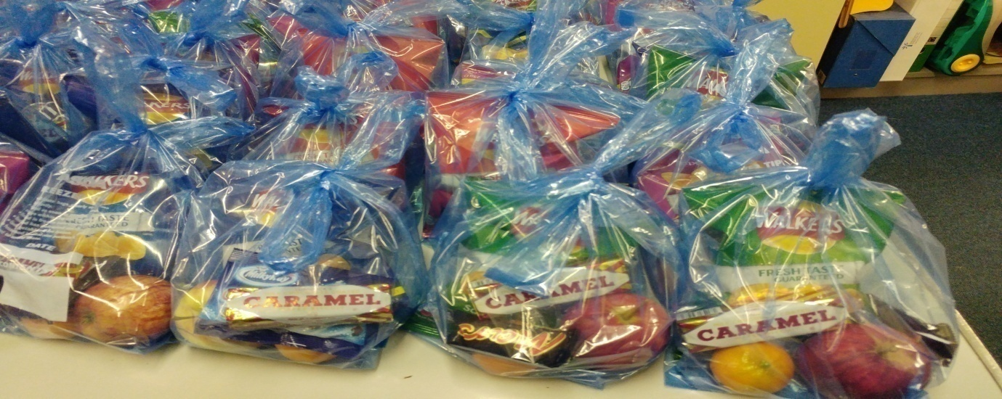
We would like to thank our Sponsors for this event, Greggs and Tunnocks for their kind donations which were greatly received by the children and young people.

Writers Group Halloween Night
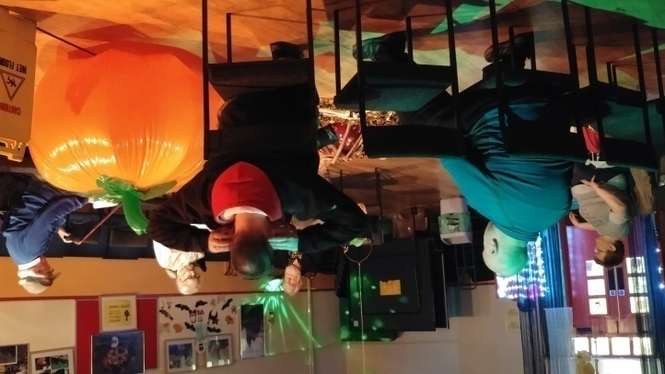
The writers group held a night to exchange tales of Halloween and to unwind from entertaining the children, young people and teachers who attended the Schools Halloween Event. The night went well and there was lots of food and good old scary tales being told around the camp fire. Pictured on the right are some of the early birds who arrived in plenty time to get a good seat at the fire.

and had asked if they could have a Halloween party all of their own and the pictures below are testimony that they had a really good time at the party.
Events 2016/2017 Continued

Remembrance Event
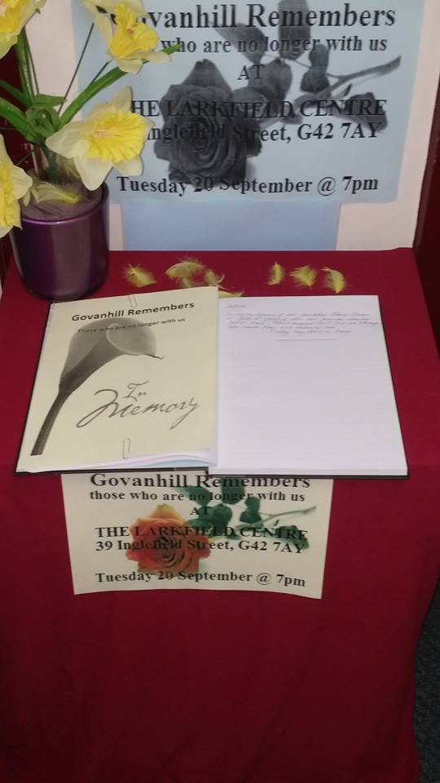
The centre held its annual Remembrance Event sadly it wasn’t as busy as it has been in the past. But there was comfort for the community who turned out on the night as the event enabled a young couple to say goodbye to someone they cared deeply for and it made it worth all worthwhile.

The book of remembrance was open for three weeks so people could drop in and leave a message to remember those they had lost.
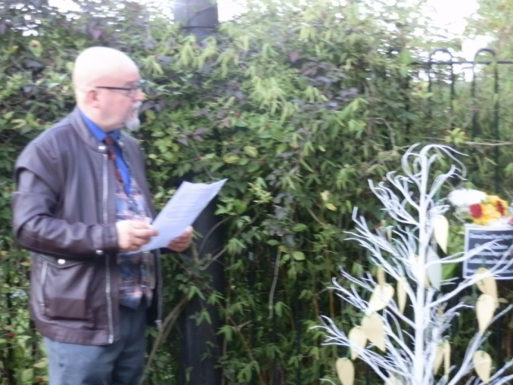
On the night the Centre's Chairperson said some comforting words and balloons were released and those who attended took time to remember those they had loved and lost over the years.
