Christmas – Hollybrook Academy Seniors Christmas Disco

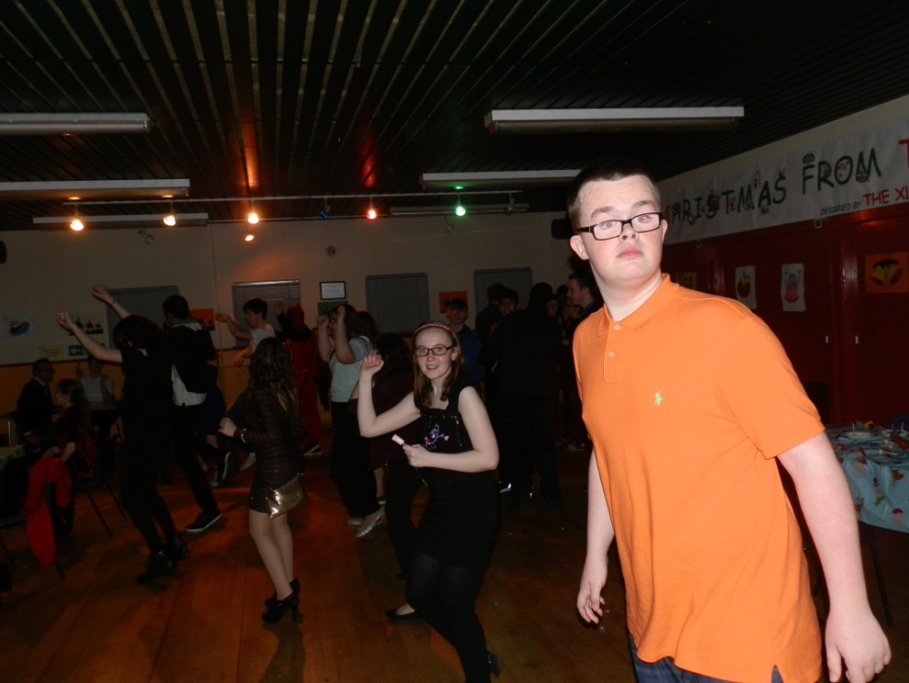
Hollybrook Academy have been holding their Christmas Disco at the centre for a couple of years now and its always a highlight for the pupils who do dinner before going to the disco so it’s all very grown up. They then dance the night away....

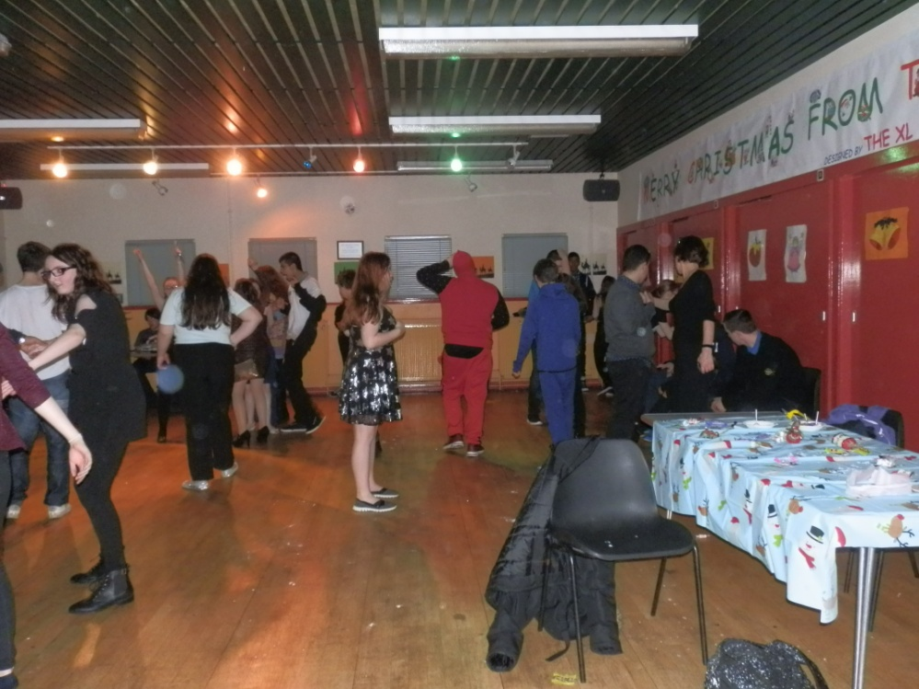

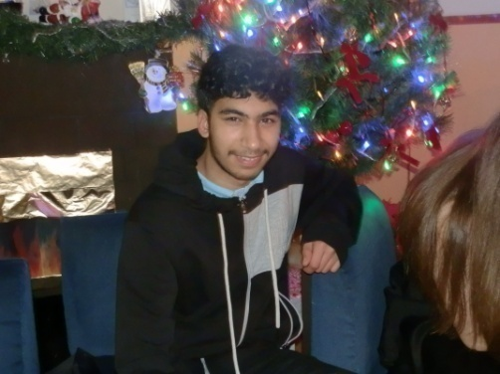

Zero Waste Workshop

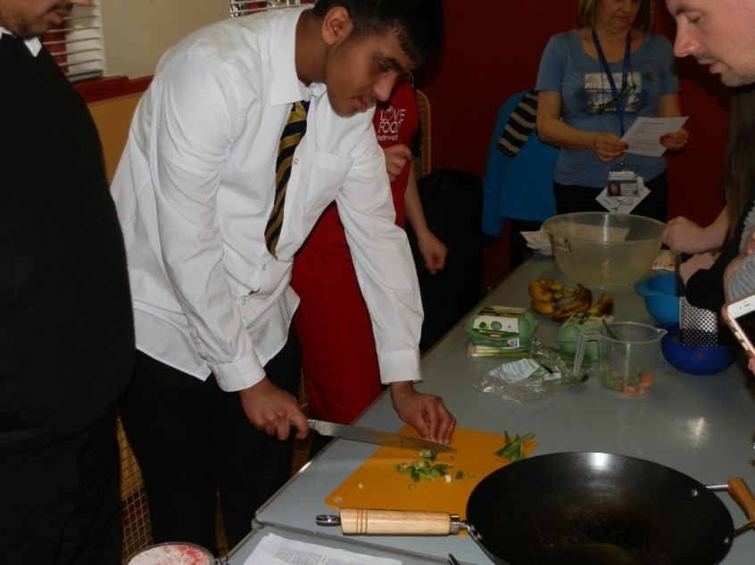
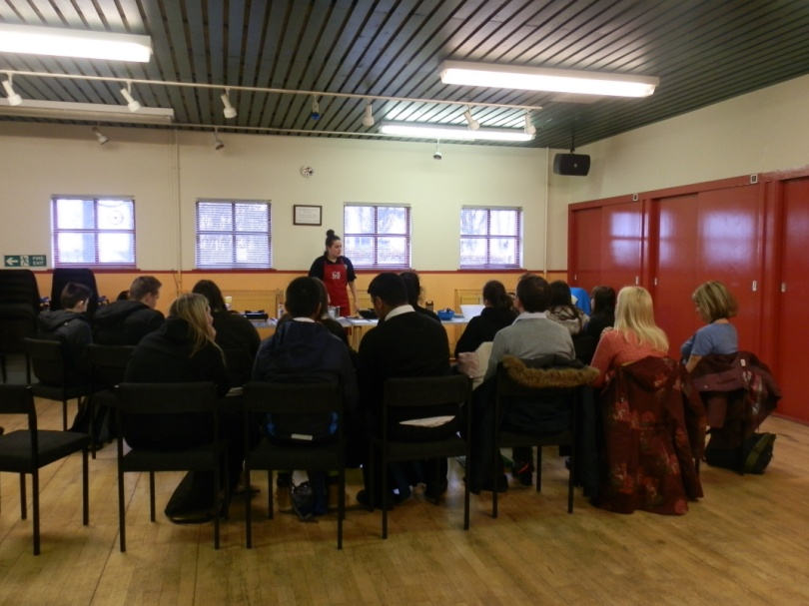
We worked with Zero Waste and Hollybrook Academy Secondary school this year and the pupils learned how to make pancakes and also about recycling which they learned lots from and thoroughly enjoyed the workshop.
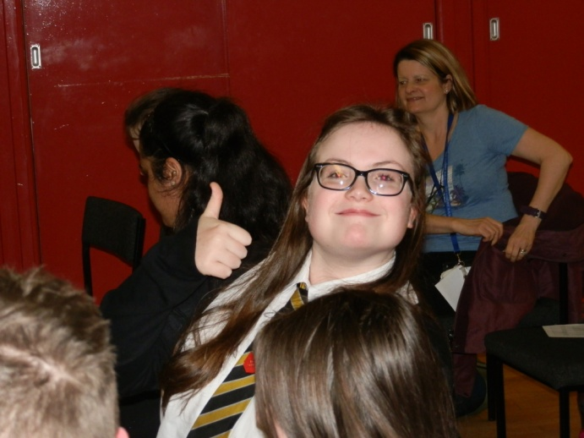
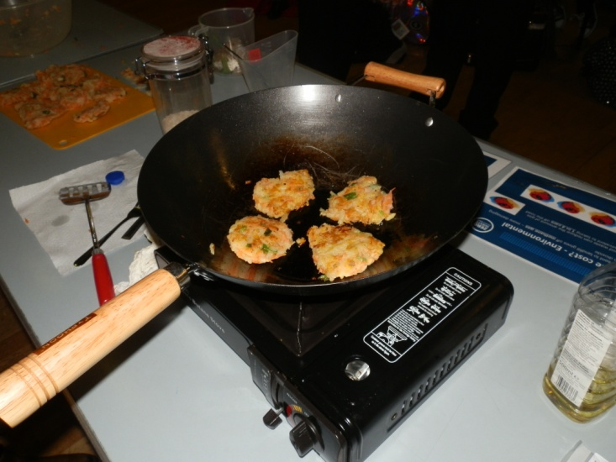
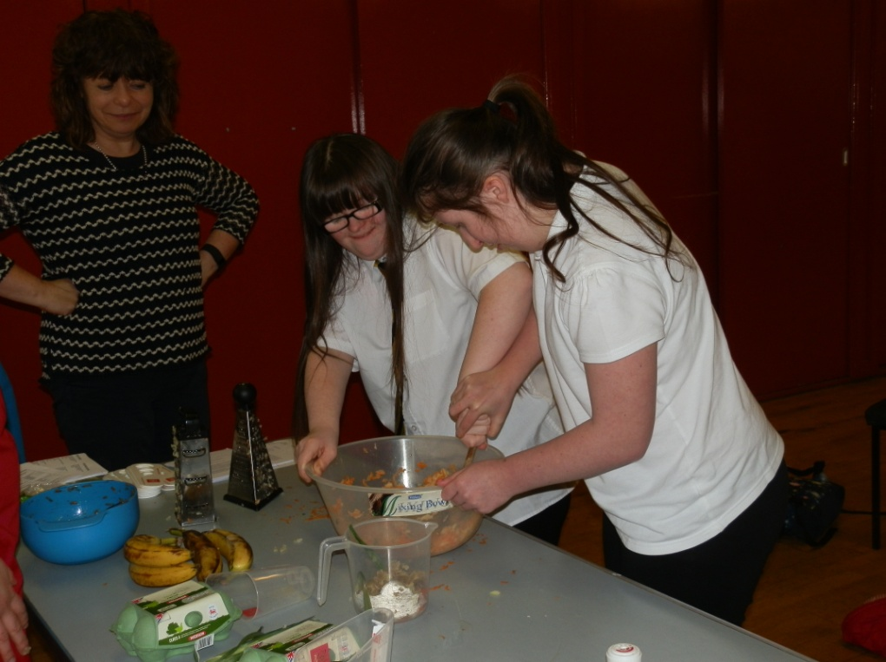
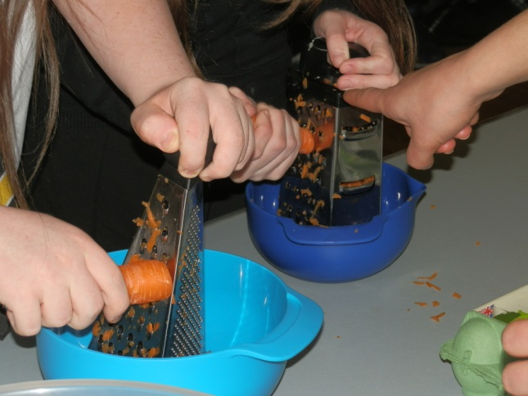

The Larkfield Centre Management Committee would like to take this opportunity to thanks those who funded the centre during the financial year 2016/2017 and also those who worked in partnership with us.

Funders/Donations
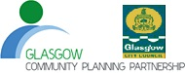

Glasgow City Council Integrated Grants

Comic Relief
SCOTMID

Fraser Foundation
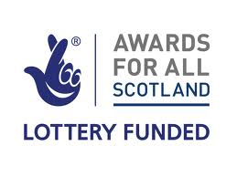

Awards for All

Foundation Scotland

James Weir Foundation
Southside Central Area Partnership

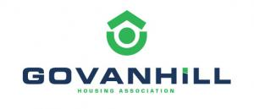

Govanhill Housing Association

Gregg’s Tunnock’s

Partners

GG&C NHS Health Improvement Team
Clyde College
Glasgow Life Communities
Glasgow Life Play Club
Govanhill Youth Project
Theatre Ecole
SEVSN
Active Life Club
Hollybrook Academy

