Centre Events Continued

Easter Event Continued
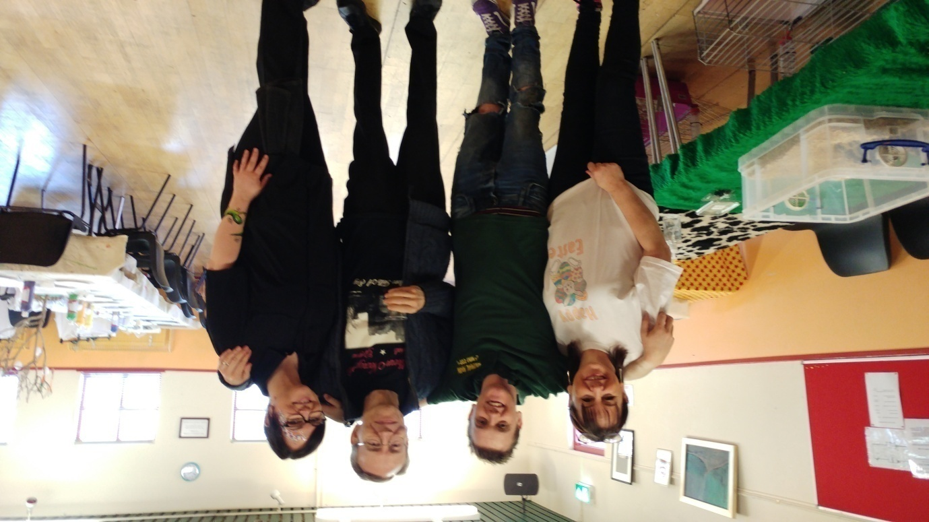
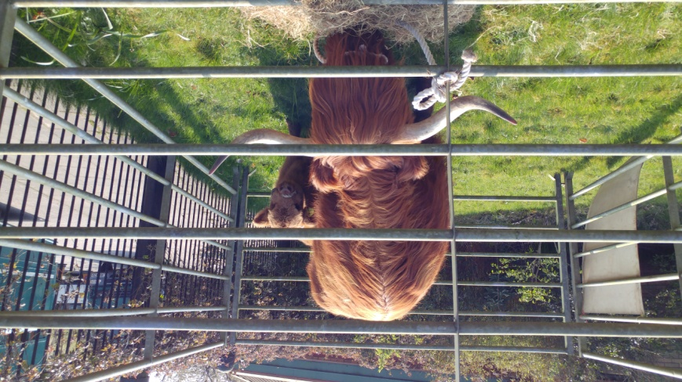
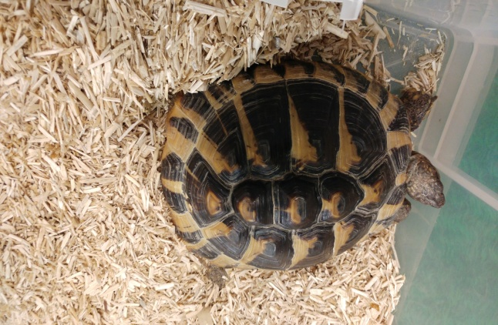
Pictured above L - R Carol-Anne Kennedy who did Textiles with the children/young people, Animal Man who kept the children entertained with a wide variety of small farmyard animals, Colin Mackie from Southern Necropolis Group who provided fun things to do and gave out information about the history of the Southern Necropolis and who famous is buried there and it's just over the bridge from the centre too and Laura from 'Let's face It' Face Painting Company who did works of art on the young people's faces.

On the right is a picture of Mum and calf----------------------
Centre Events Continued

Easter Event Continued
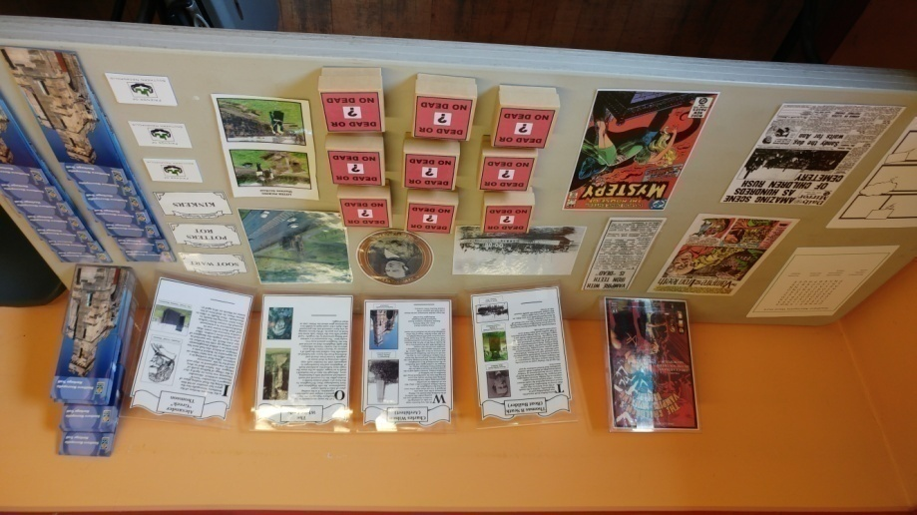

Pictured on the left is the table full of information and things to do at the Southern necropolis Cemetery by appointment contacting Colin Mackie.

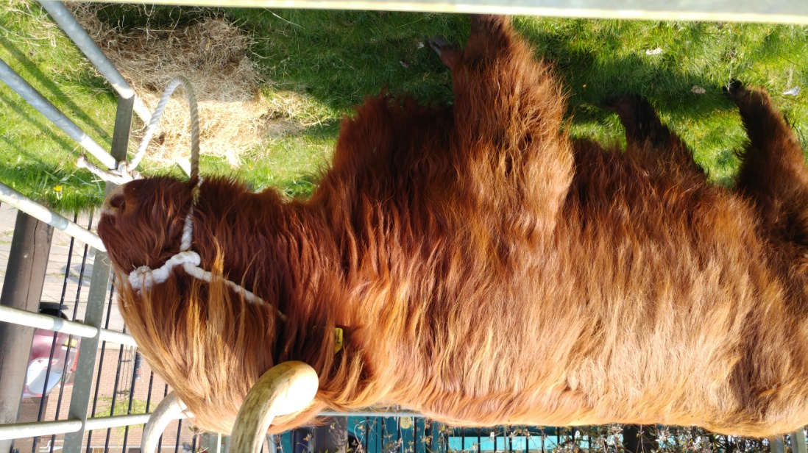
Pictured below is one of the main attractions the Highland cattle from Pollok Park

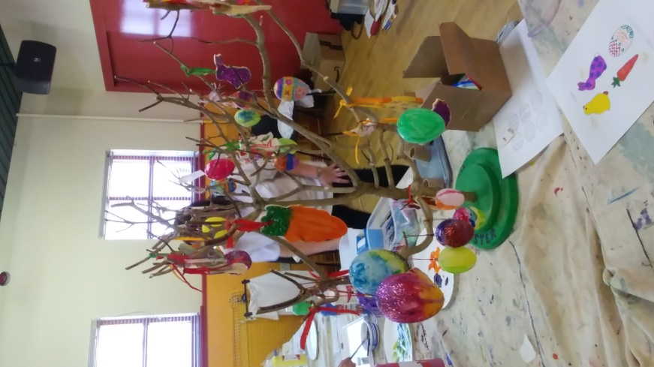
Left is a picture of the Easter decorations made by the children/young people.

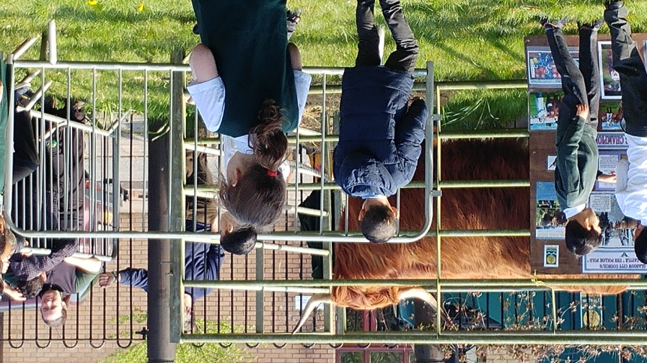

Centre Events Continued
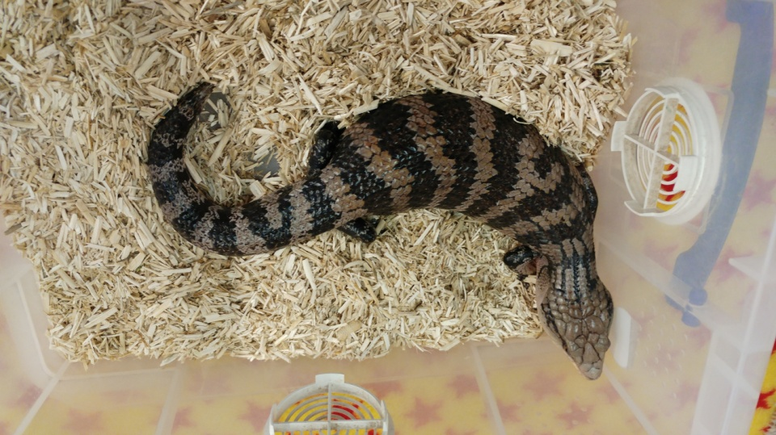
Easter Event Continued

Pictured below is the Animal Man having a
makeover for the Easter Event

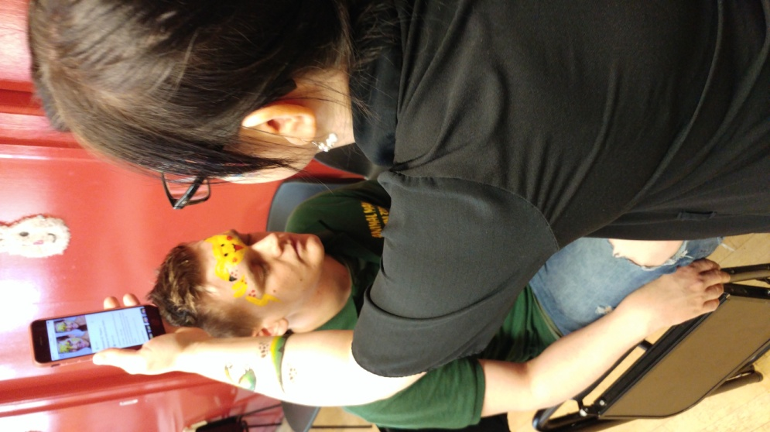

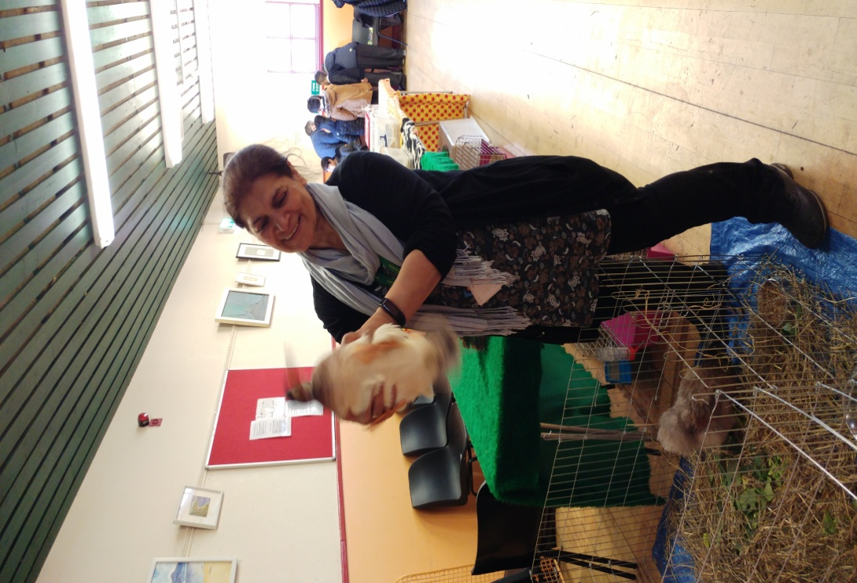

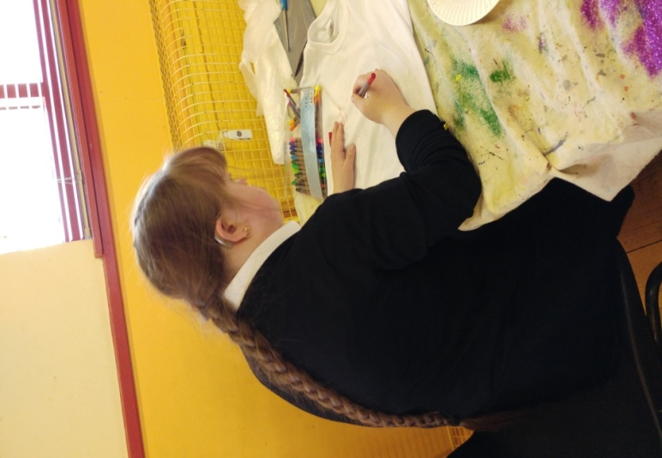

Centre Events Continued

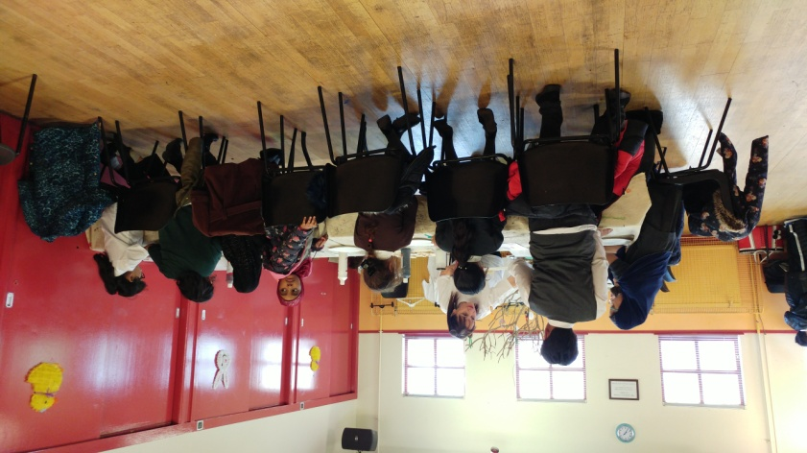
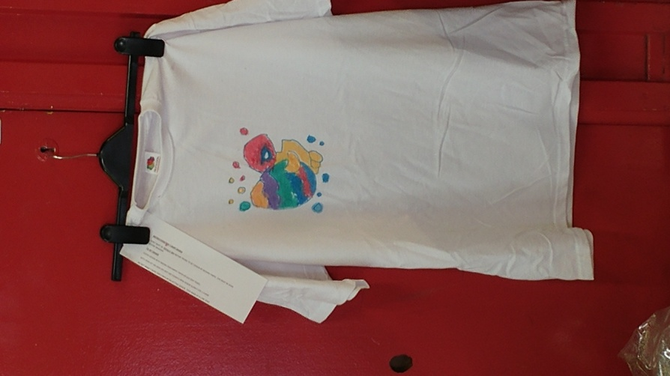
Easter Event Continued
