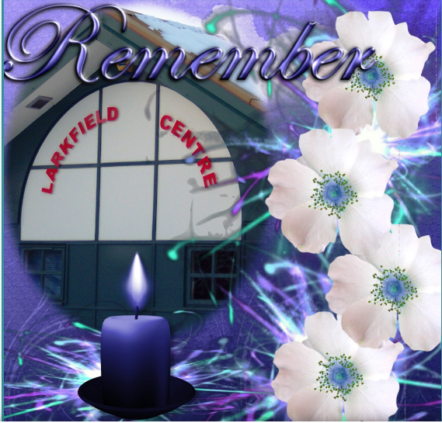
Events Continued

Remembrance Event

This event is held in memory of people that Govanhill has lost over the years with some of them having either worked at the centre or were part of its management committee or attended groups/events even functions at the centre. It's a way of saying we will never forget them and they will be remembered.....
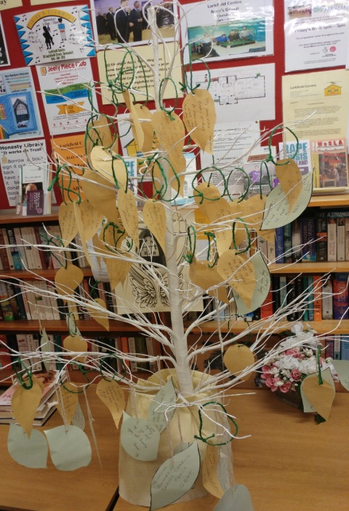

The event is lead by the Centre's Chairperson Marc Sherland who is a Writer and Poet who has created spoken words to be used at this Annual Event. We also have a Book of Remembrance book for people to sign with the names of those they have lost and a name tree to put a leave on with the name/s of those we have lost and you can also light a candle to keep their memory alive on the night.

Sadly during this year we had to say farewell to our former Chairperson Joseph Cairns who remained part of the centre until he went into hospital where he passed away about two weeks later. He has left a huge void but from a far will support us through it.
Rest in Peace Joe, you were one in a million!
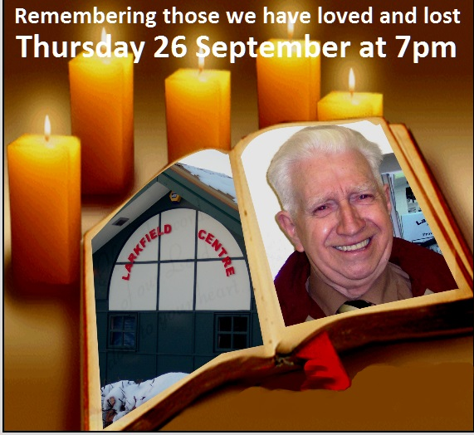
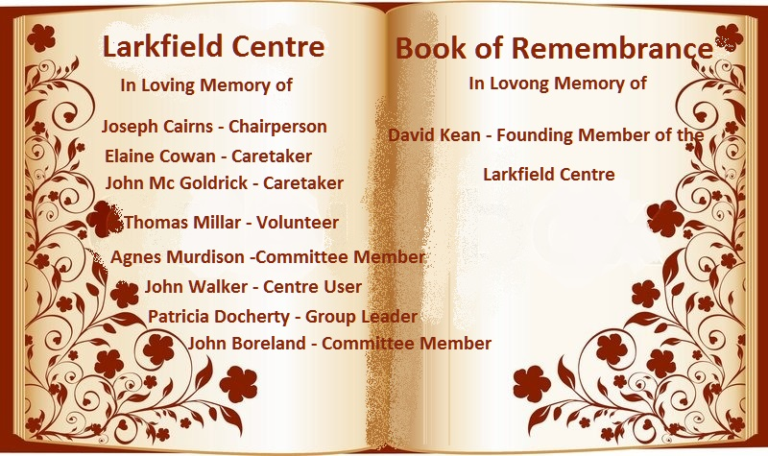

Events Continued

Marie Curie

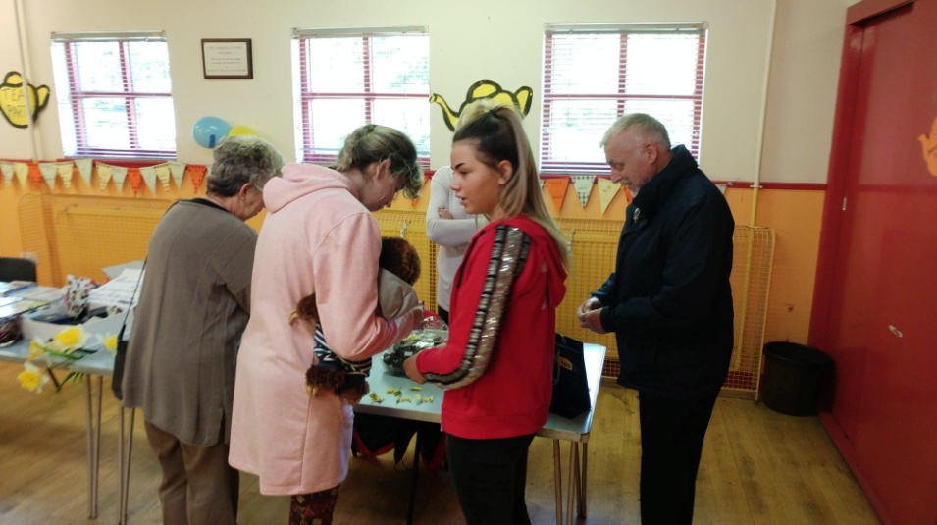
Each year we hold an event to raise funds for Marie Curie as cancer has touched the lives of many of our centre members, centre users and friends over the years and it's a way to pay respects to those who help them through difficult times.

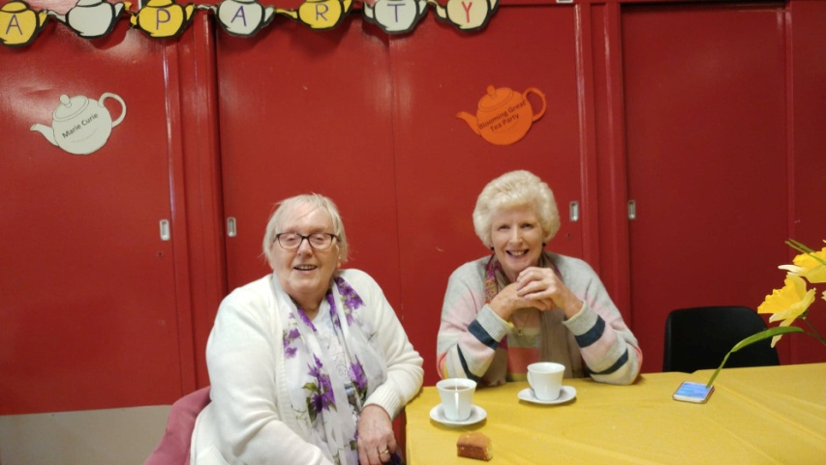
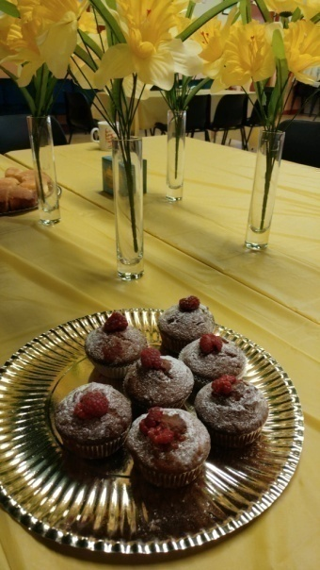
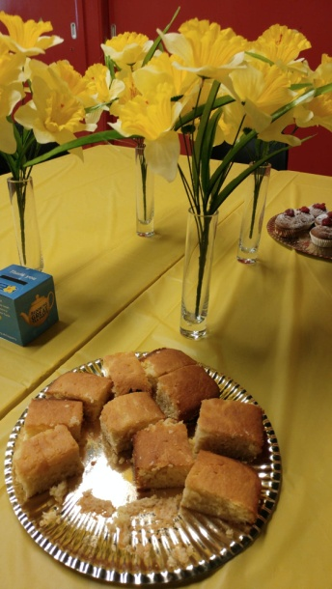

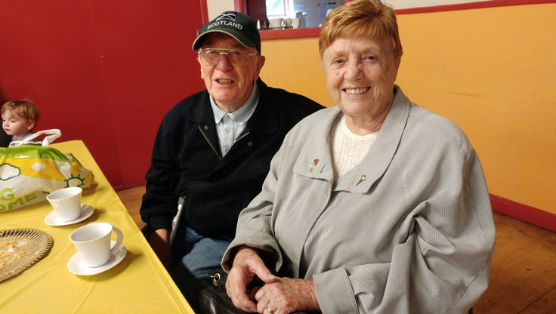
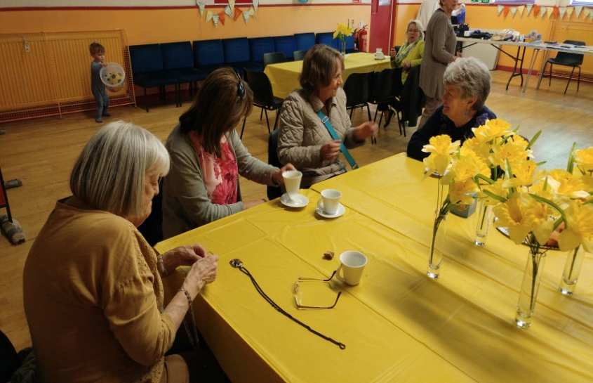

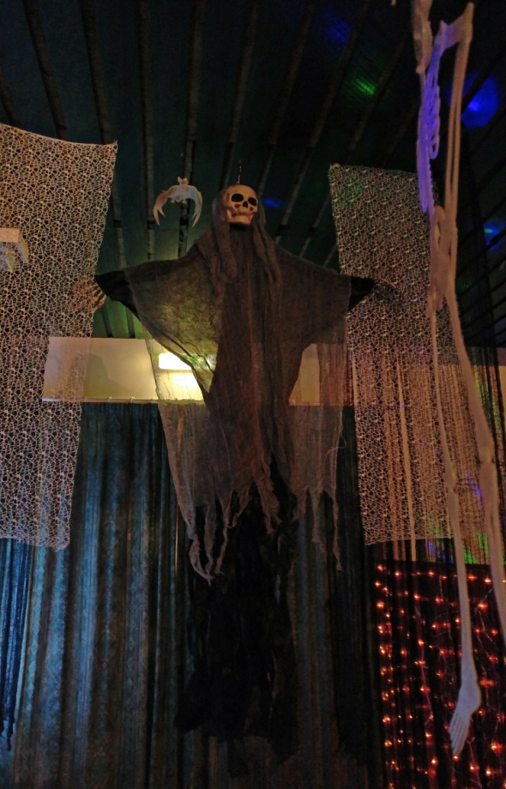
Events Continued

Halloween Event

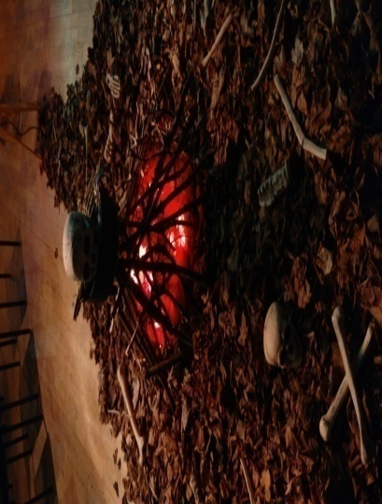
Each year we invite along to the Halloween Event the four local primary schools and the Assisted Learning Needs Secondary School. They are advised beforehand that they can learn a poem or a tell a scary tale or even a joke if they like. This event lets children and young people know that the spoken word can be fun!

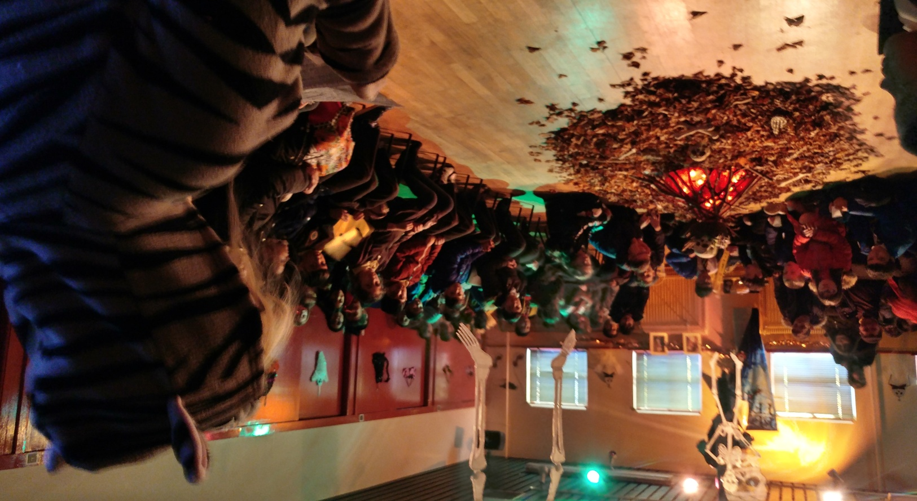

Events Continued

Halloween Event Continued
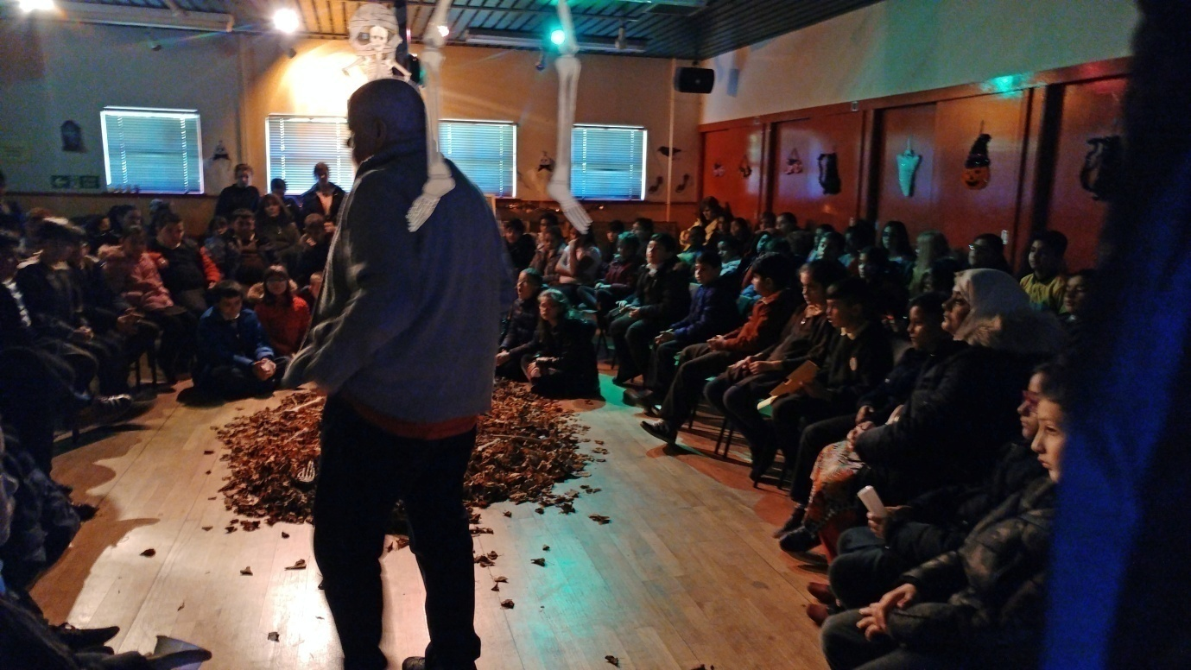
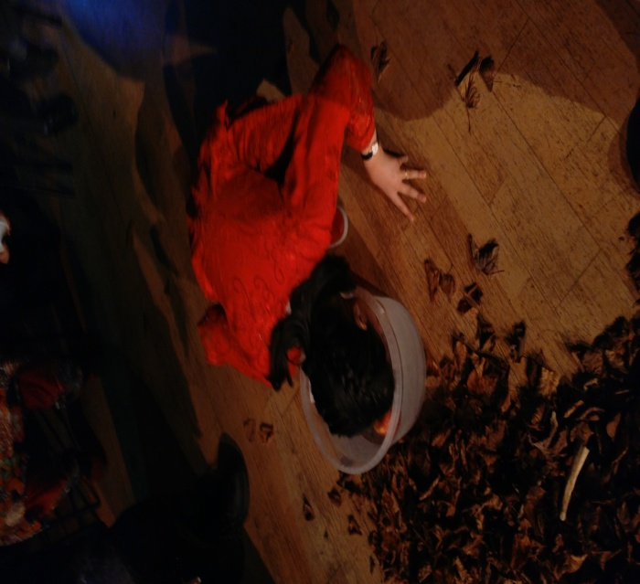
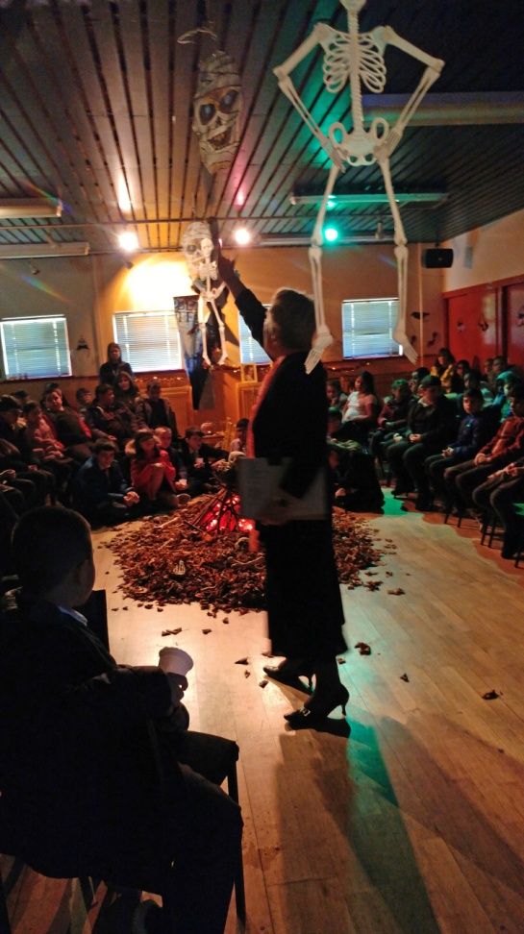

Events Continued

Halloween Event Continued

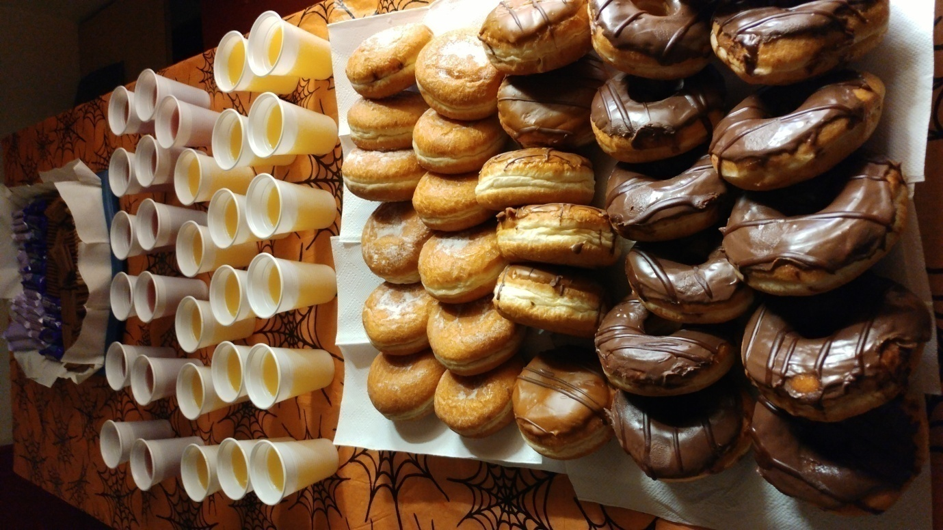
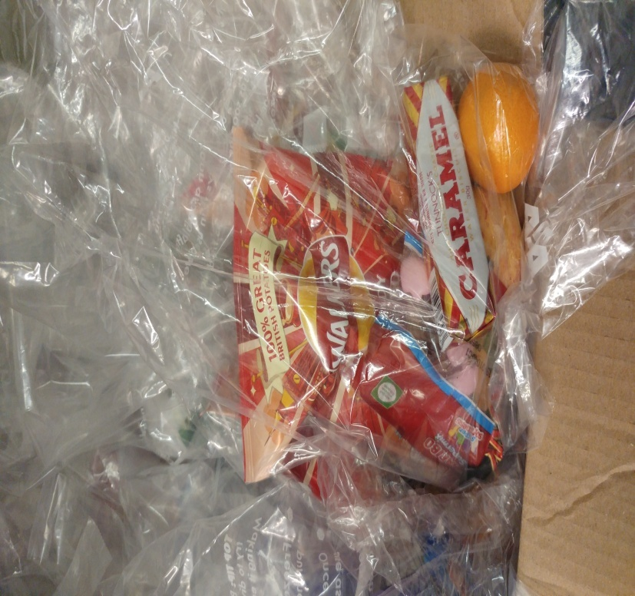

The event was sponsored by the following:

Greggs, Farmfoods and Tunnocks. A huge thank-you to them as without their support we wouldn't be able to offer as much as we do to the children/young people participating....

