Events Continued

Christmas

Christmas Lights Switch-on

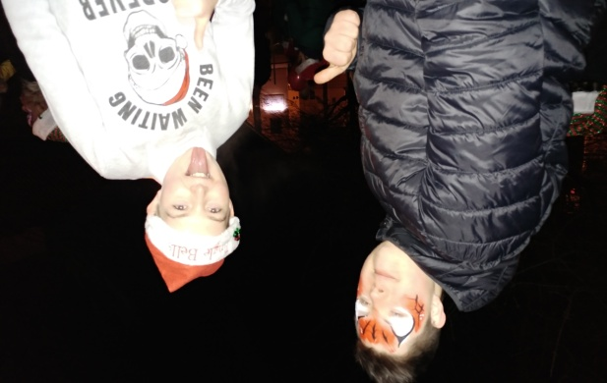
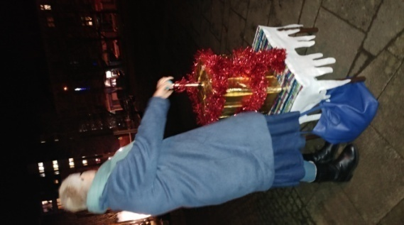
This is the first of our Christmas events that brings the community together to see the tree on the Millennium Square being lit up and to be entertained by Hollybrook Academy School Choir, while having a cup of tea and a mince pie. Pictured below you can see how it brightens up the lives of the community.

This year saw Councillor Mhairi Hunter switch the lights on bringing with it lots of smiles.

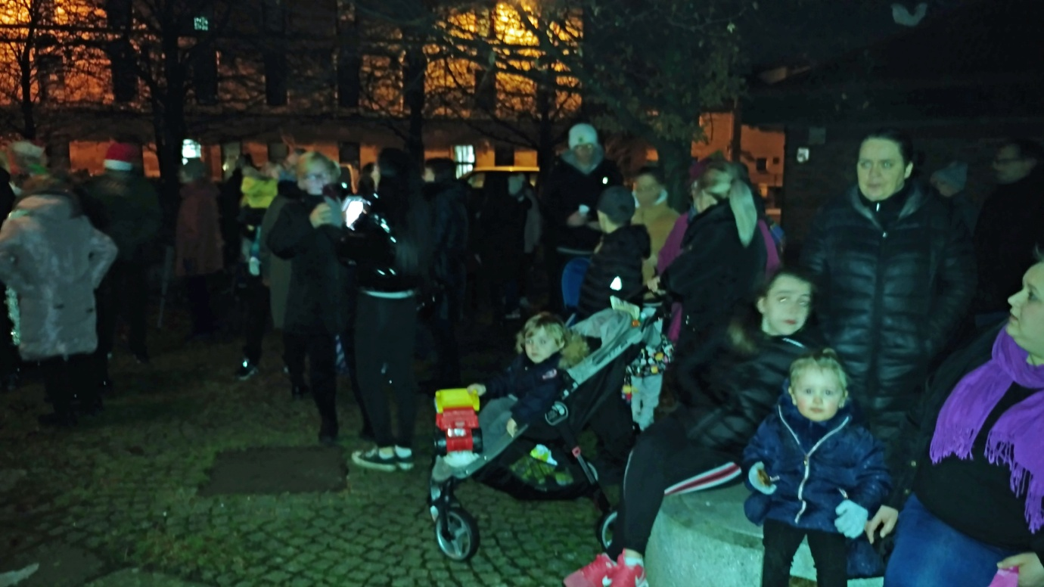
Events Continued

Christmas Continued

Christmas Lights Switch-on Continued
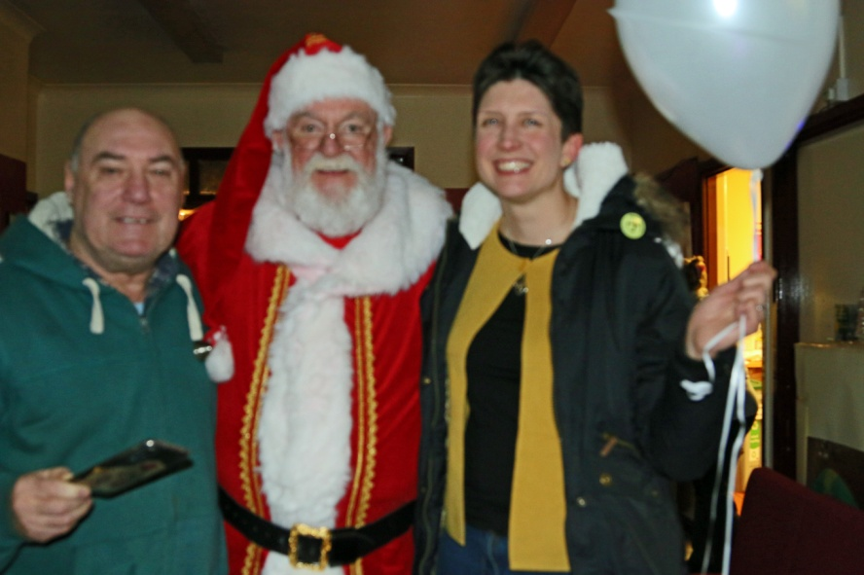
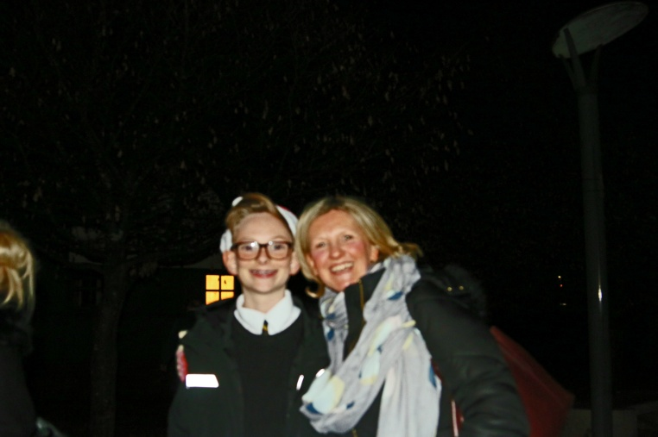
Pictured above is Head Teacher of Hollybrook Accademy and her son.

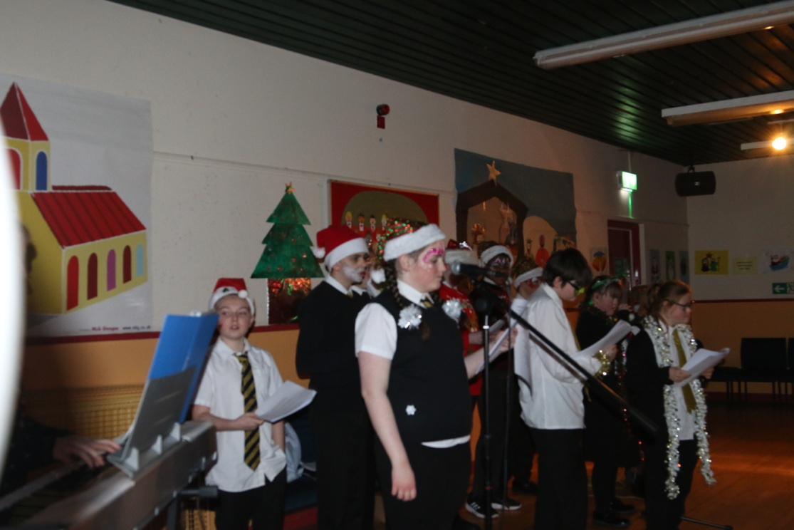
Local MP Alison Thewliss pictured on the left with caretaker James Cavanagh and Santa.

Pictured below is Elizabeth and Jane who made the coffee and teas, huge thanks to both of them.
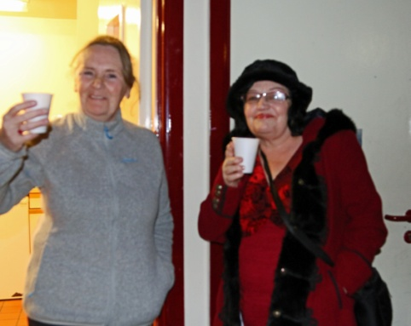

Events Continued

Christmas Continued

Pantomime

The pantomime sold out really quick this year as tickets went on sale mid November and by end of the month the tickets were sold out. It is a popular event as it gives local people the experience of the theatre at a greatly reduced cost. Below are some pictures taken on the nght!

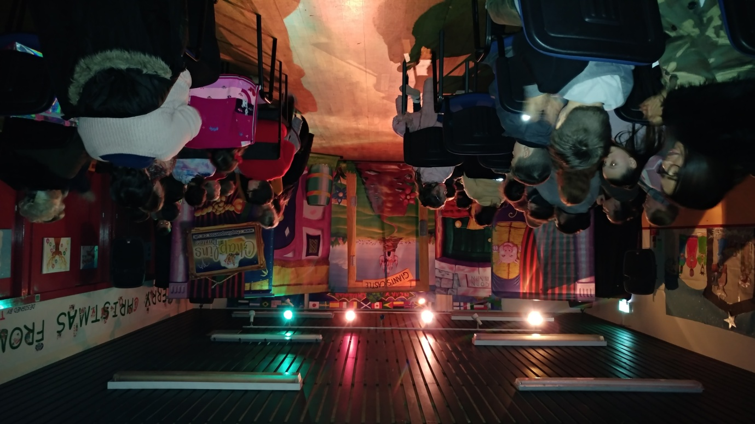
Waiting patiently on the show to start!
Oh no they're not, Oh yes they are!
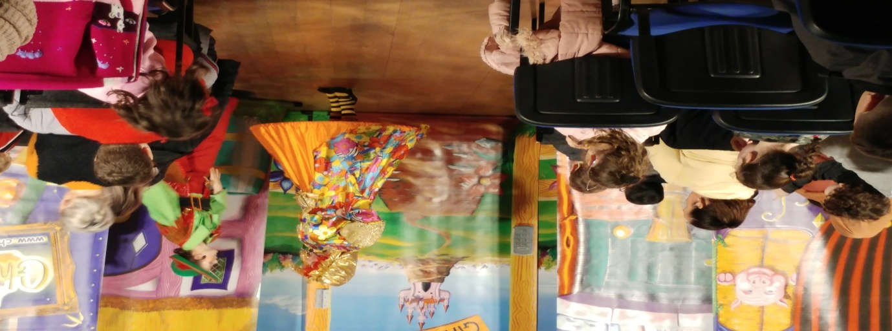

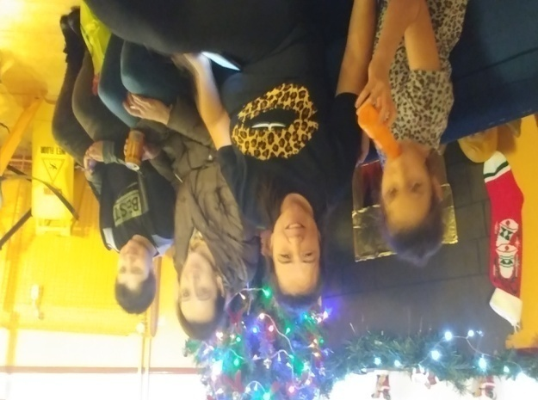
Events Continued

Christmas Continued

Pantomime Continued
