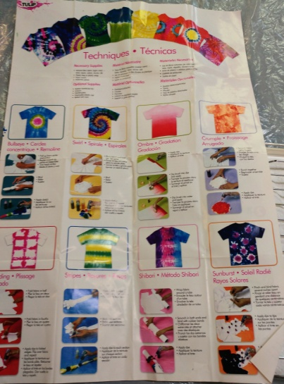
Hollybrook Academy

The centre worked in partnership with Hollybrook Academy which is a secondary school for young people with assisted learning needs and we were working towards an exhibition on Festivals around the world and to show off the new art skills the group had learned. Pictured are some of their work at the start of their learning journey through to the exhibition.
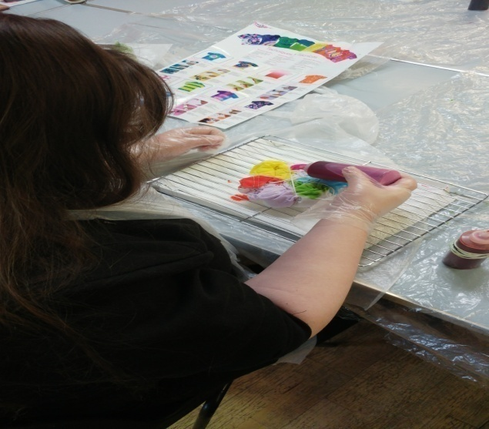
They learned about colour used in the various festivals and things of recognition. They also learned about dip dye and mono print.
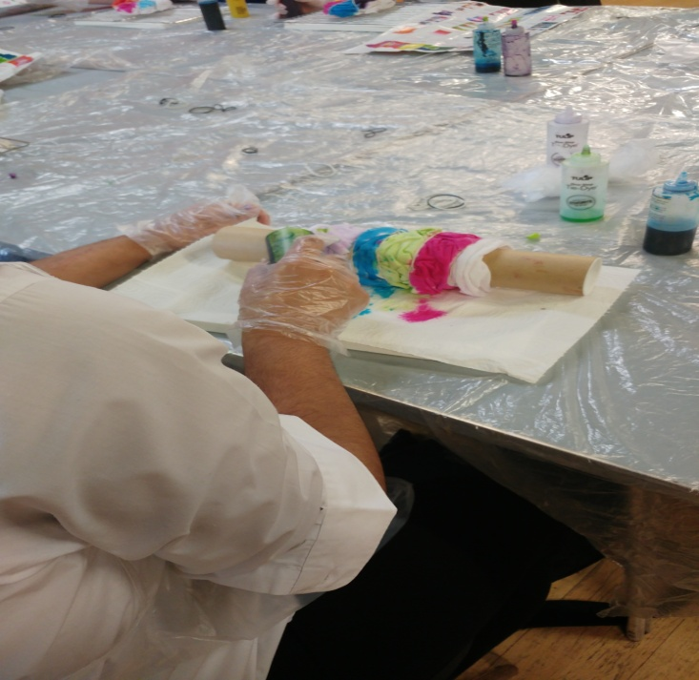

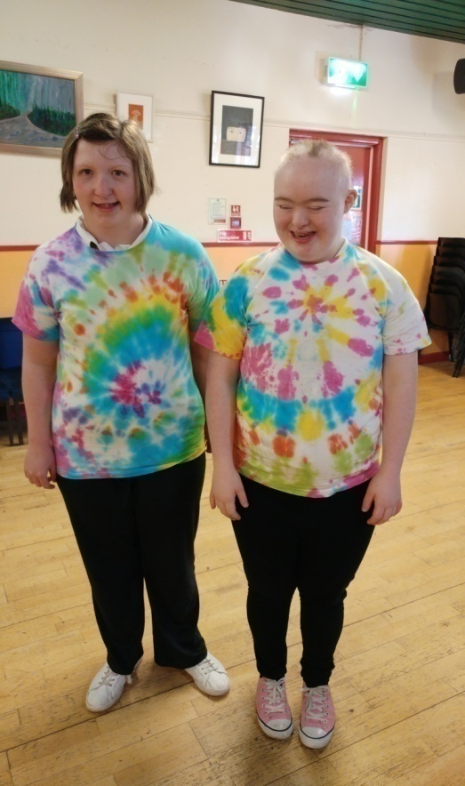

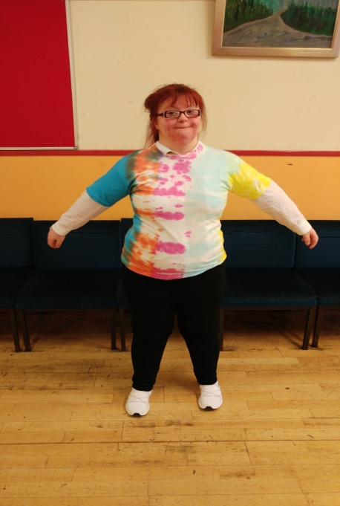

Hollybrook Academy Continued

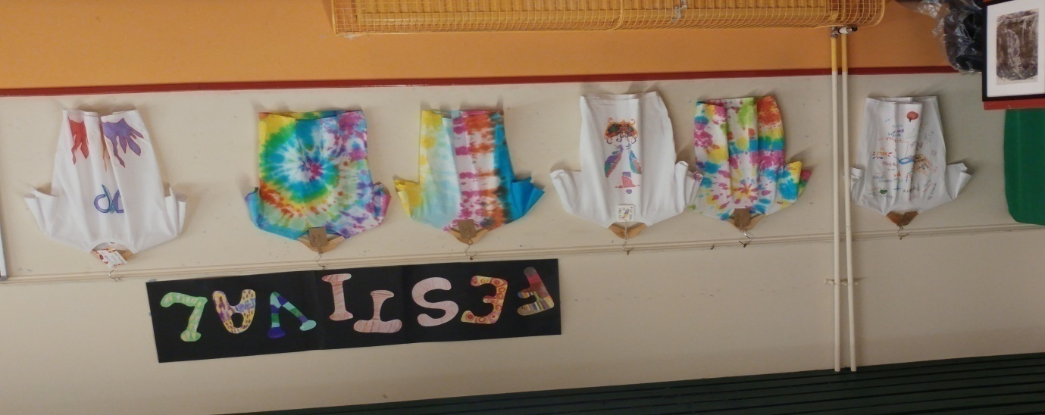
Below are pictures from the Exhibition which saw local Glasgow City Councillor, Mhairi Hunter attend and was really impressed by the quality of the work the young people had produced.
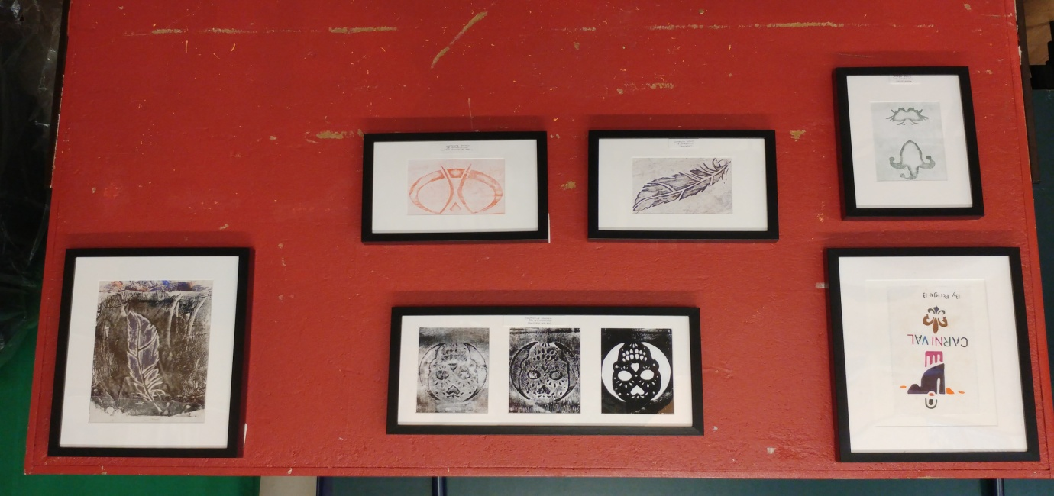
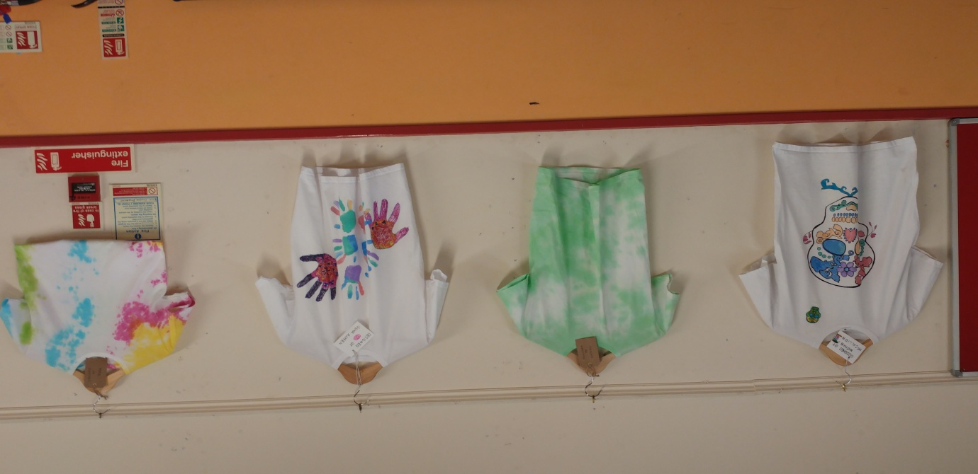

Hollybrook Academy Continued

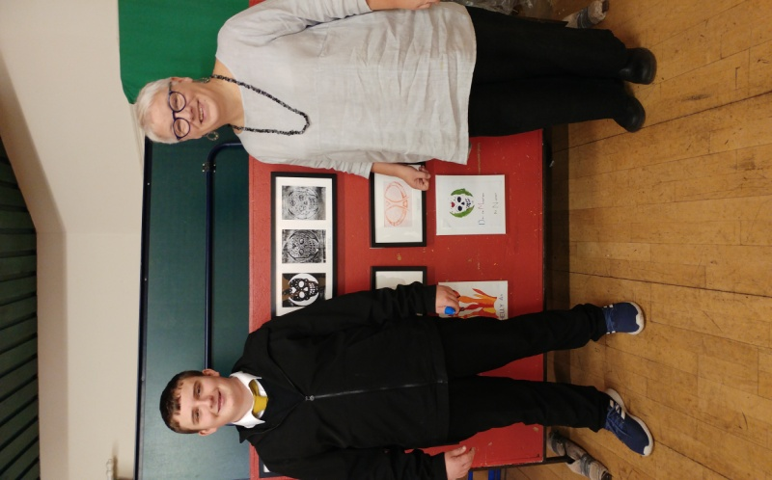
More pictures from the event!
Councillor Hunter is pictured with some of the young people...
