Thank - you to the following:

Glasgow City Council Integrated Grants Fund

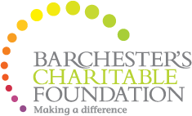

Barchester Foundation

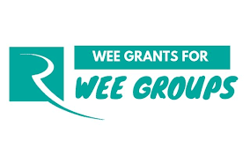

The Robertson Trust Wee Grants

Greggs for Donation to Halloween Event

Thank - you to the following Continued:

Tunncock's for Donation to Halloween Event

Farmfoods for Donation to Halloween event

Govanhill Housing Association - for Donation to Santa's Grotto

Please note: Sadly the centre closed its doors to classes/groups and the public on the 27 March 2020 due to the Covid-19 Pandemic as advised by the Government and look forward to welcoming the community back when it is safe to do so!

