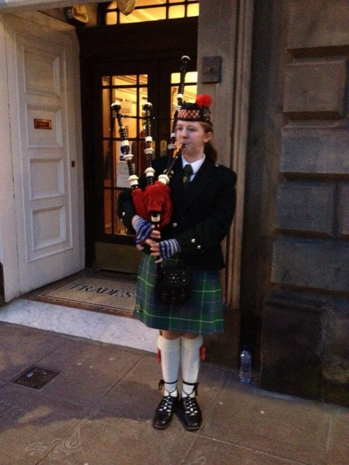
Group News Continued

Piping and Drumming

The piping and drumming group continues to meet on a Wednesday from 6.30pm – 7.30pm teaching young people how to play the chanter and progress onto the Bagpipes. It is one of the centre’s oldest running groups.

The young people learn how to read and play music and we have a dedicated group of young people who want to learn and progress to the pipes. Pictured is group member Ellie who has improved so much she has been asked to play the pipes at the Trades House in Glasgow.

Men’s Group

The men’s group continue to meet on a Thursday afternoon from 2pm – 4pm. They are always looking out for new members to come along and join them especially for a game of pool/snooker or chess.

Language Class (Arabic, عربى )

The Language class continues to be with 14 young people from around 6yrs – 16yrs of age attending Monday - Thursday’s. The young people enjoy learning together. They are very polite and a credit to their teacher and parents.

The group remains so popular that they continue to have a waiting list for a place in the class.

Group News Continued

Drama Group

Sadly the drama group lasted only a few months into the new financial year as numbers had dropped and partners couldn’t justify staff time.

Women's Group

The women’s group continue to meet in the centre on a Friday from 1pm-3pm. They have participated in cooking, aromatherapy; keep fit and stress management over the last year.

New members are always welcome and the kettle is always on for a cuppa after the exercise!

Below and on the next page are some pictures of the ladies enjoying themselves during the activities:
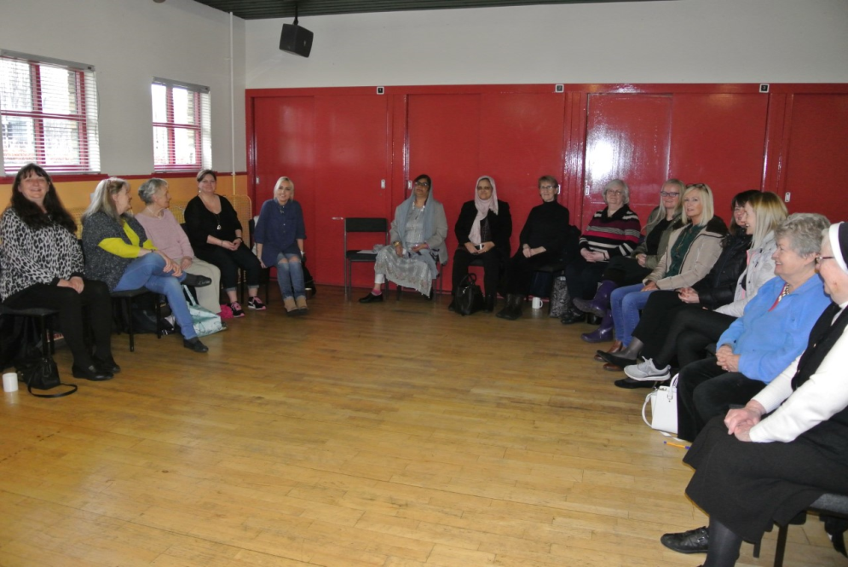
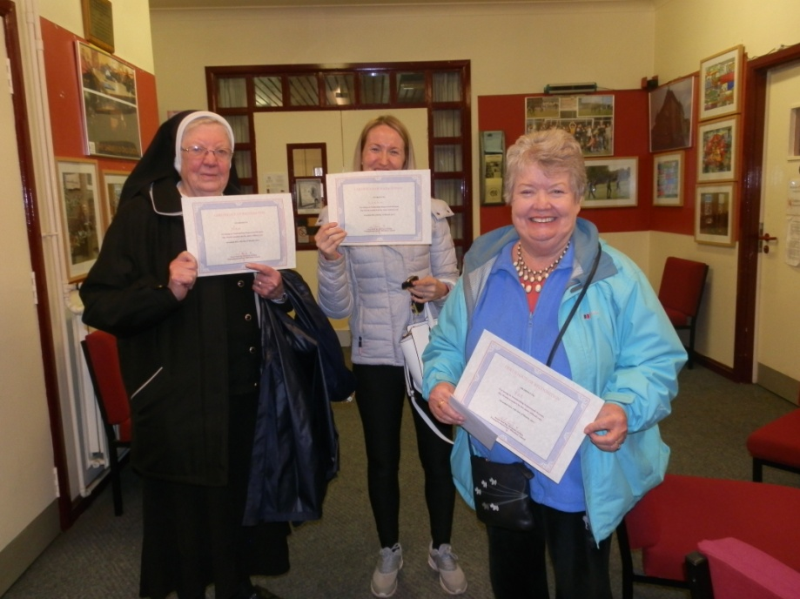

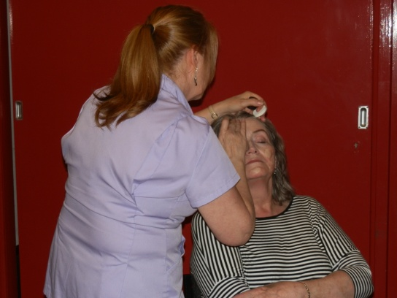

Group News Continued

Women's Group Continued
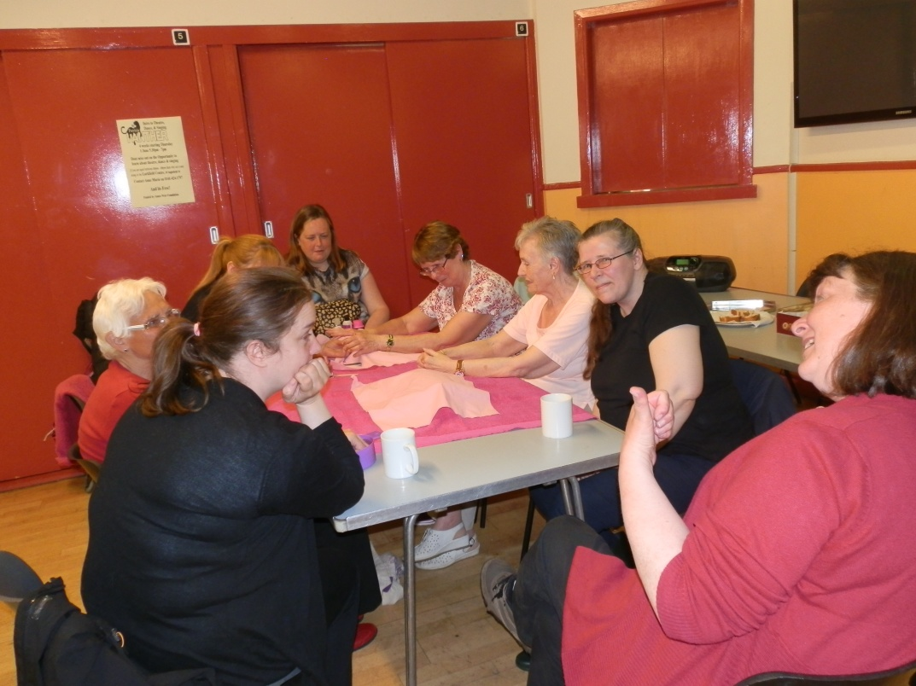
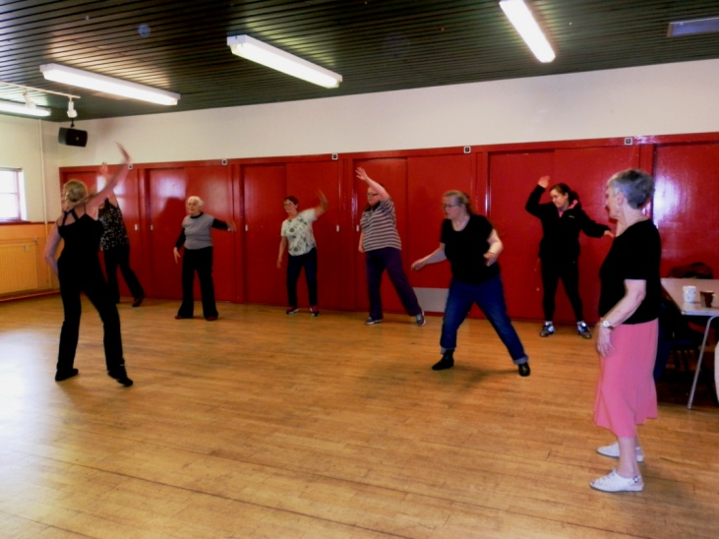

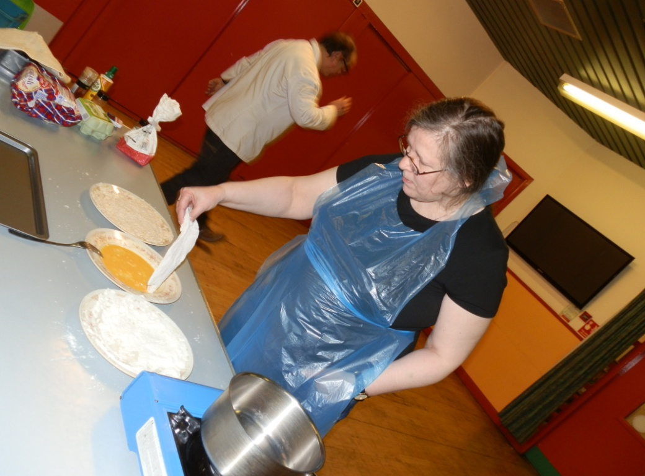

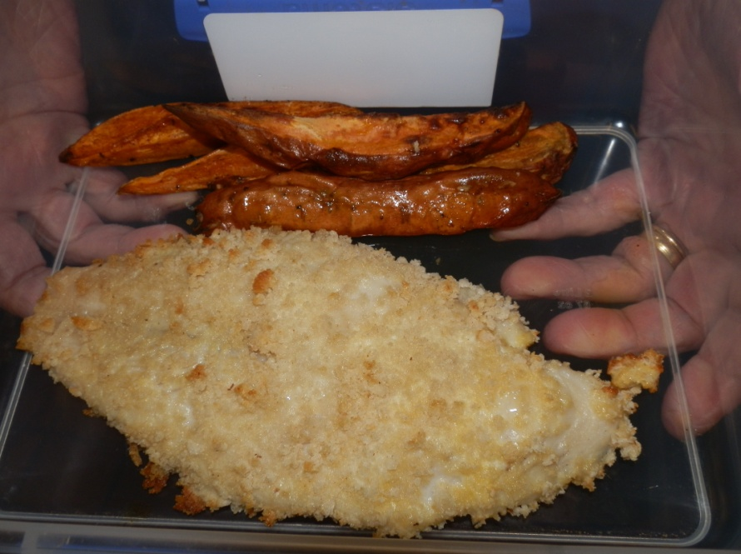

Group News Continued

Larkfield Lambs

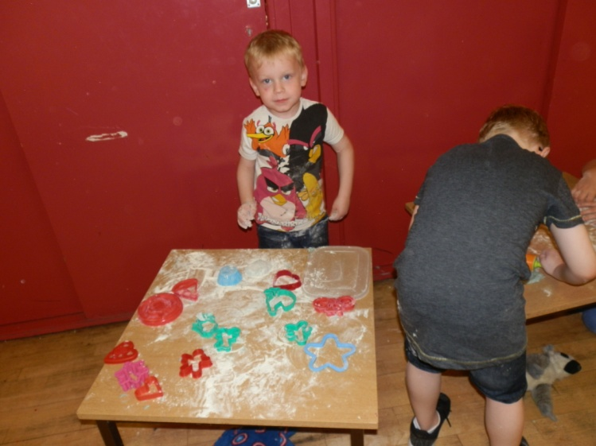
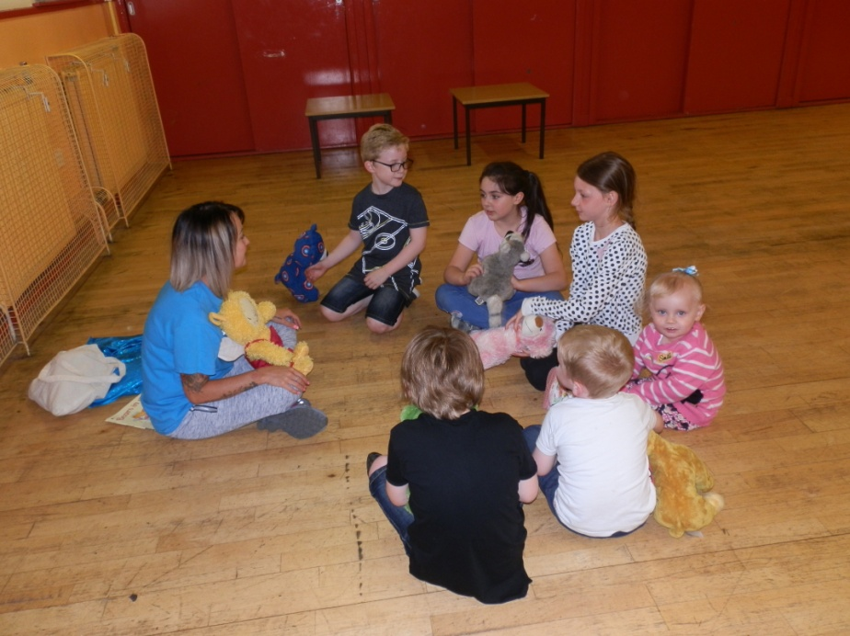
Sadly we were unable to sustain this group and only held about 4 workshops this year due to the lack of numbers. It was disappointing to let the group go as it had been one that the community during consultation had highlighted that there was a gap in our provision of services for the community. Hopefully we might be able at some point to revisit this and see if funding is available for something else for this age group. Below are some pictures from the last session of the Larkfield Lambs!
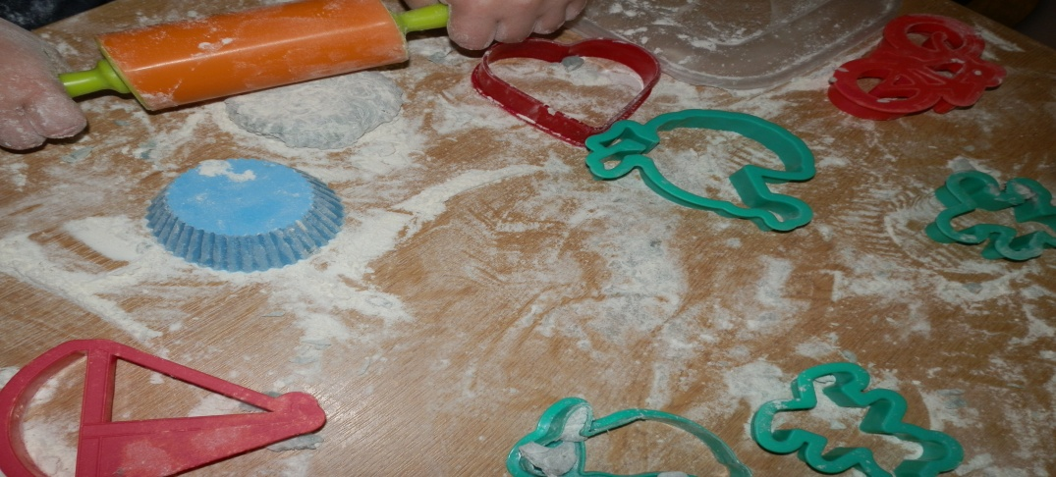
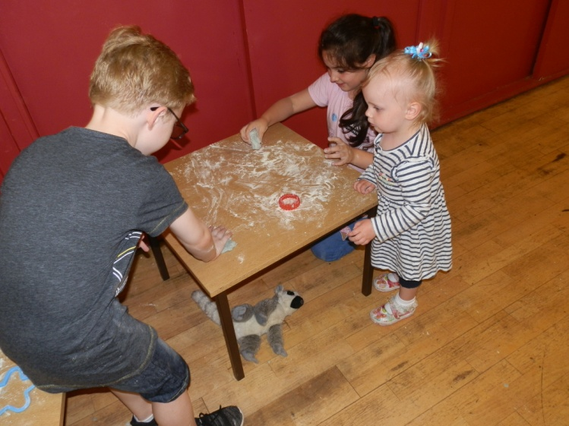

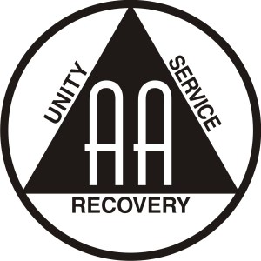
Group News Continued

AA Group

The AA continue to meet on a Wednesday evening at the Larkfield Centre from 7.30pm – 10pm providing support to those who need it. If you feel you need someone to talk to then come along on a Wednesday evening the group is welcoming to all who come through its doors.

Book Group

The Book Group met on the first Wednesday of the month from 2pm – 4pm but sadly it no longer meets due to lack of numbers as some of its group members were unable to attend due to health issues and the remaining members were unable to sustain the group as they couldn’t recruit enough members to make it worthwhile.
Play Club by Glasgow Life

The ‘Play Club’ continues to meet at the centre on a Tuesday from 3.30pm – 5.30pm.

Please note the time change. The service is for children between the ages of 5yrs and 12yrs. This service is delivered in partnership with Glasgow Life and enables children to come together to learn, play and socialise, providing opportunities to play games and learn skills in arts and crafts. Its fun and children love it.

Group News Continued

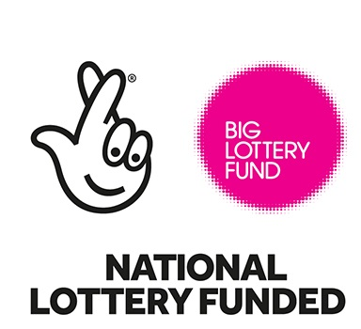
SKYY Group (Singing Keeps You Young)

The SKYY Group grew out of the Tea Dances as there was a core group who wanted to sing and that’s just what they do on a monthly basis sing and enjoy themselves and it is currently funded by Awards for All.

The pictures show older people enjoying themselves in a safe and friendly environment.
