Events 2017/2018

Marie Curie (Blooming Great Tea party)

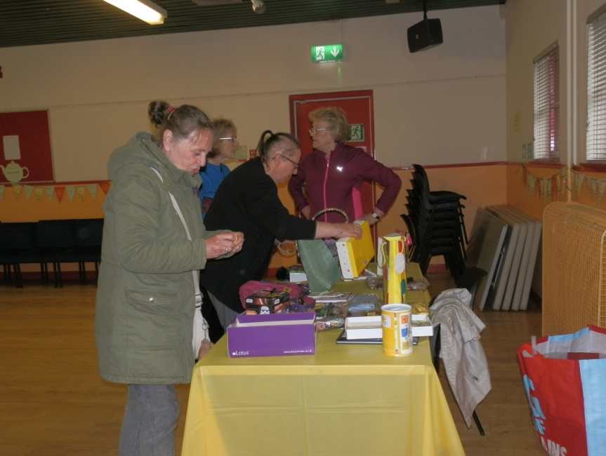
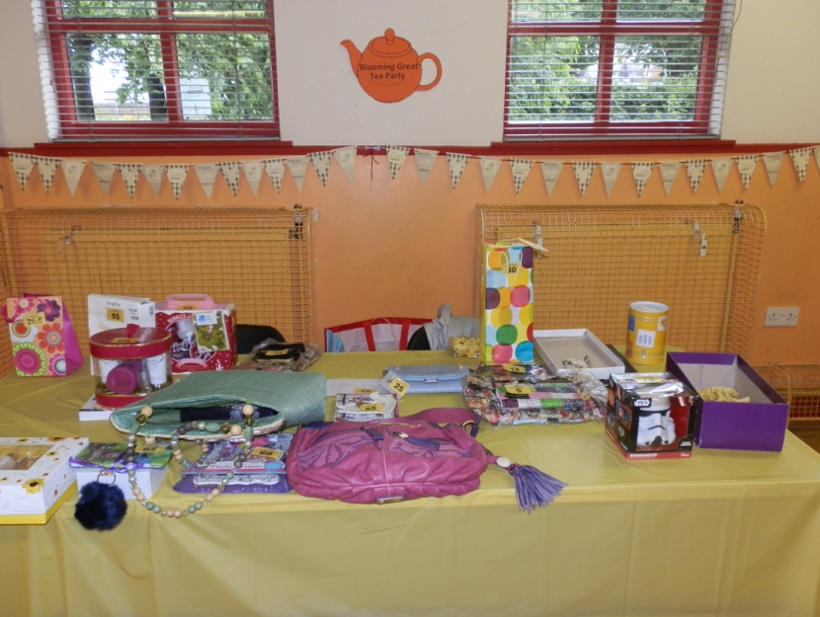
The Centre Management Committee hold annually a fundraiser ‘Blooming Great Tea Party’ in aid of Marie Curie as it is a truly worthy cause as cancer has touched the lives of many of our centre users if not them directly a member of their family and also its management committee.

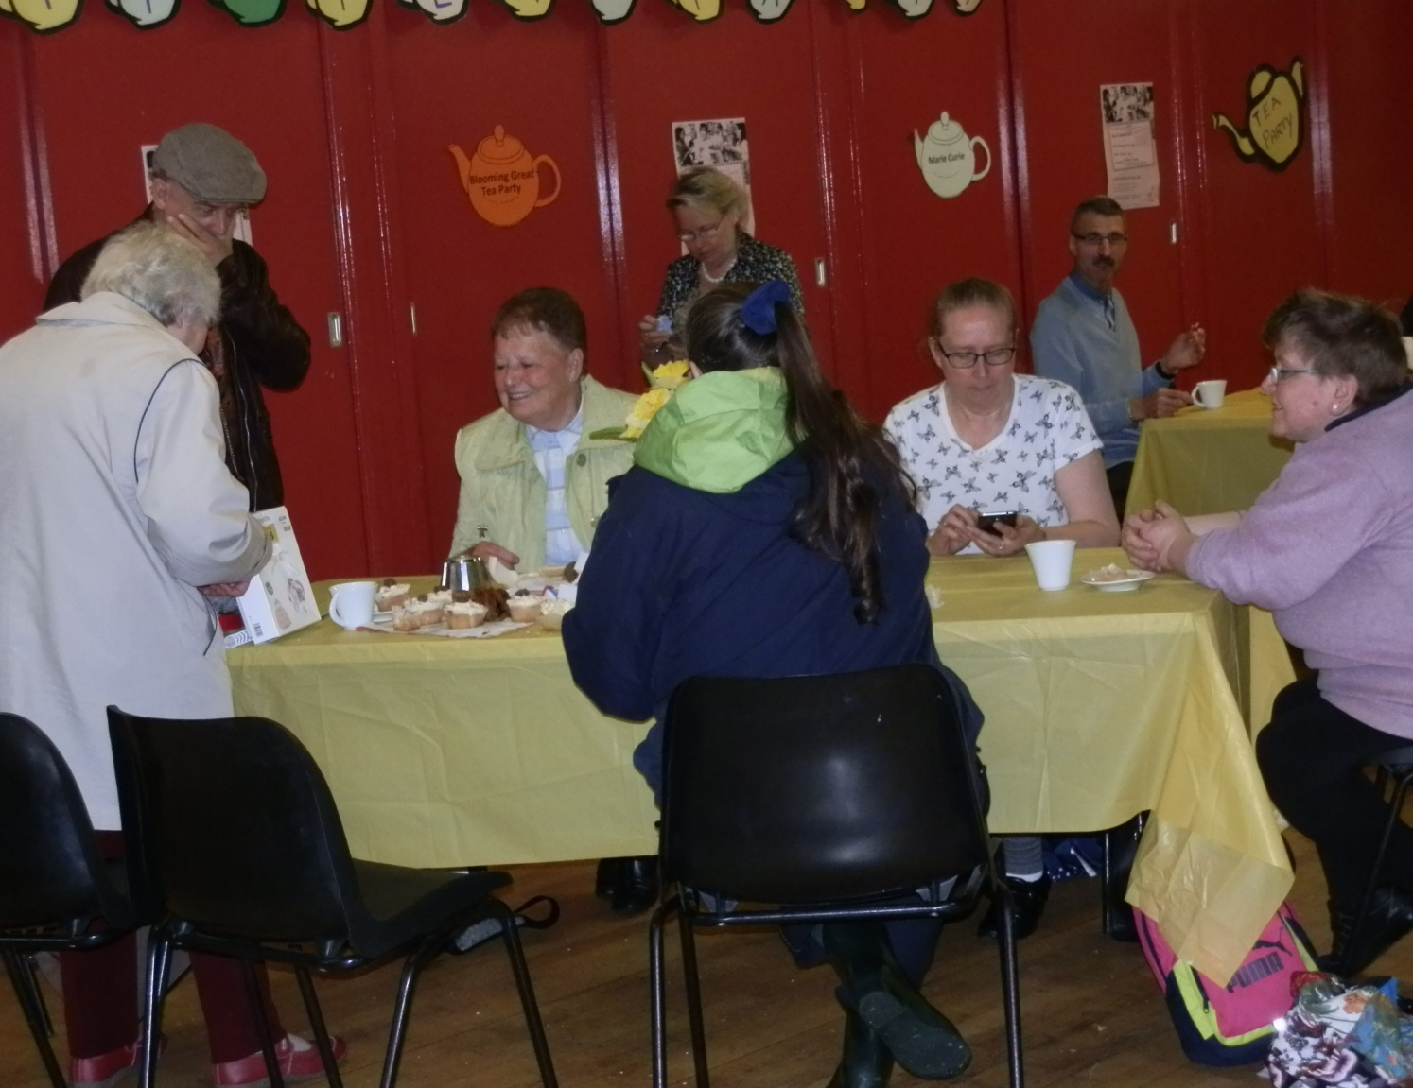

Events 2017/2018 Continued

Easter

The annual Easter Event was well attended but unfortunately this year due to a staffing issue we were unable to hold the event as a community event and rather than cancel the event we invited the local primary schools, the Assisted Learning Secondary School along with the Assisted Learning sector campus from Clyde College (Langside).

The photographs on the next few pages will give you a flavour of the fun that was had at the event.

Pictured below is from L-R John Peebles (Vice Chairperson) Margaret Walker, Helen Gilmour (Committee Member) Charmaine Dunsmuir who helped out in the kitchen providing juice and crisps.

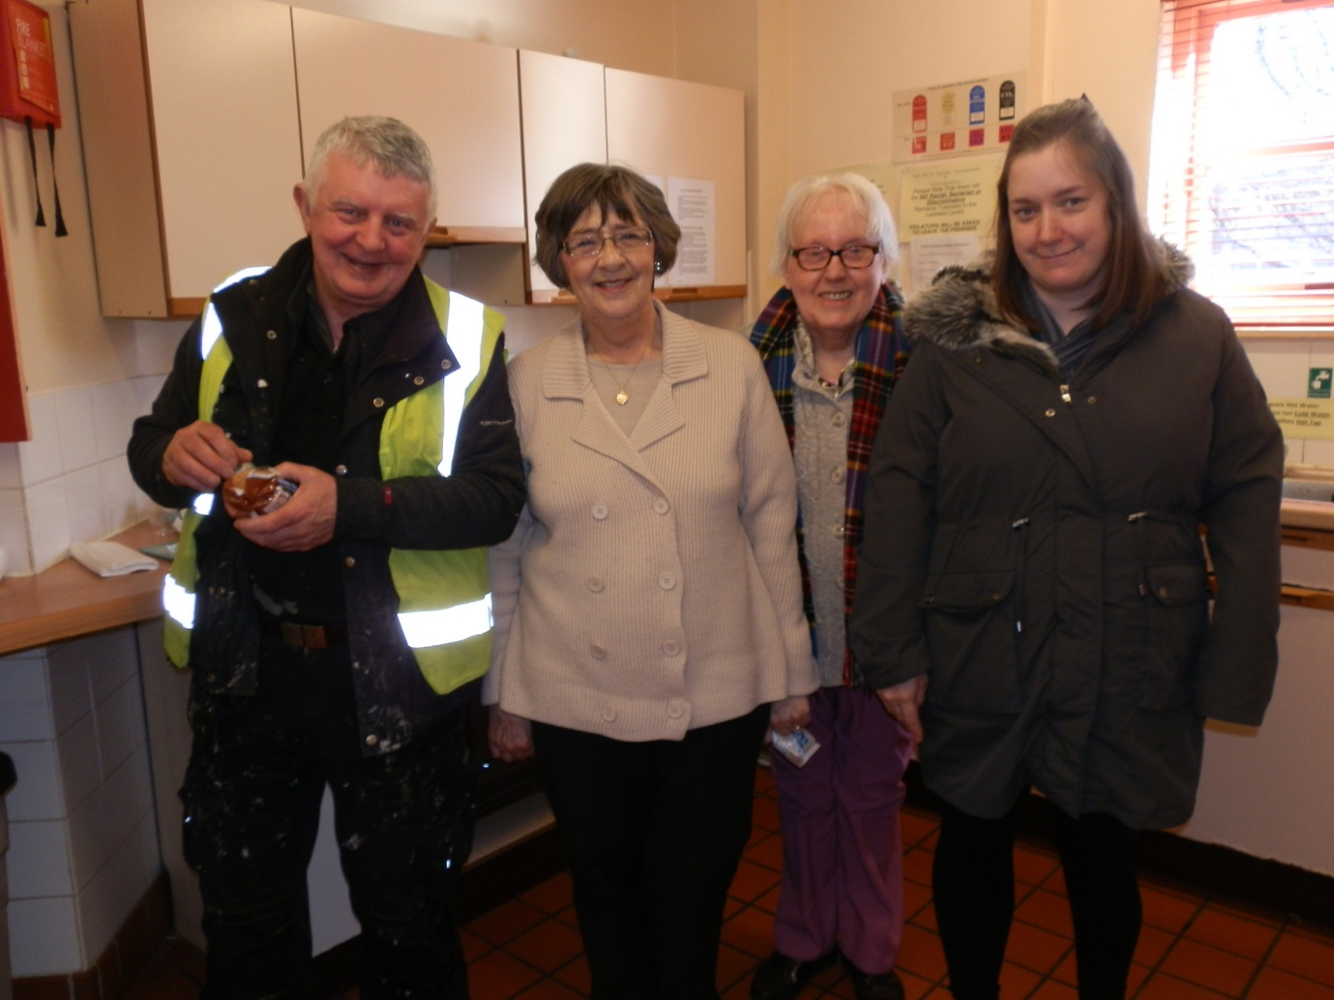

Events 2017/2018 Continued

Easter Continued
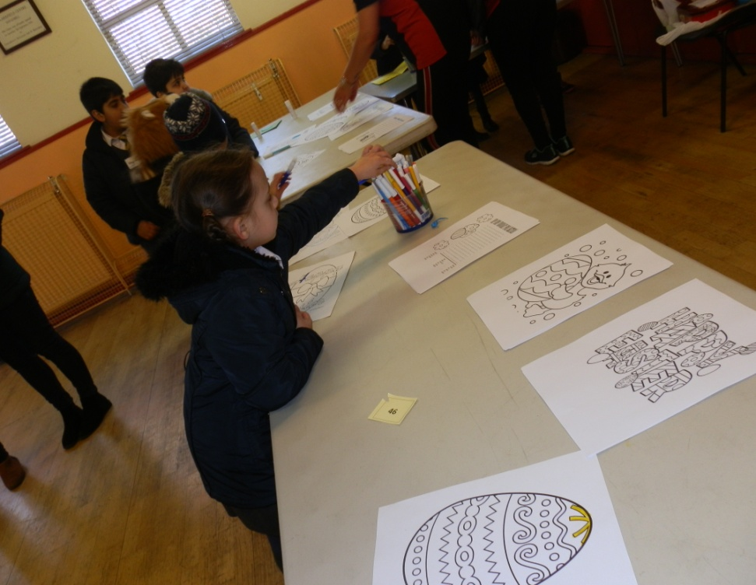
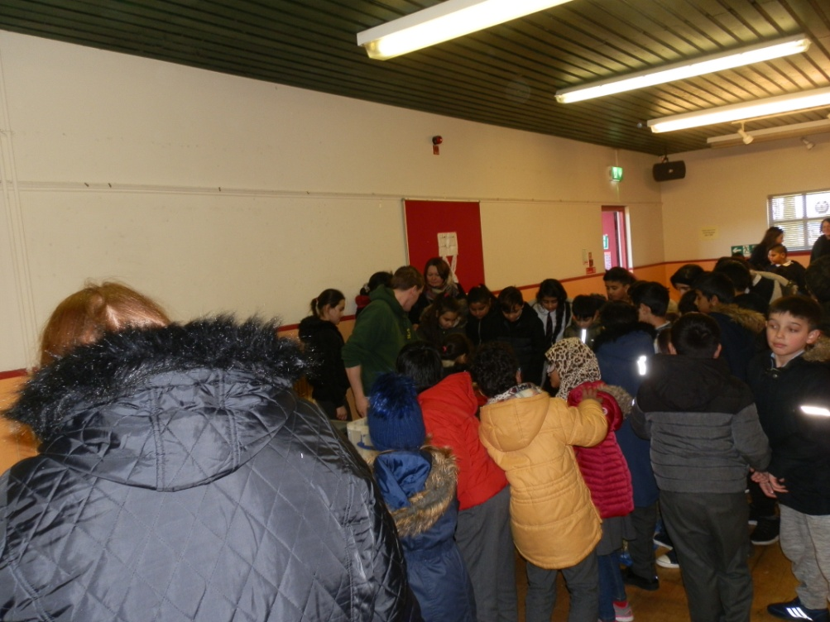

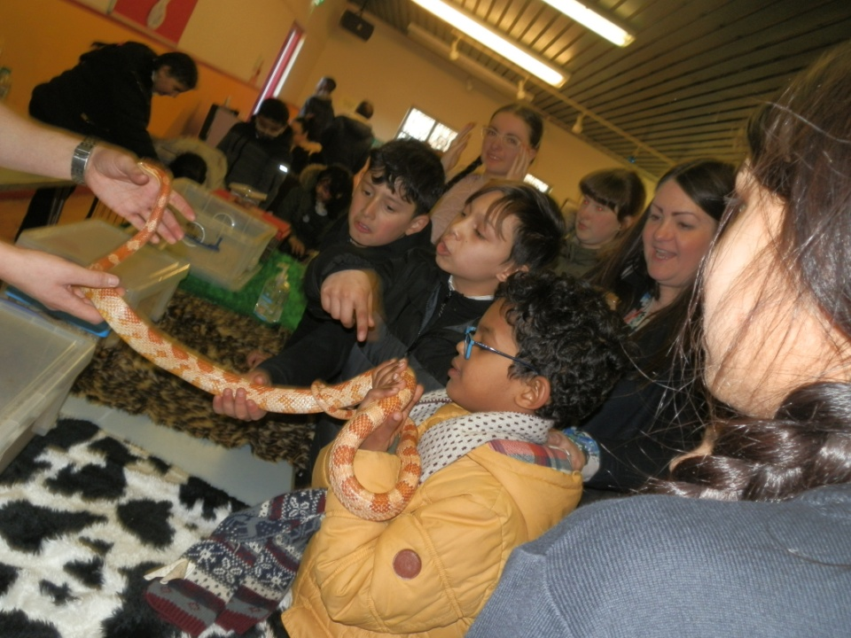
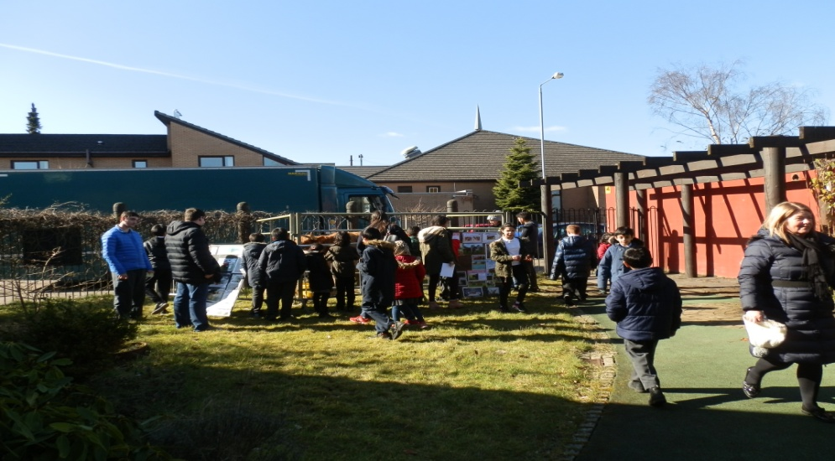
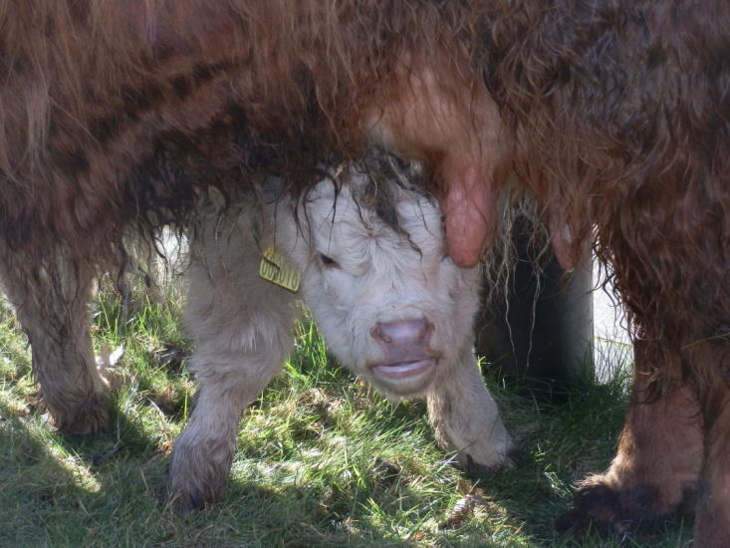

Events 2017/2018 Continued

Easter Continued
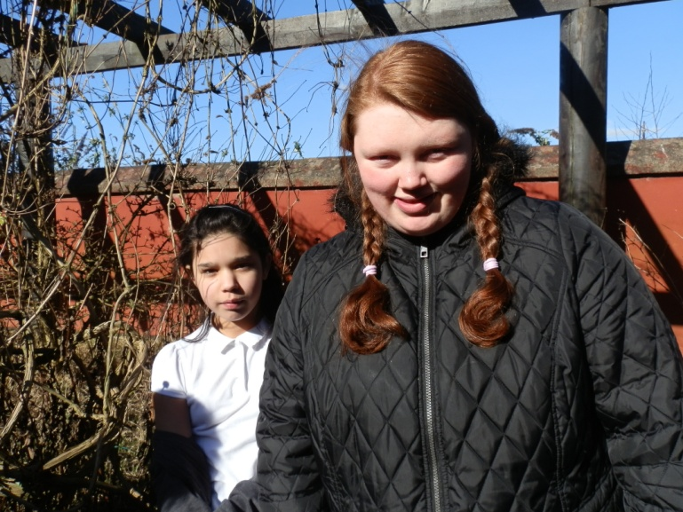
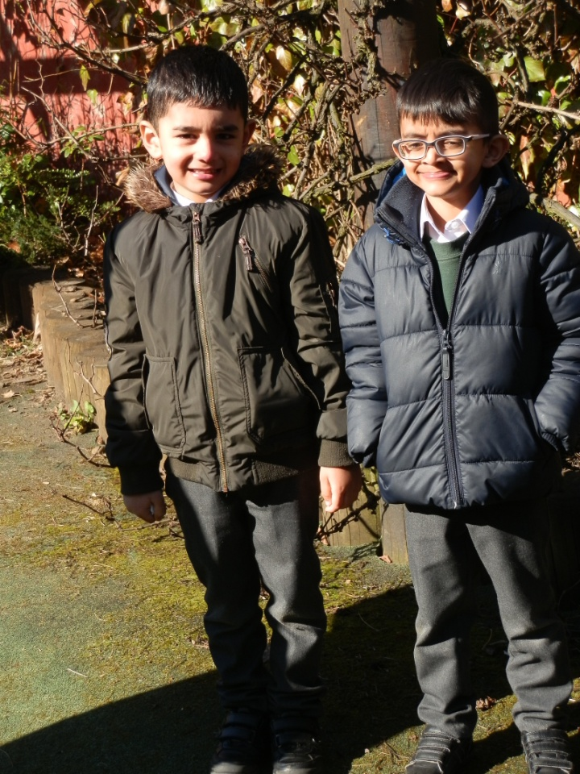

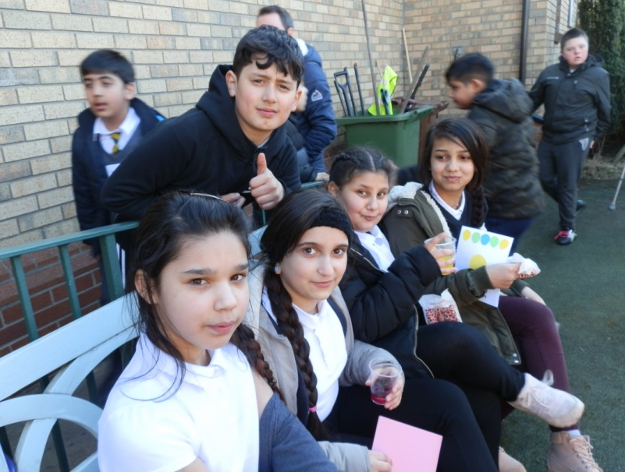

Events 2017/2018 Continued

Easter Continued
