Events 2017/2018 Continued

Christmas Lights Switch-on

As ever the Christmas Lights Switch-on was at full capacity again and a huge thank-you to the community for coming out and supporting this family event.

Santa popped along to visit the children and the adults giving out balloons and sweets to the community.

Santa even posed for pictures with the children and their families.
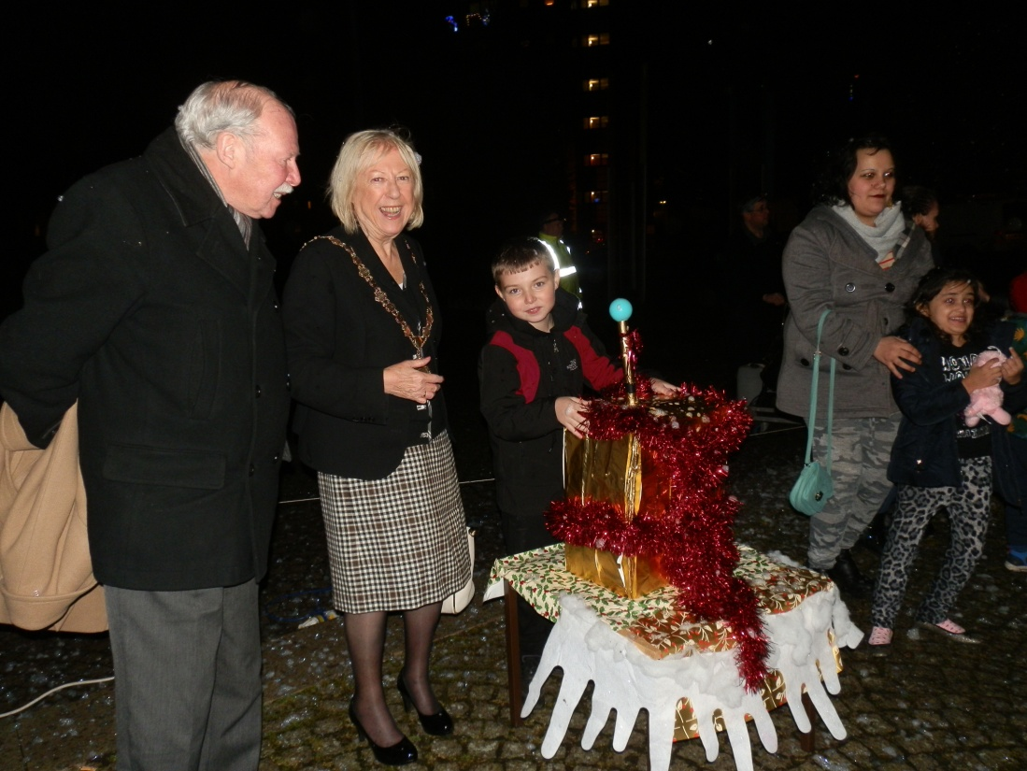

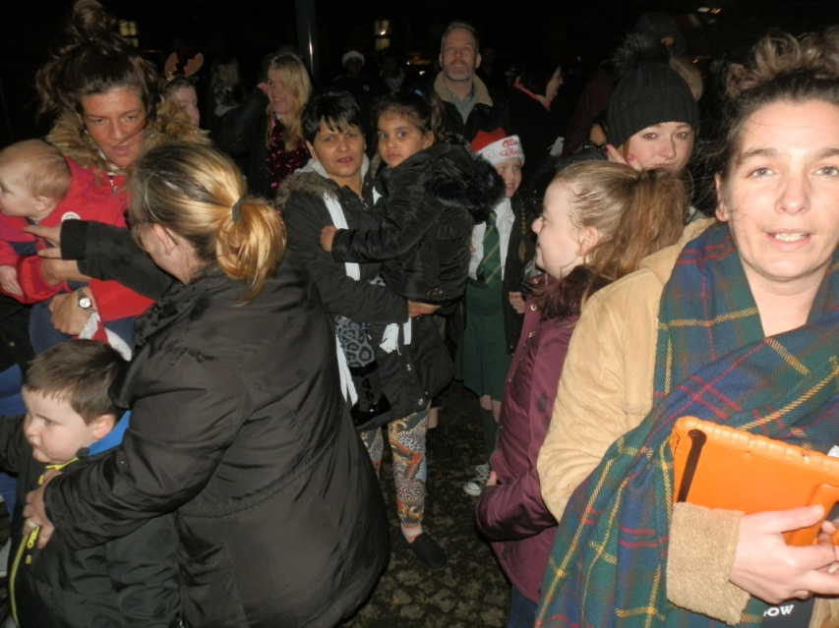

Getting ready to Light up Govanhill’s Christmas Tree on the left is the President of Glasgow & District Burns Association Enez Anderson.
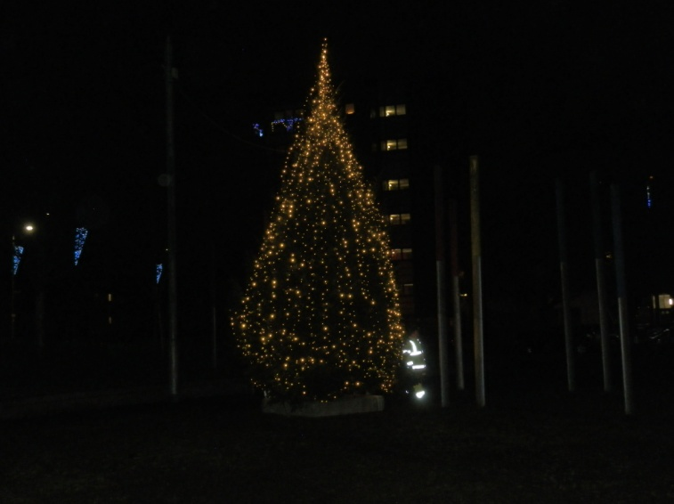

Events 2017/2018 Continued

Christmas Lights Switch-on continued
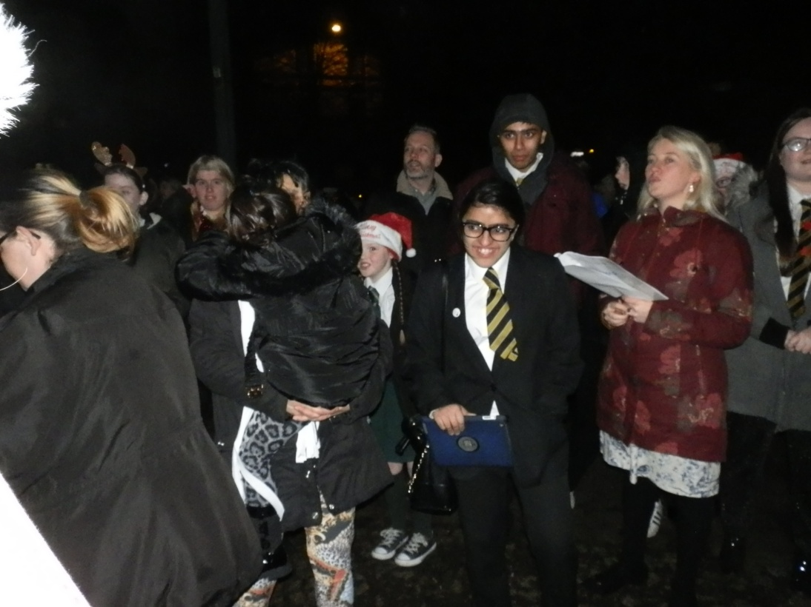

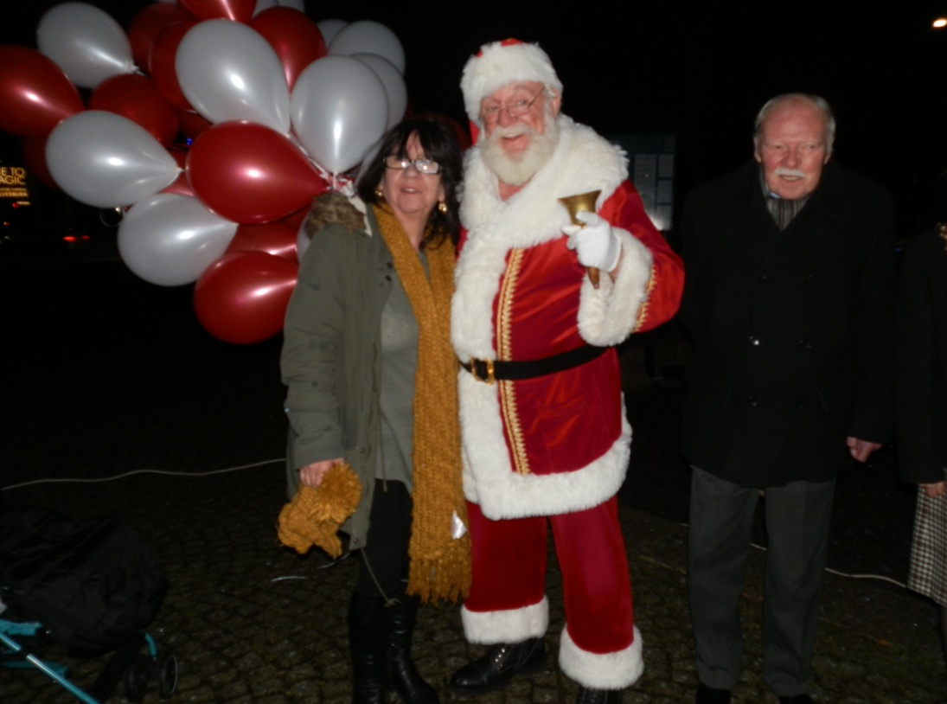

Above, local lady Kathy Reid Graham catches up with Santa

Events 2017/2018 Continued

Christmas Lights Switch-on continued
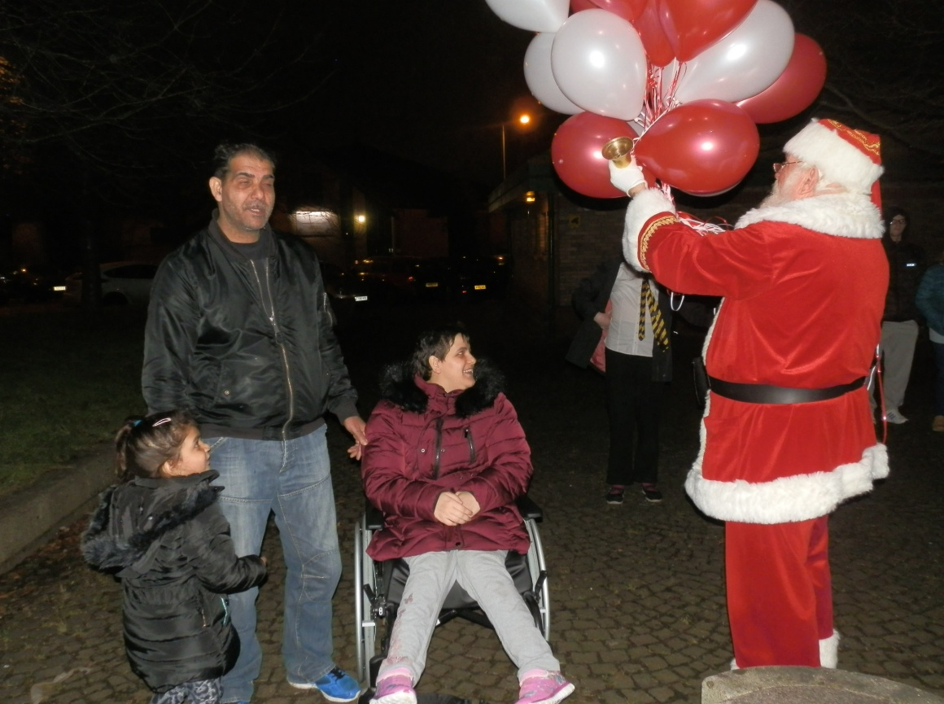

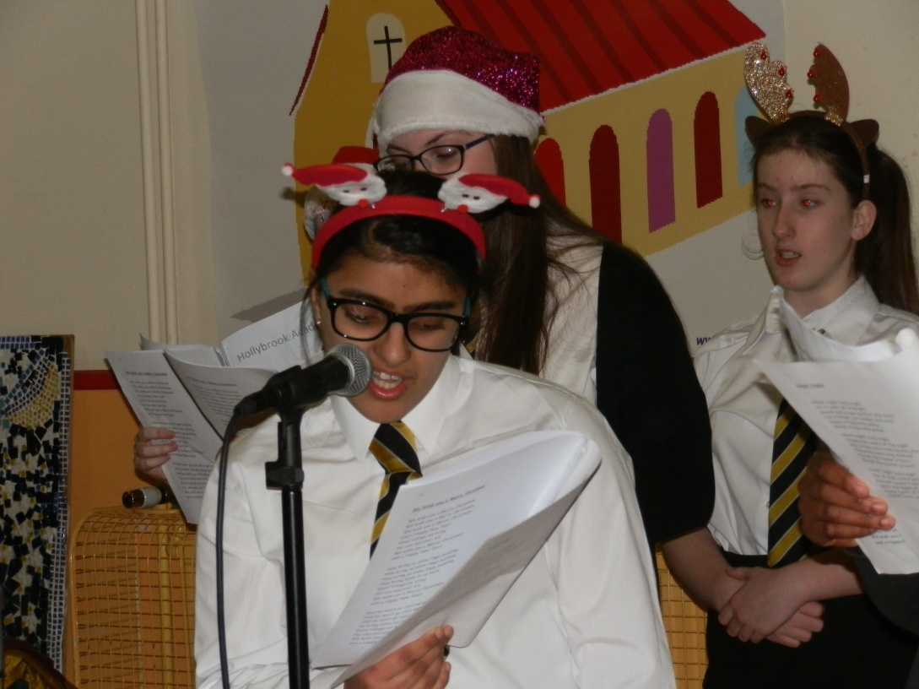

Events 2017/2018 Continued

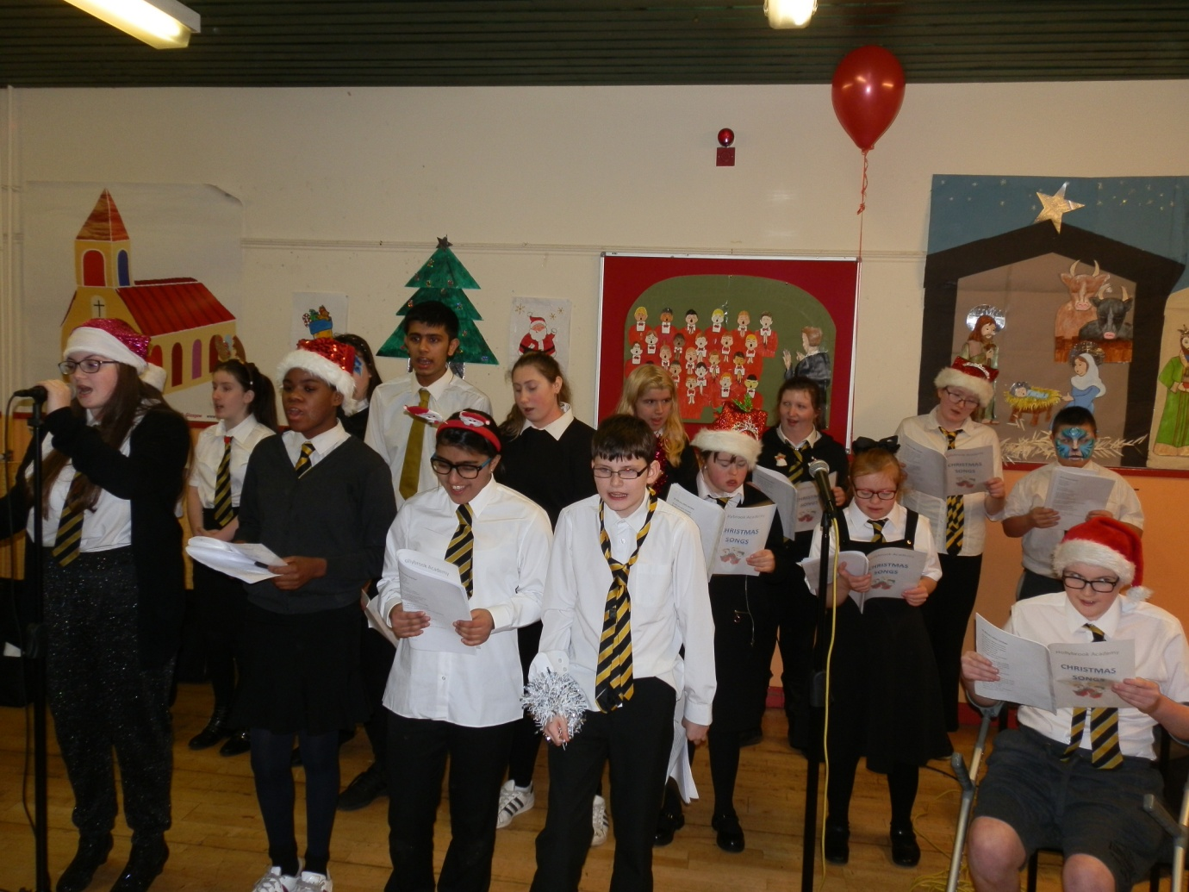
Christmas Lights Switch-on continued

Hollybrook Academy School Choir are pictured doing a wonderful job of entertaining the local community

Events 2017/2018 Continued

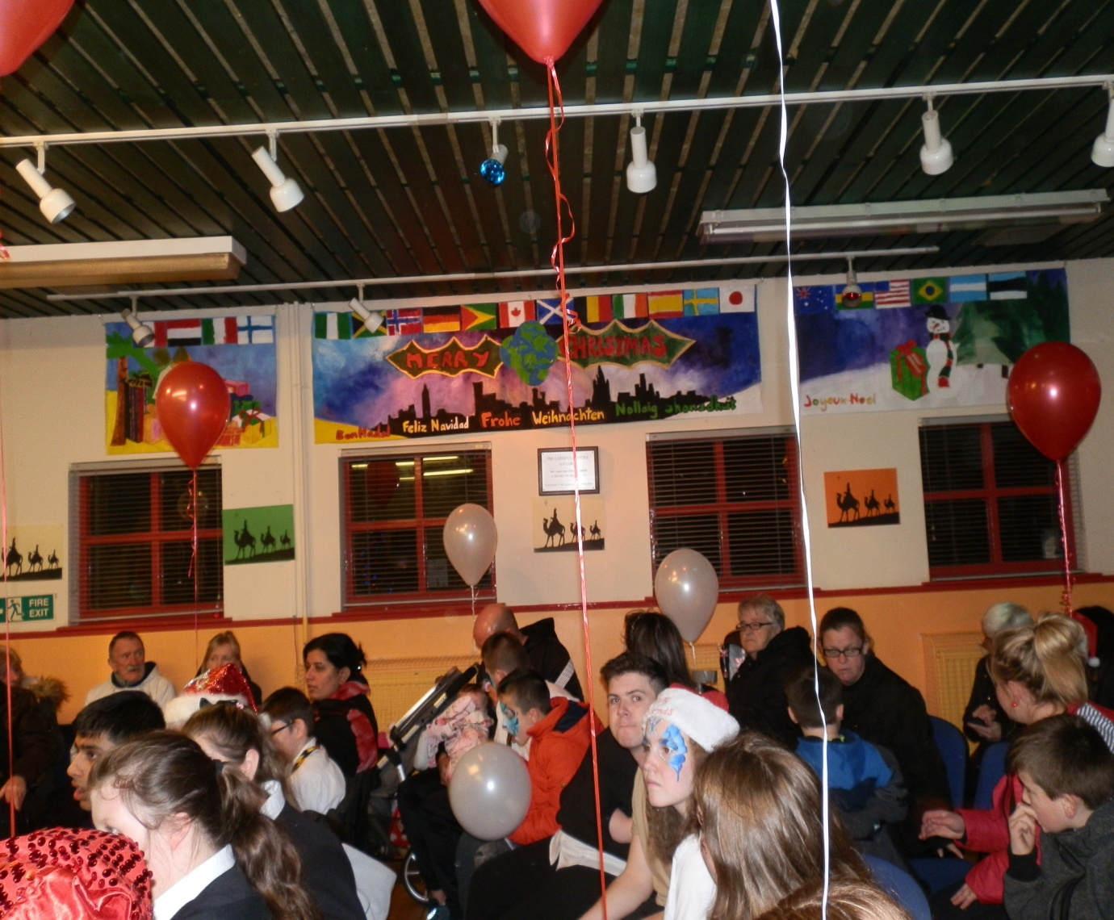
Christmas Lights Switch-on continued

New Christmas Artwork Banner ‘Christmas around the World’
Designed and created by pupils from Hollybrook Academy under the watchful eye of local Artist
Susan Kennedy
Events 2017/2018 Continued

Christmas Lights Switch-on continued

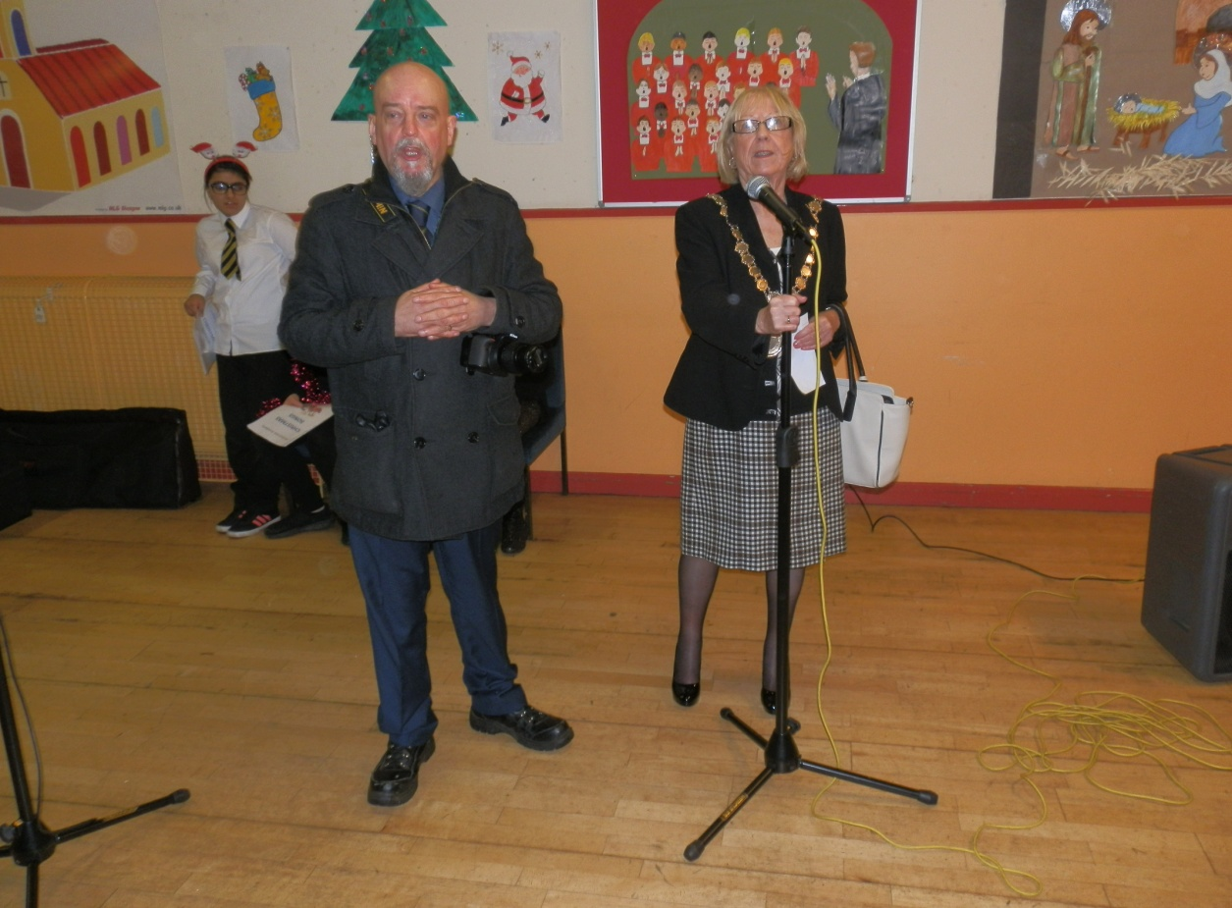

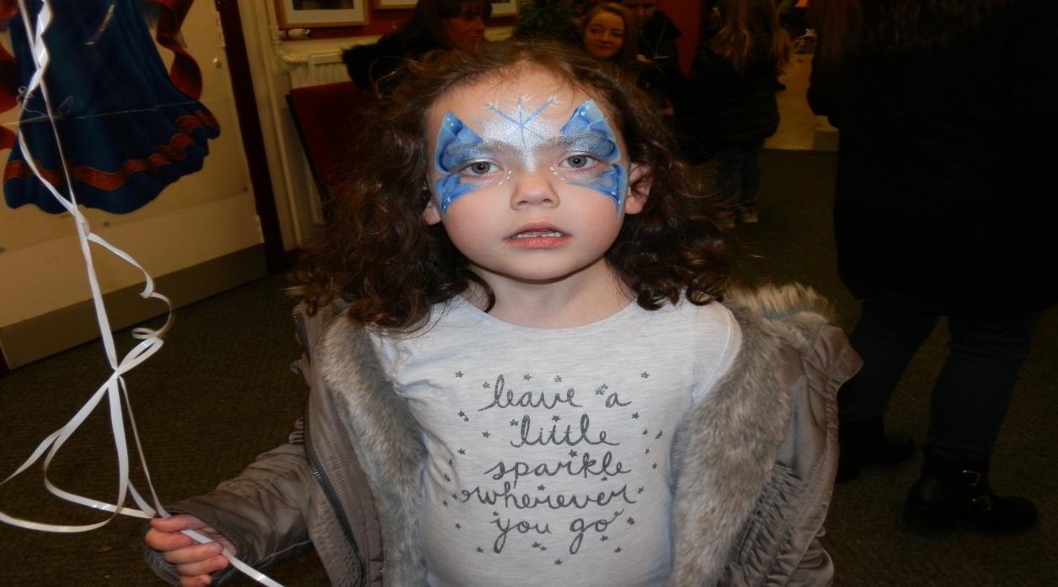

Events 2017/2018 Continued

Christmas – Pantomime

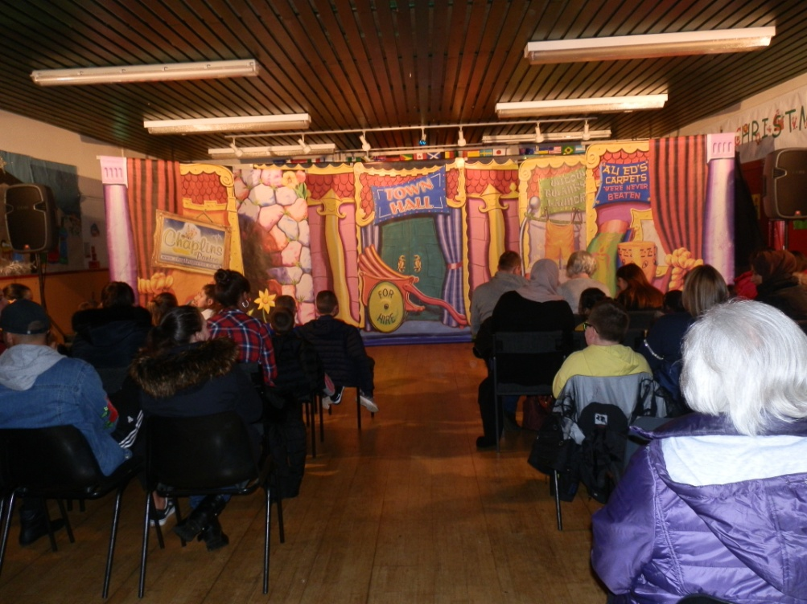

Once again we had a full house for the Pantomime.
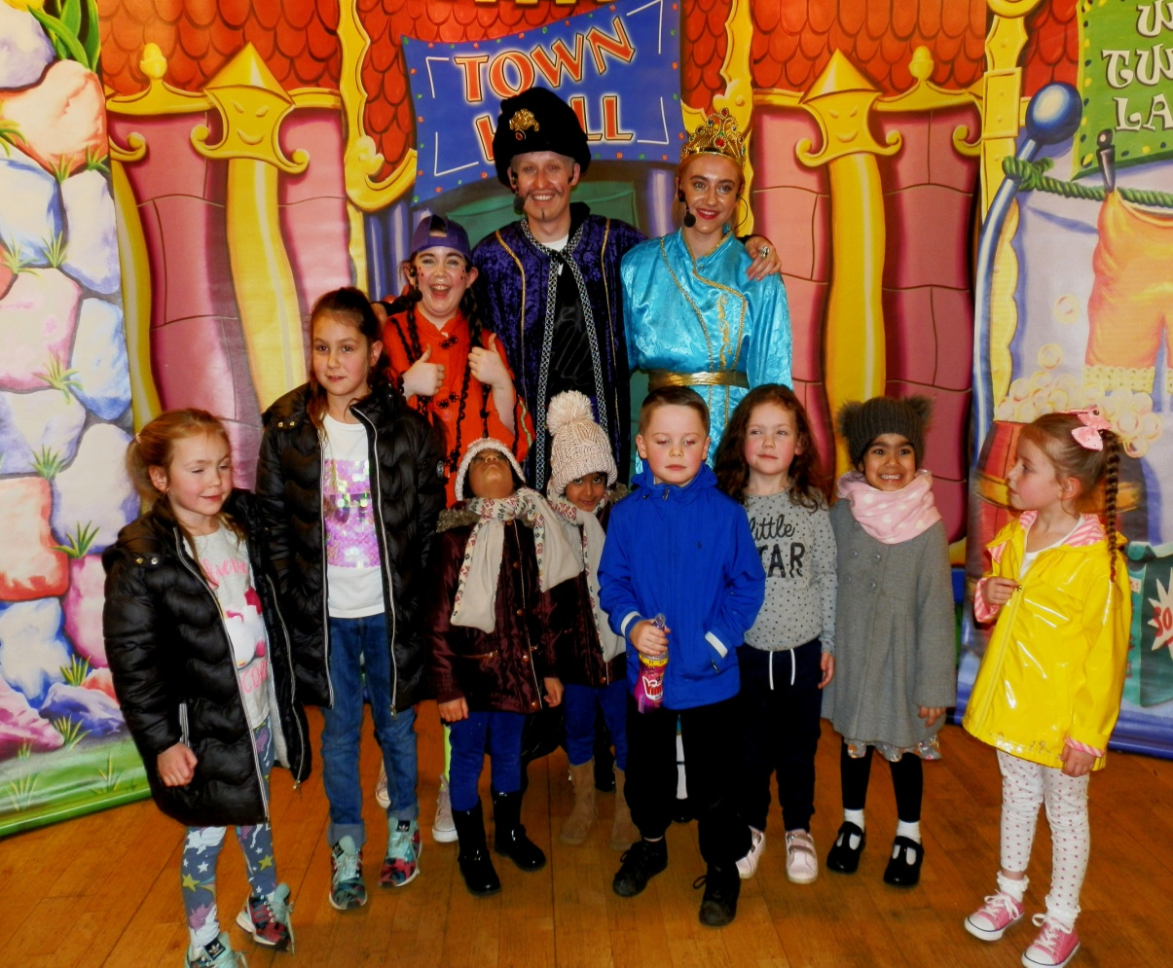
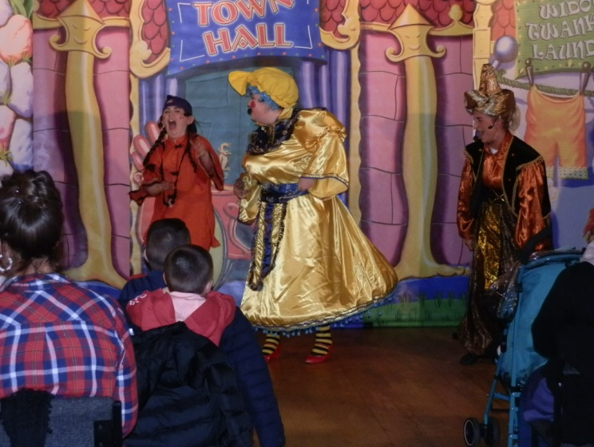

The children just loved meeting the cast of Aladdin

Events 2017/2018 Continued

Christmas – Santa’s Grotto

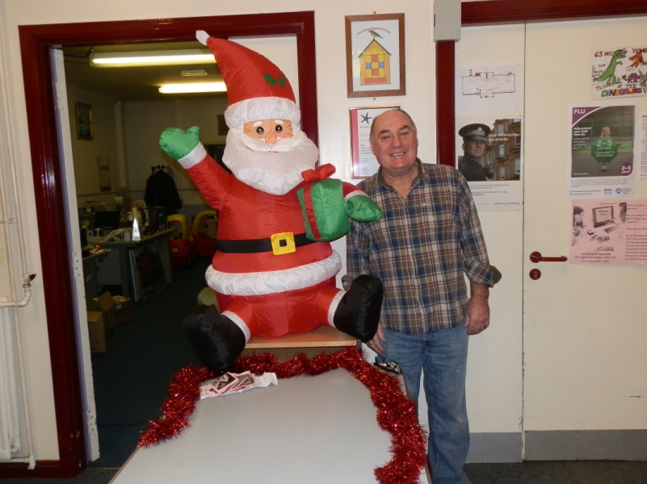
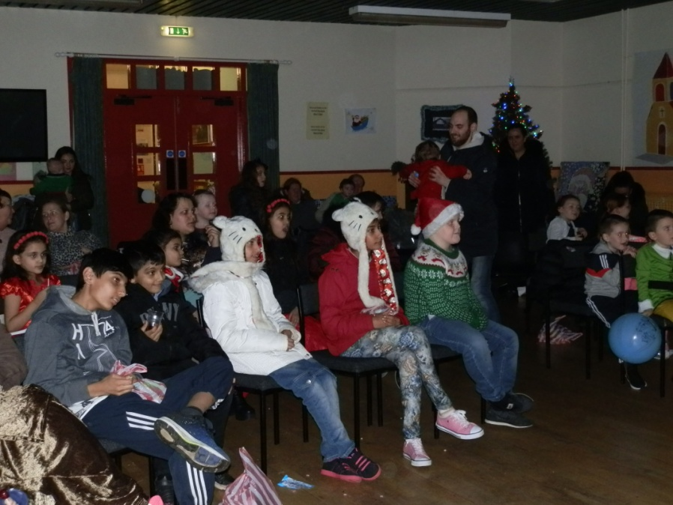
The Christmas Santa’s Grotto continues to give the opportunity to local families to bring the children along to meet Santa in his magical grotto and be entertained by Children’s Entertainer ‘Tommy Tricks’ who captivates the Children with his Magic Show, Balloon sculptures, dancing and much more.

Pictured on the right is Staff member Jim Cavanagh enjoying the fun of the Grotto.
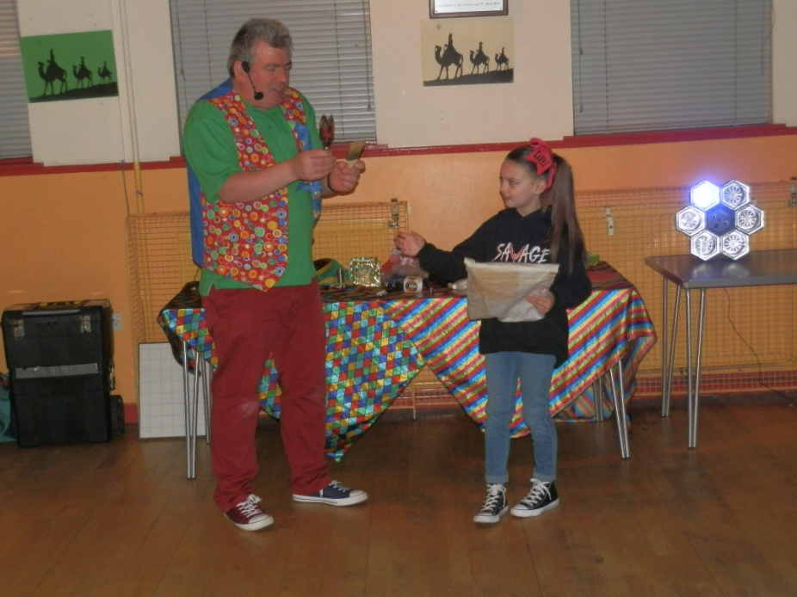

Assisting the Magician with the show!

Events 2017/2018 Continued

Christmas – Santa’s Grotto Continued
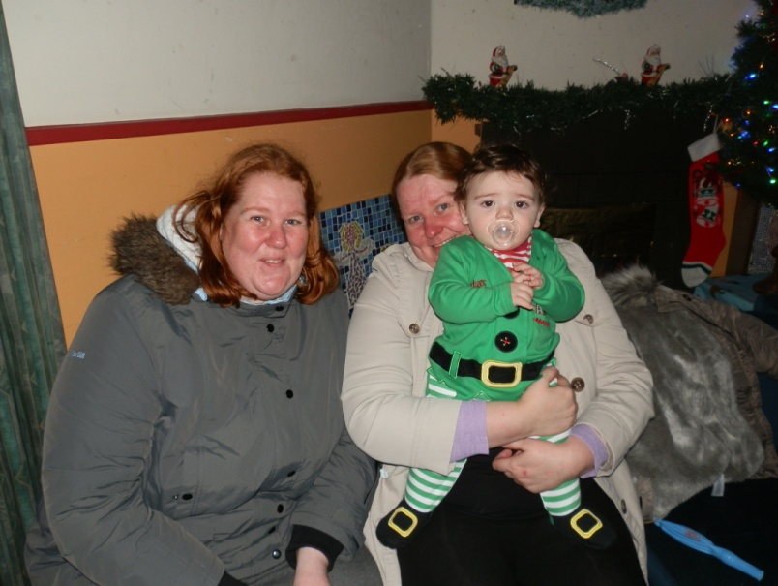

Waiting patiently for Santa to arrive

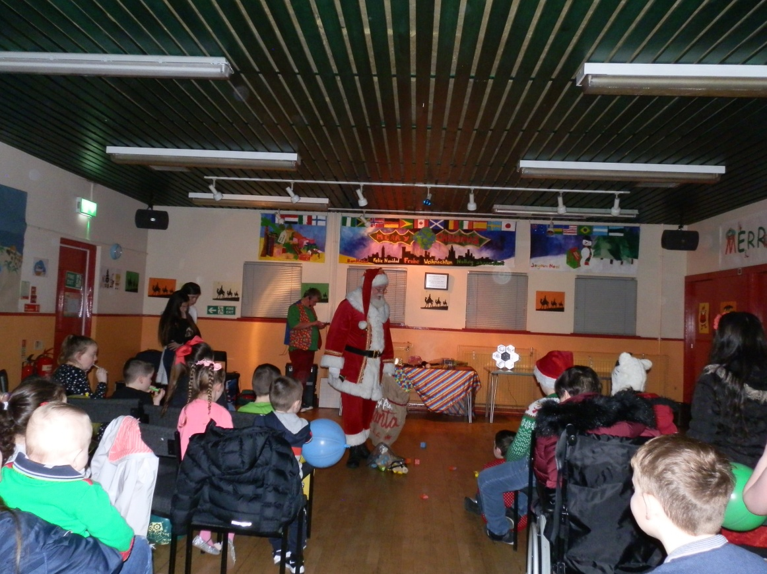

Santa Arrives
At the Larkfield

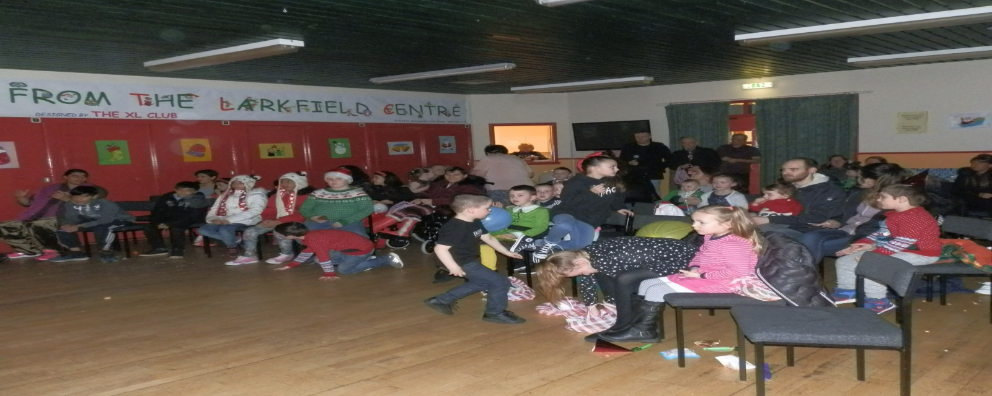

Events 2017/2018 Continued

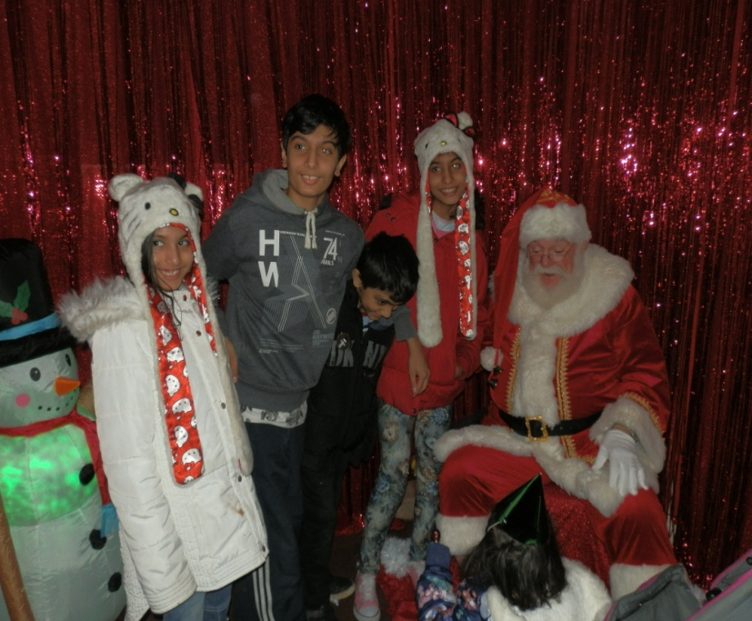
Christmas – Santa’s Grotto Continued
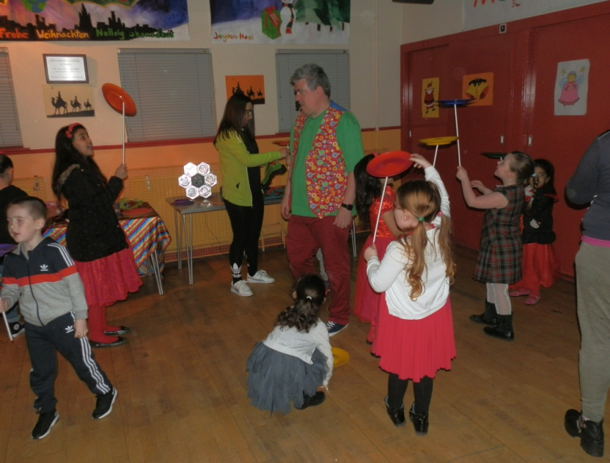
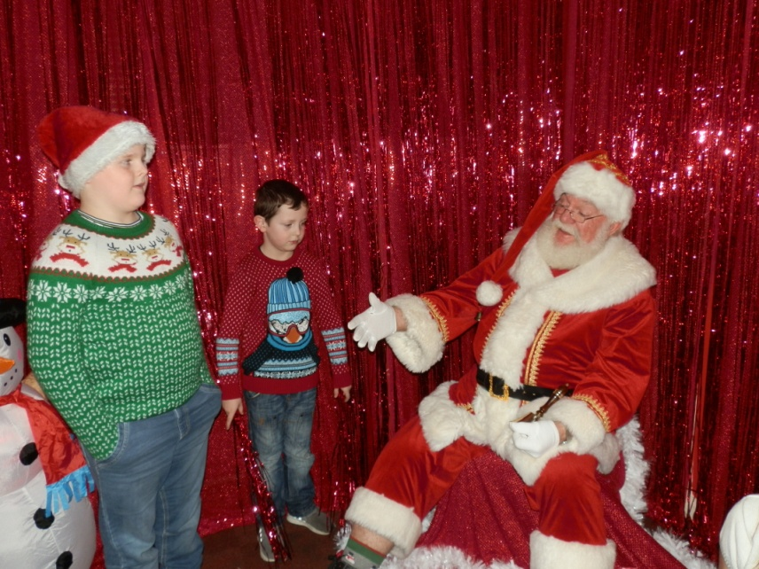
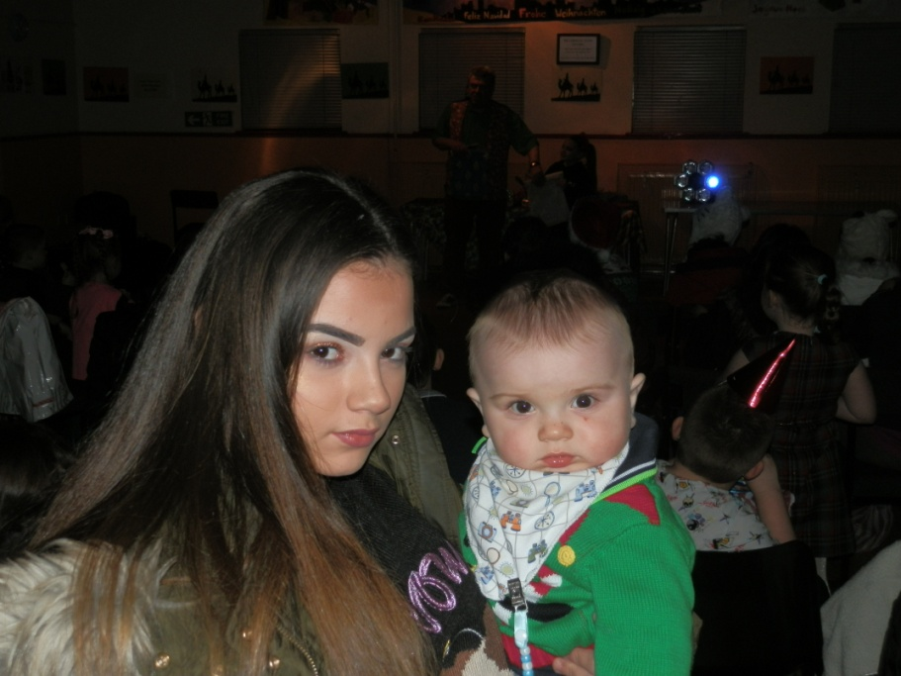

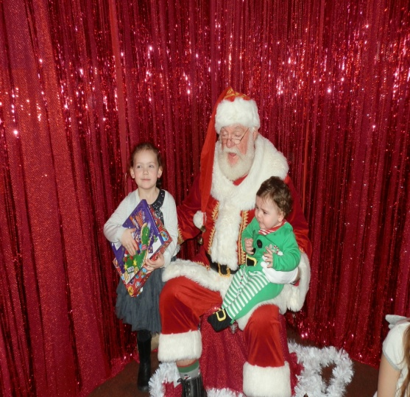
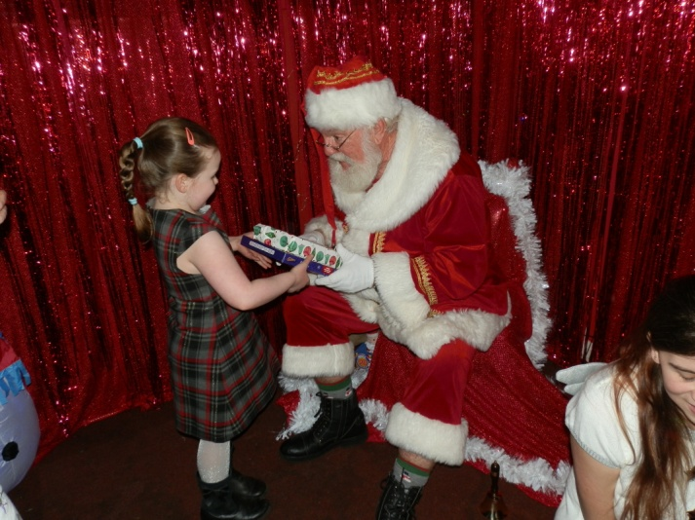
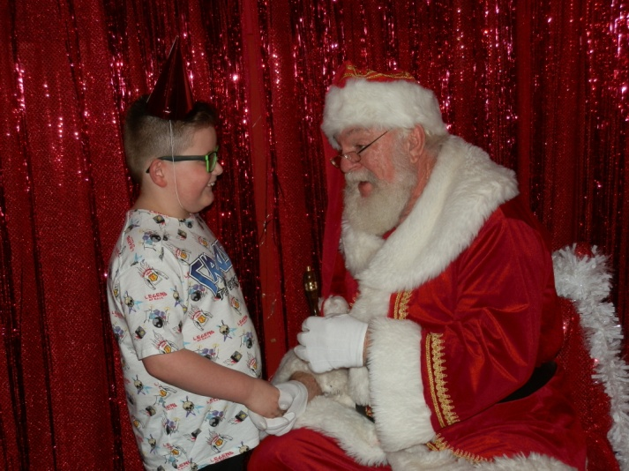

Events 2017/2018 Continued

Christmas – Santa’s Grotto Continued

